To enter a meet
Go to the Bellshill Sharks homepage or use the link in the email.
Bellshill Sharks Swimming Club Home (gomotionapp.com)
Scroll down to events and select the meet you wish to enter – you may need to select “More Events” to see all events available.
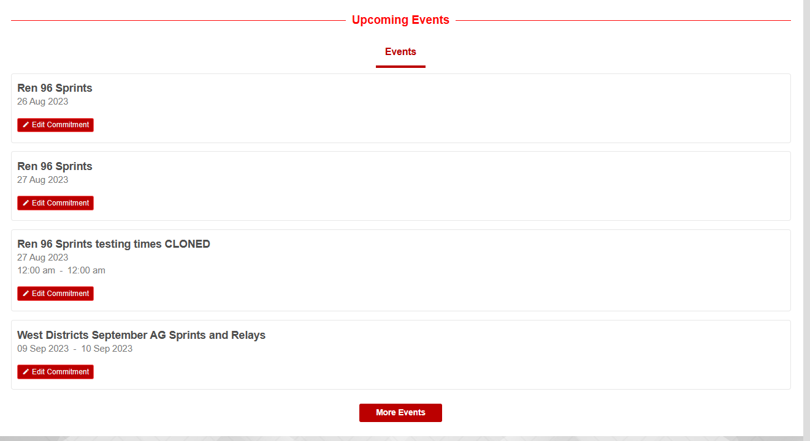
When you click on the event select “edit commitment”
On the Athlete sign up page select the relevant swimmer
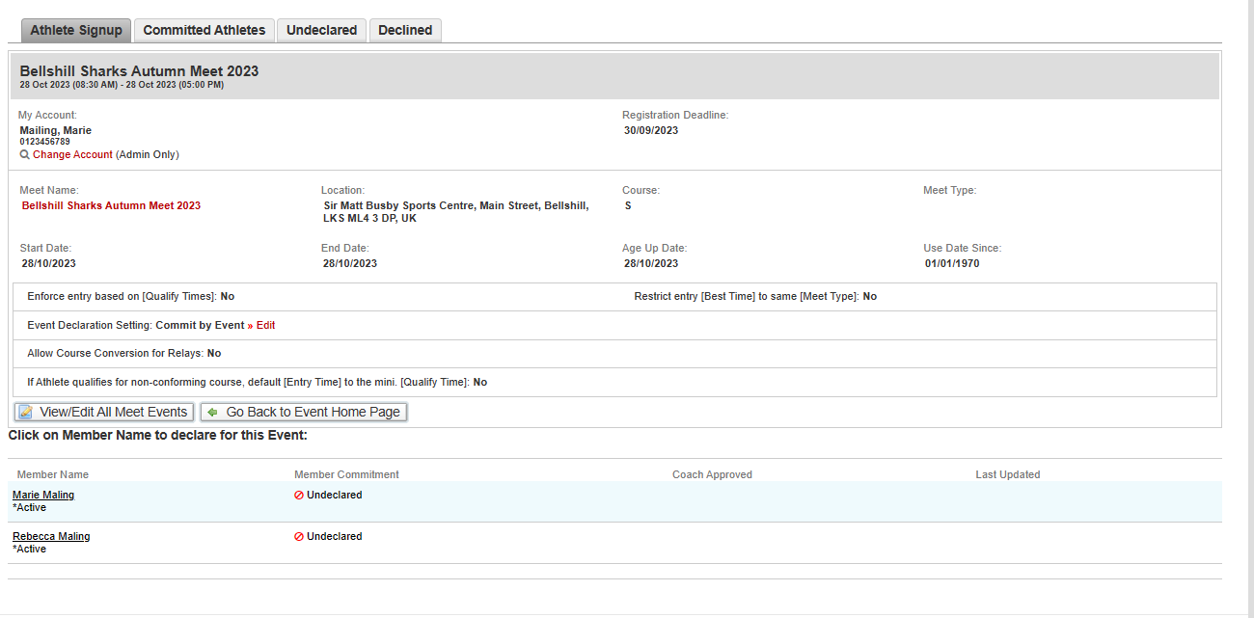
You will then be presented with any relevant information for the meet such as warm up times, costs etc.
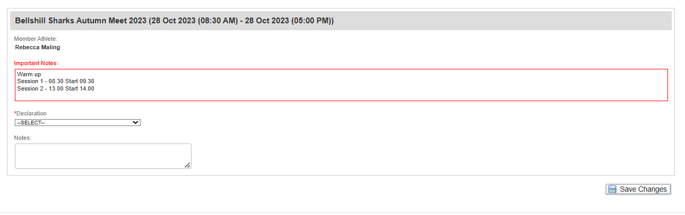
To enter the meet please select “Yes, Please sign <<Name>> up for this event
If you do not wish your swimmer to enter this event please select No thanks
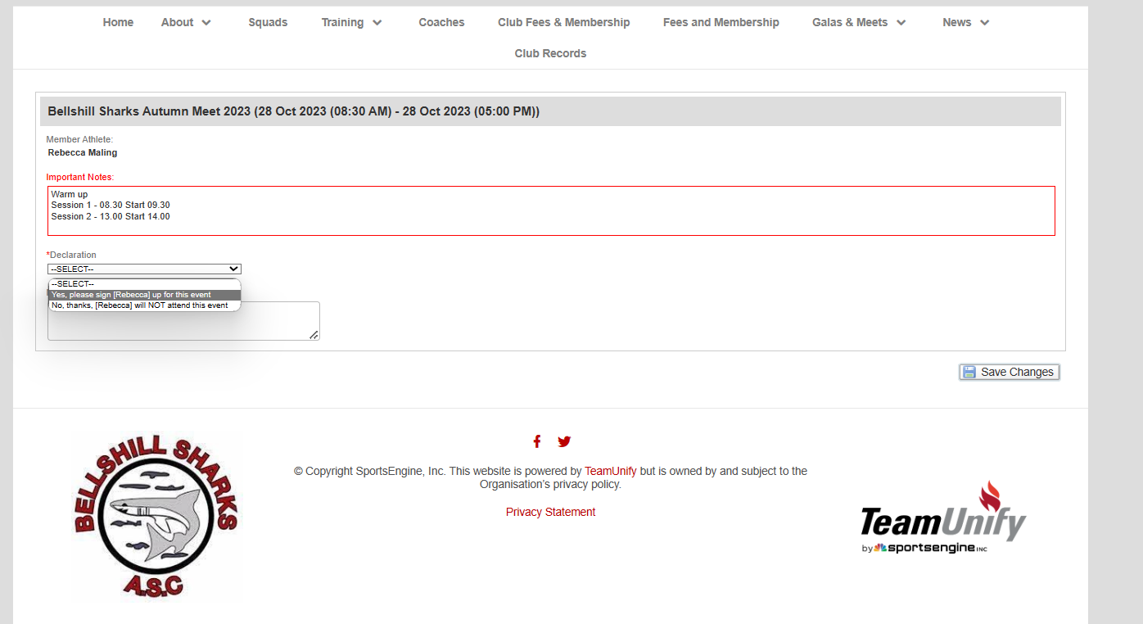
Select the swims you wish the swimmer to enter and save changes
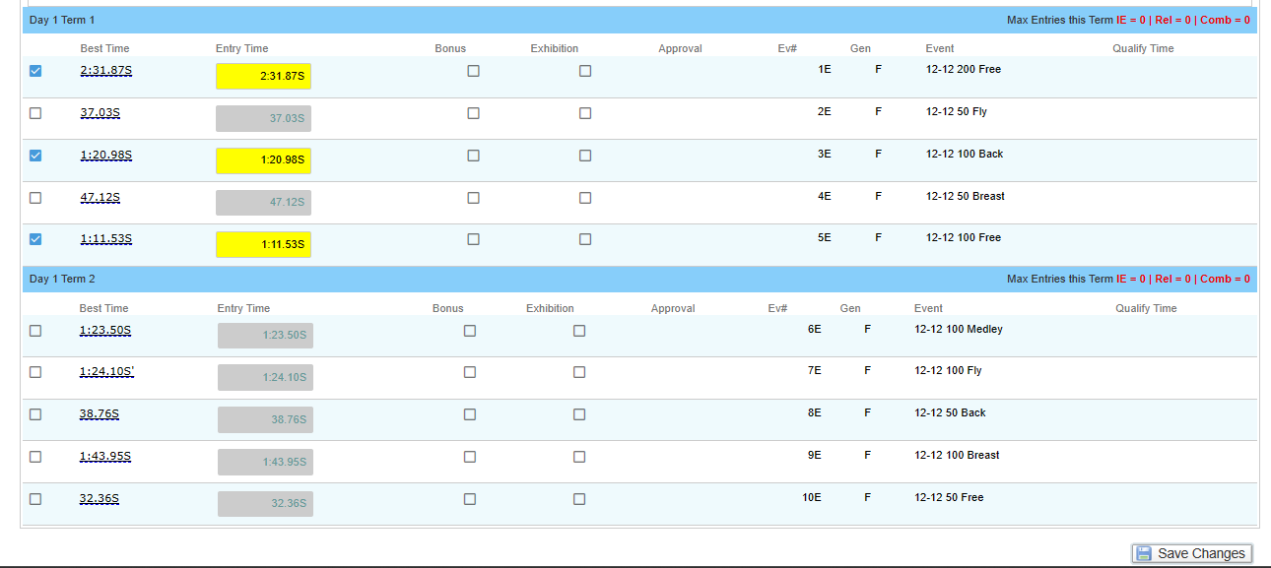

The events will then show as committed
Changes can be made by selecting the edit commitment button, selecting the swimmer and repeating the steps above.

On a mobile device
Open the menu using the ellipse(three lines/hamburger)
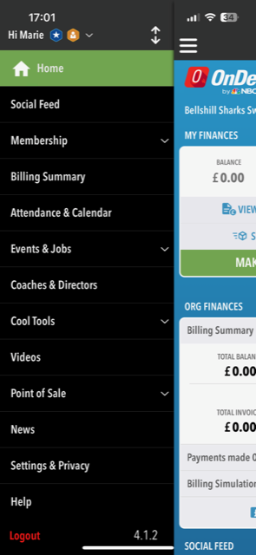
Select “Events and Jobs” then “events and meet entries”
Select the event you wish to enter
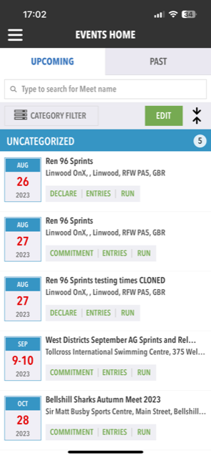
Select Commitment

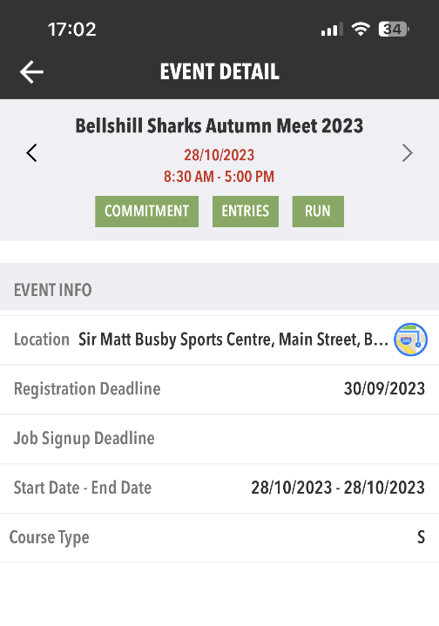
Select the swimmer you wish to enter and there swims and apply to save.
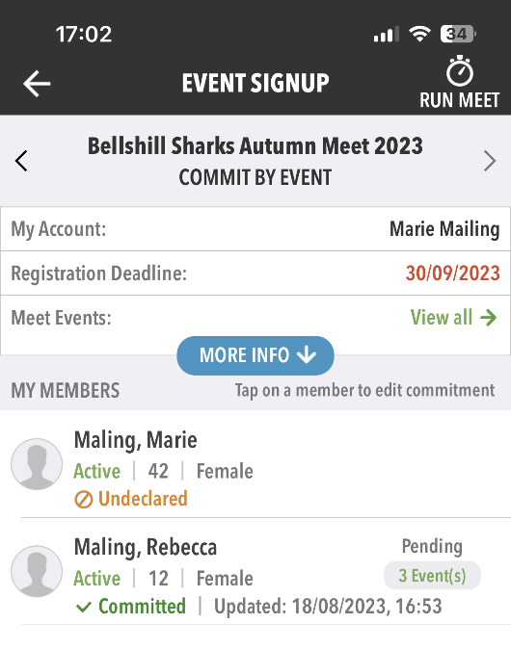
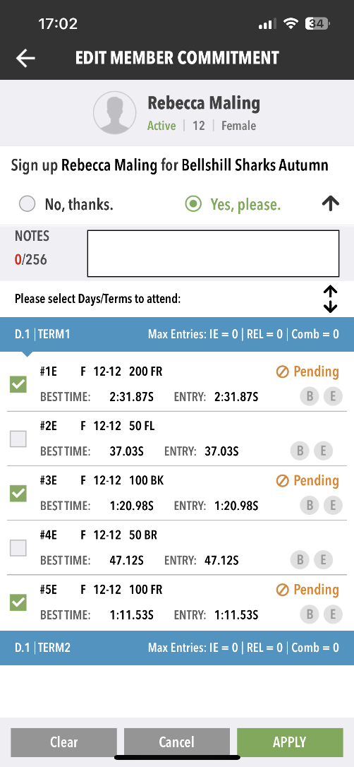

Please contact entriesbellshillsharksasc@gmail.com if you have any issues or questions.

