College Hoodies

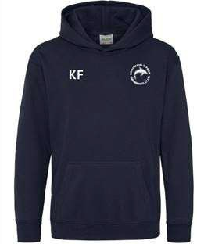
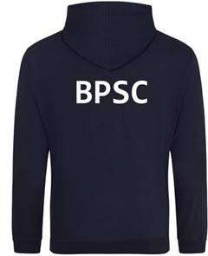

Adults (come with a drawstring) Price £28.00
Sizes:
XS 34" S 36" M 40" L 44" XL 48" 2XL 52" 3XL 56" 4XL* 60" 5XL* 62"

Child (come without a drawstring) Price £21.00
Sizes:
3/4 26" 5/6 28" 7/8 30" 9/11 32" 12/13 34

