Joggers

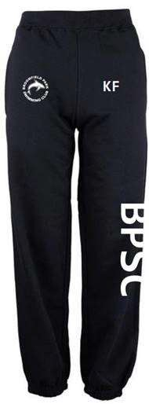
Adults Price £26.00 Sizes:
S 30" M 32" L 34" XL 36" 2XL 38"

Childs
Price £20.00 Sizes:
5/6 20" 7/8 22" 9/11 24" 12/13 26"

