Onesies

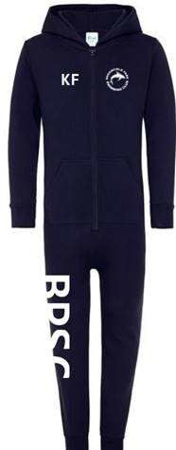
Adult (CC001)

Price £56.00 Sizes:
XS 32" S/M 36/38" L/XL 40/42" 2XL 46"

Child (CC01J)

Price £37.00 Sizes:
XS 3/4 S 5/6 M 7/8 L 9/11 XL 12/13

