Poolside Tops

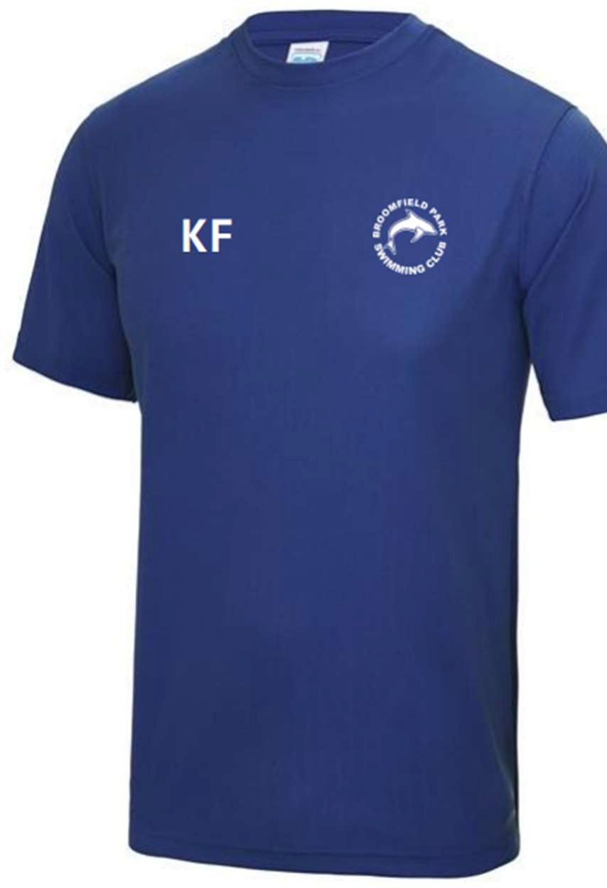
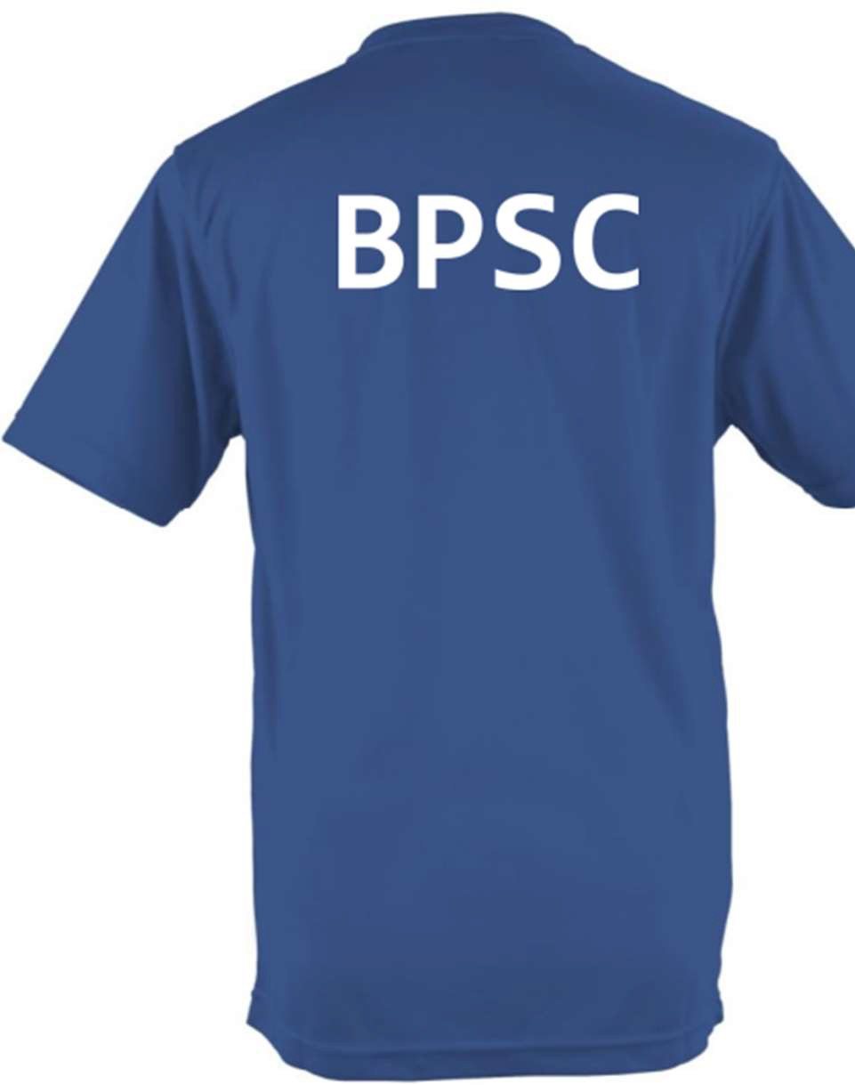

Adult
Price £14.50 Sizes
XS 35” S 38” M 40” L 43” XL 45” 2XL 48” 3XL 50”

Child
Price £13.00 Sizes:
XS Age 3-4, S Age 5-6, M Age 7-8, L Age 9-11, XL Age 12-13

