Shorts
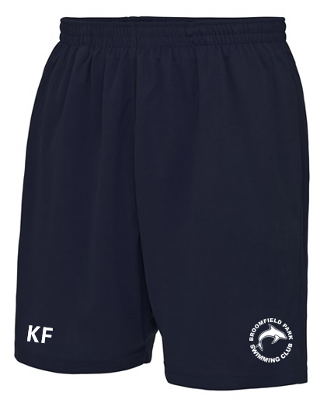

Adult
Price: £19.00
Sizes:S 30" M 32" L 34" XL 36" 2XL 38

Kids
Price: £13.00
XS 3/4 S 5/6 M 7/8 L 9/11 XL 12/13

These cool shorts feature an elasticated waistband with drawcords; a mesh lined inner, side pockets for storage, sweat wicking Neoteric™ fabric and plenty of room to move during your workout.
Fabric
100% Polyester
Weight
140gsm
Specification
Elasticated waist. Mini mesh lined inner with drawcord. AWDis' own Neoteric™ textured fabric with inherent wickability and quick drying properties. Side pockets. Internal key pocket. UPF 30+ UV protection. Worldwide Responsible Accredited Production (WRAP) certified production. WRAP certified. Vegan certified. BSCI certified. Oeko-Tex certified. SEDEX certified.
Washing Instructions
Machine wash 30°. Do not bleach. Do not tumble dry. Do not iron. Do not dry clean

