Womans Retro Shorts

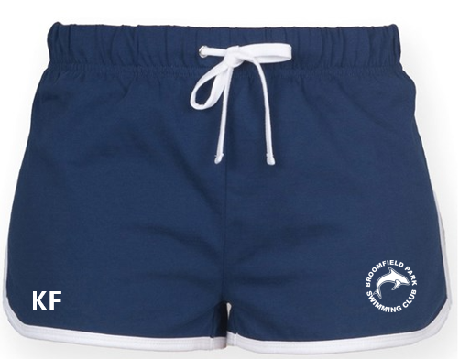
Adult
Price: £18.00
Size: XS 8 S 10 M 12 L 14 XL 16 2XL 18

Fabric
100% Cotton single jersey
Weight
220gsm
Specification
Retro shorts with contrast binding and drawcord. Elasticated waist. Removable Skinnifit label. SEDEX certified. Oeko-Tex certified. BSCI certified. Vegan certified.
Washing Instructions
40 cotton. Do not bleach. Do not tumble dry. 2 dot iron. Do not dry clean. Wash at 40 degrees. Wash dark colours together. Re-shape whilst damp. Dry out of direct sunlight. Iron on reverse of decoration

