ON DECK Quick Reference Guide – Parent : Registration ‘Commit’ of Events
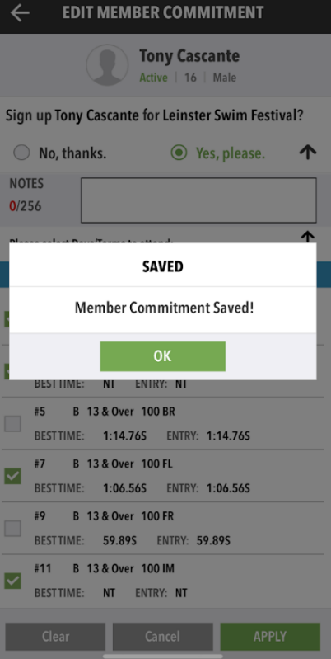
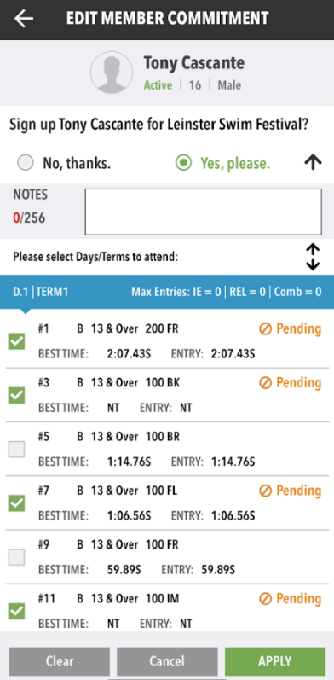
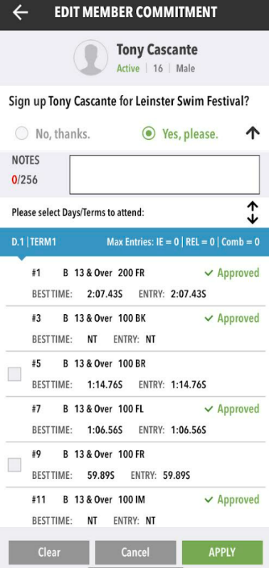
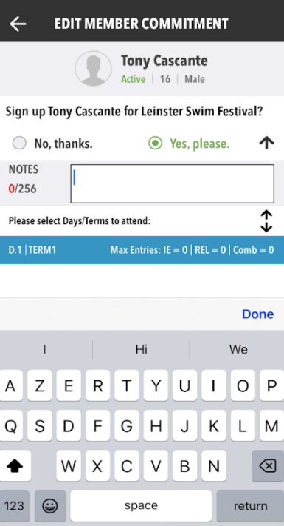
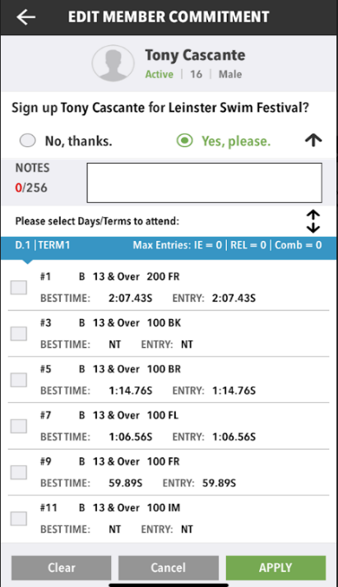
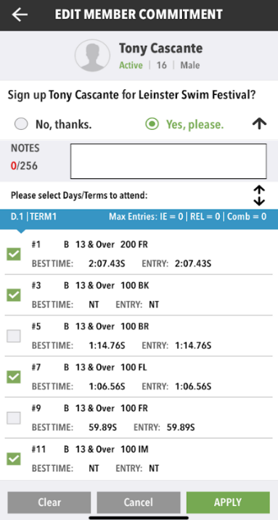
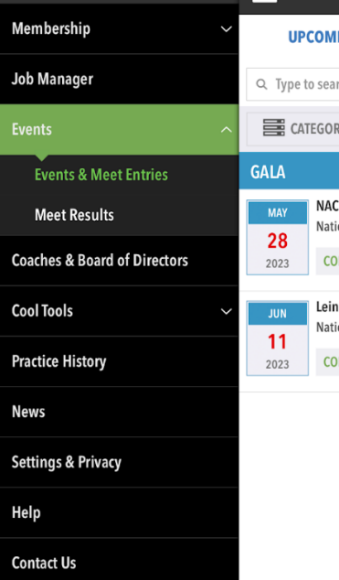
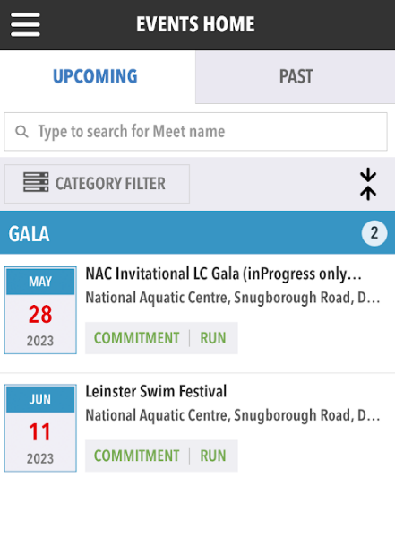
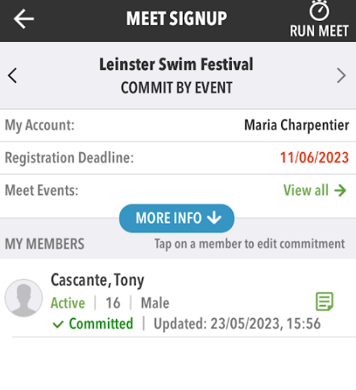
Click on 3-Bar to display slide menu
Status change to approved once reviewed
Events are now ‘pending’ approval by Coach or Admin
Click on ‘bar’ to view events available to register
If NOT attending -then click apply
Click on box to register

Install ON DECK application on your Mobile
The screenshots shown are iOS, if you are using ADROID they will differ slightly.
REMEMBER to use your PARENT UserName and Password

Click on Events & Meets
Select Gala

Select ‘Committed’

Default is ‘YES’

If Swimmer not attending the GALA, please select NO, THANKS – this helps with planning and relay events allocation.

You will ONLY have access to the Galas your swimmer was associated.

Same case with the events (races), you will ONLY see the ones applicable to your Swimmer.

Click ‘Apply’ to confirm selection


Read left to right, top to bottom
Click ‘OK’ to review

