Pathway Programme

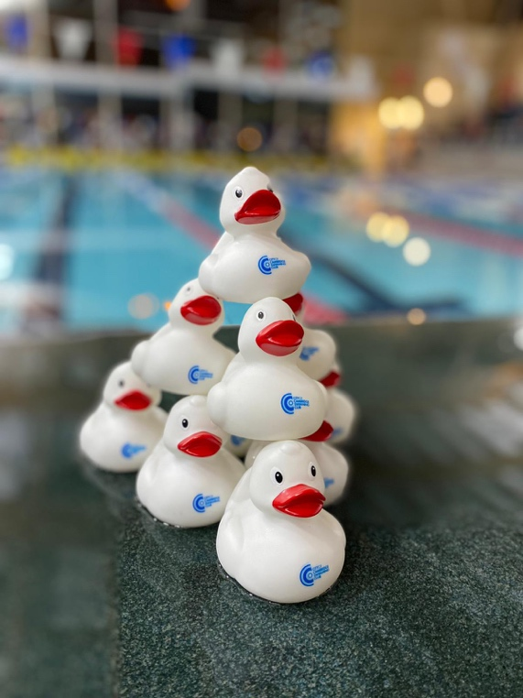

Pathway Squads
The Pathway Squads at CoCSC serve as the initial entry point for our junior swimmers. These squads provide a crucial transition from Learn to Swim (LTS) programs into a club environment, introducing young swimmers to coaching and the technical aspects of competitive swimming. In the early stages, the club encourages swimmers to remain within their LTS programs where possible to support their ongoing development. This ensures that they build a strong foundation of skills and confidence before fully integrating into the club's competitive framework.

Bronze, Silver & Gold Squads
The Bronze, Silver, and Gold Squads mark the entry level of the Pathway Programme at CoCSC, designed for swimmers aged 7-10 years who have achieved a minimum standard of SE Learn To Swim (LTS) Level 5-6 or equivalent. We highly encourage swimmers to continue their participation in their Learn to Swim (LTS) or lesson programs while being part of these squads, as it plays a crucial role in their overall development.

Entry Requirements:
- Swimmers must have a basic understanding of backstroke, breaststroke, and front crawl.
- Swimmers should be able to demonstrate a rhythmical butterfly kick (dolphin kick) action on their front & back.

Focus Areas:
- Transitioning swimmers from a lesson/teaching program environment into a club/coaching environment.
- Developing fundamental skills and techniques across all strokes.
- Improving body position in the water.

Competitions:
- Swimmers at this level are expected to participate in the Club’s Mini Meet series and Club Championships, focusing on front crawl, backstroke, and breaststroke.
By ensuring that swimmers remain engaged in both their LTS programs and the Pathway Squads, we aim to provide a well-rounded development experience that sets the foundation for future success in competitive swimming.
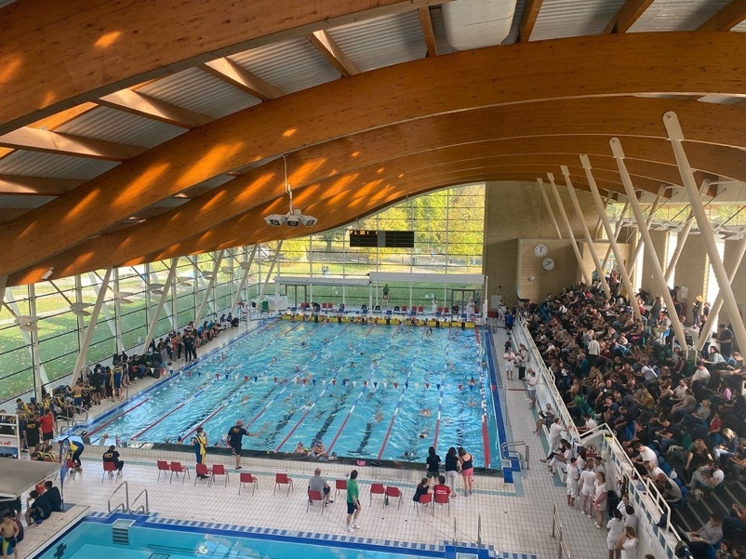

Pathway Skills List
This skills list for the Pathway Squads provides the foundational techniques and skills necessary for young swimmers to transition smoothly into the Academy Squads. It emphasises the correct technique, body positioning, and basic race skills to prepare swimmers for higher levels of competition and continued progression through the club.

 | Skill
Freestyle | - Breathing Pattern: Breathe every 3 or 4 strokes.  - Breakout: No breathing on breakout.  - Finish: No breathing for the last 5 meters to a finish.  - Wall Kicks: Execute 2–3 kicks off every wall.
Backstroke | - Body Position: Maintain a still head with a good understanding of body rotation.  - Wall Kicks: Aim to perform 2-3 kicks or more off every wall, aiming to breakout at the flags.  - Turns: Aim to consistently perform a legal competitive turn at training pace.  - Finish: Always finish on the back, counting strokes to the wall every time.
Breaststroke | - Timing: Understand the timing of the stroke.  - Underwater Phase: Hold the underwater phase for 5 seconds.  - Dolphin Kick: Use a dolphin kick within the underwater phase every time.  - Turns and Finish: Touch and finish with 2 hands.
Butterfly | - Timing: Rhythmical butterfly kick (dolphin kick) action on their front or back. Introduction to Butterfly swim
Starts + Turns | - Legal Competitive Start: Perform a legal competitive start at training pace on all 4 strokes with a competitive legal underwater phase.  - Streamline Position: Swimmers must ensure they are in a streamline position off every wall.

Academy Programme

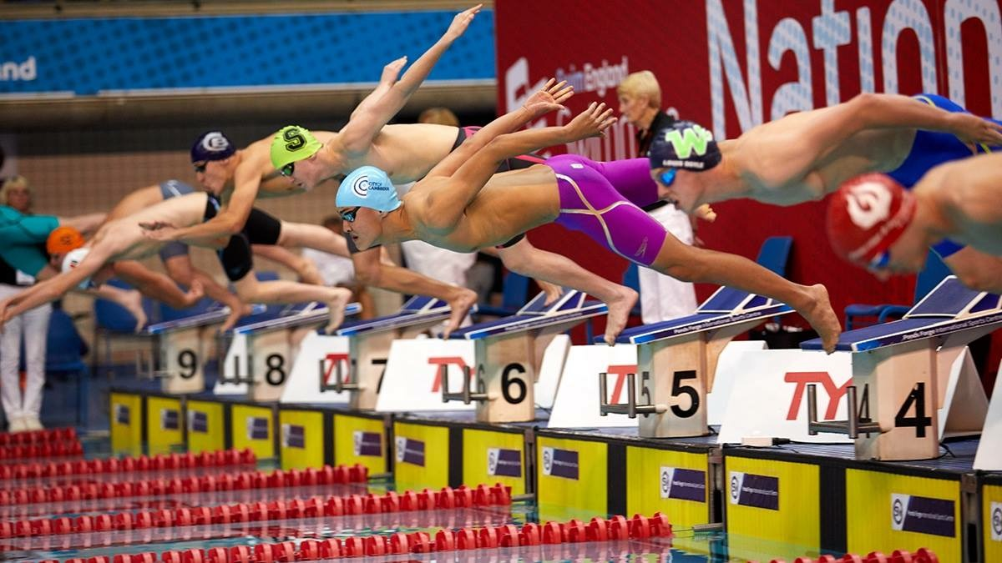

Academy Squads (A1, A2, A3)
The Academy squads at CoCSC serve as the foundational stage where most swimmers begin their competitive swimming careers. This is the critical section of the club dedicated to the fundamental development of skills and techniques essential for long-term success in the sport. Academy squads will be targeted at 9-12yrs.
Focus and Objectives:
In the Academy squads, the primary focus is on teaching and refining the fundamental skills of swimming. Our goal is to ensure that every swimmer has the platform to build a strong technical foundation, which they can build upon as they progress through the club. The emphasis is on mastering the basics, including stroke techniques on all 4 strokes, starts, turns, and finishes, to provide a solid platform for future development.

Skill Development:
The Academy squads are designed to help swimmers improve their skills through structured training sessions that emphasise technique and efficiency in all four competitive strokes. Coaches work closely with each swimmer to provide individualised feedback and guidance, ensuring that they develop the necessary skills to reach their full potential.

Progression and Development:
As swimmers advance through the Academy squads, they will be equipped with the essential skills needed to progress to higher levels within the club. Our coaching team is committed to offering each swimmer the opportunity to develop their abilities and prepare for more advanced training in the Academy, Competitive and Performance Squads.

Competitive Opportunities:
While the primary focus is on skill development, Academy squad swimmers are also introduced to competitive swimming at Level 3 AND Level 2 meets. Participating in club-organised competitions, such as the CoCSC Club Championships, Mini Meets and Open Meets to provide valuable experience and help swimmer set and achieve progression and personal goals.
Key Points
- Introduction to Competitive Swimming: The Academy squads are where most swimmers start their competitive swimming careers.
- Fundamental Skill Development: Emphasis on teaching and improving fundamental skills and techniques.
- Strong Technical Foundation: Ensuring swimmers have a solid technical base to build upon.
- Individual Potential: Offering each swimmer the opportunity to develop skills to reach their full potential.
- Progression: Preparing swimmers for advancement to Age Group and Senior swimming levels.
- Competitive Experience: Introducing swimmers to competitive swimming through club-organized competitions.
By focusing on these core areas, the Academy squads at CoCSC aim to provide a supportive and effective environment for young swimmers to begin their journey in competitive swimming, ensuring they have the skills and confidence to progress through the club and achieve their individual goals.

Academy 3
Academy 3 swimmers should already have a basic understanding of all four legal strokes and be looking to develop their legal competitive starts and turns, performing these consistently in training and racing. The main focus will be on continuing to develop excellent skills, technique, and body position.
Swimmers at this level should be competing in the Mini Meet series, Club Championships & Club Open Meets in all strokes.

Academy 2
Academy 2 swimmers are required to have a solid understanding of all four legal strokes and should consistently perform legal competitive starts and turn skills. The primary focus for these swimmers will be the continual development of their technique and body position, consistently demonstrating these skills in training. Aerobic development will also be introduced at this stage.

All swimmers should be competing in the Mini Meet series and Club Championships. Additionally, swimmers at this level should aim to qualify for and compete in Level 3 and Level 4 swim meets, including selected team meets/galas as advised by the coaching team. This competitive experience is crucial for practising skills and techniques in a race setting.

Academy 1
This is the top level of the CoCSC Academy Programme. Swimmers will be competing at Level 2, Level 3, and Level 4 swim meets, including the Mini Meet series, Club Championships, County Championships, and any selected team meets/galas.
Swimmers will have a strong understanding of all four strokes, skills, and turns, including the Individual Medley. The focus will remain on the continual development and improvement of individual skills and techniques to achieve a competitive standard. The amount and frequency of aerobic development will increase at this stage.
All swimmers within the Academy squad structure will be between the ages of 9 and 12 years. Progression from the Academy to either the Performance or Competitive Squads will be based on a collection of attributes such as skill, performance, technique, enthusiasm to progress through the structure and develop competitively long-term, attendance at training sessions, behaviour, and 100 and 200 IM times swum at time trials.
Swimmers from this squad may be offered an opportunity to move into either the the CoCSC Performance or Competitive squads. Progression through all Academy squads will be at the discretion of the squad coach and in agreement with the Assistant Coach.

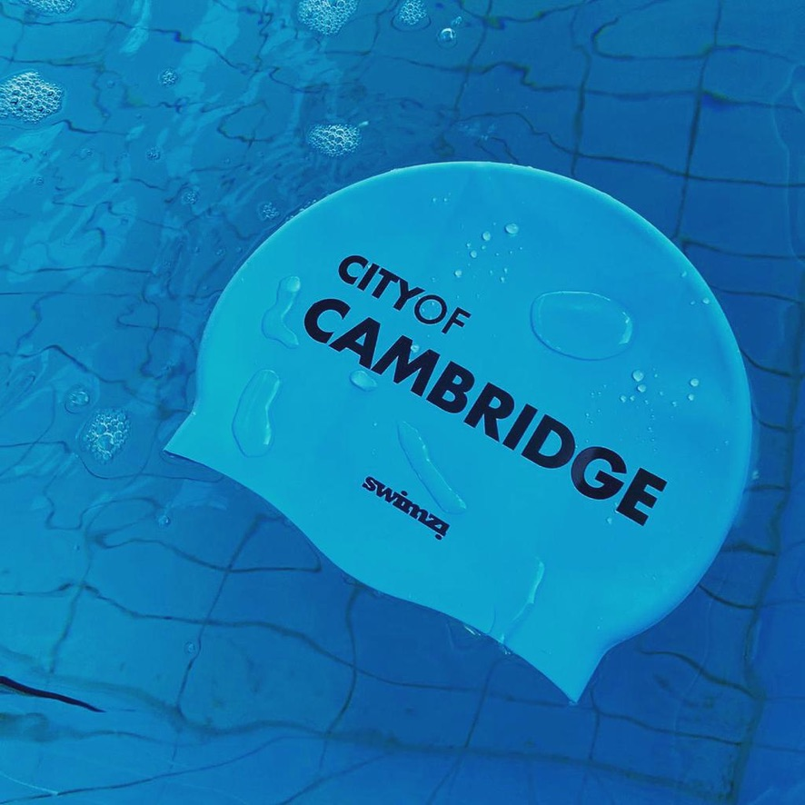

Academy Skills List
Stroke | Skill
Freestyle | - Breathe every 3 or 4 strokes  - No breathing on breakout  - No breathing last 5m to a finish  - 2–3 kicks off every wall
Backstroke | - Head still with good understanding of body rotation  - 3 kicks or more off every wall (target breakout past the flags)  - Consistently perform a legal competitive turn at race pace  - Finish on back (count strokes to wall every time)
Breaststroke | - Understanding the timing of the stroke  - Hold the underwater phase for 6 seconds (total)  - Use dolphin kick within the underwater phase every time  - Touch turn and finish with 2 hands
Butterfly | - Breathing every 2 strokes  - 3 kicks or more off every wall  - No breathing last 5m  - No breathing on break out  - Turn and finish with 2 hands
Starts | - Perform a Legal Competitive Start at race pace on all 4 strokes with Competitive Legal Underwater phase.  - Swimmers must ensure they are in a STREAMLINE POSITION off every wall.

Performance Programme

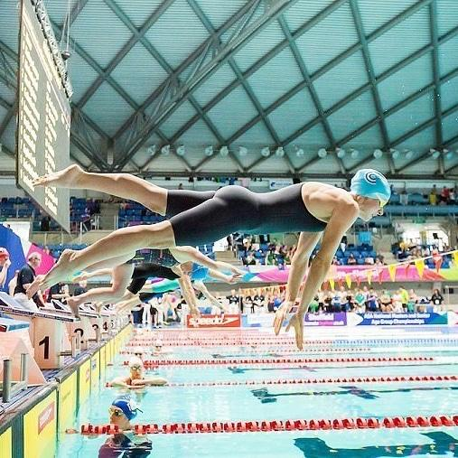

Performance Programme Criteria
The Performance Programme is made up of three squads P1, P2, P3 and to be part of the Performance Programme, swimmers must demonstrate the highest level of commitment, with swimming as their primary activity and focus outside of their academic studies.

The criteria must be met and maintained throughout the season to enter and remain within the Performance Programme. All squad places will be constantly reviewed throughout the season and any swimmer not meeting the highest standards could be reallocated to a new squad.

Goal Setting
Swimmers will set, track their progress towards and reevaluate when achieved, their goals. In collaboration with the coaching team, swimmers will set long term (12-18 months), mid term (6-12 months) and short term (3-6 months) goals. These goals should align with the squad criteria and aid the swimmers in their progress.

Performance 3 (P3) Criteria
To be part of Performance 3 (P3), swimmers must meet the following criteria:

Entry and Retention Requirements:
Accepted Criteria for entry into squad
Age: 10yrs to 14yrs (Age @ 31st December)

- Qualification for Swim England East Region (SEER) in 1x Event or more.
- To have achieved Swim England Cambridgeshire County Qualifying Time in 5x Event or more in the age groups specified at the Championships.
- Compete at the SE County Development Meet in their weaker events.
- Proven ability and commitment to following a demanding training programme (swimmers, with parental support)
- Attend a minimum 75% attendance of ALL training with the aim to complete 90% -100% attendance.
- Undertake a comprehensive and full Pre-Pool routine as detailed by the coaching team, before every training session & at competitions.
- Up to date licensed times (within the last 12 months) in the following events: every 50m and 100m event, 200m Freestyle, Backstroke, Breaststroke and Individual Medley and the 400m Freestyle & Individual Medley every 12 months. All as a minimum.
- 100% commitment to team events (Arena League, County Relays)
- A Team Player – Professional, Polite, Supportive, Caring, Empathetic.
- Always represent the club with distinction with exemplifying dedication and sportsmanship.
- Everyone that swims within the Performance squad automatically agrees to the Club and Swimmers Code of conduct and the Parents Code of Conduct.

Considered criteria for entry into squad
- To have achieved Swim England Cambridgeshire County Qualifying Times in 3 events in the age groups specified at the Championships.
- If there is room in the squad, further consideration will be given to those that have obtained 1 x Cambridgeshire County Qualifying time,
OR: Swimmers assessed by the Coaching Team to have near term potential and or having longer term potential may be admitted or retained within a squad on a probationary period of between 3 – 12 months.
- The swimmer must be able to show commitment and demonstrable progress towards the overall squad criteria and show improvement at designated competitions and within training.
- Swimmers that are identified/selected for any CoCSC Arena Team or Cambridgeshire County Relay.
- Demonstrate a strong application of skills and technique during both training and competition.
- Maintain a high level of trainability and strive to meet the standards required for progression to P2.

Basic Criteria
- Ability to consistently demonstrate 3+ fly kicks off all walls/turns in streamline under pressure.
- Males have the ability to hold 10x100 @1:35 Free or Back, Females can hold 10x100 @1:40 Free or Back, SCM.
- Males and Females can Kick 10x100 @2:10 on their No1 Stroke.
- Consistently hold required pace times for 50/100/200/400 reps.

All moves squad moves are at the discretion of the CoCSC Coaching Team with the consideration of the individual at the forefront of the decision.

Performance 2 (P2) Criteria
To be part of Performance 2 (P2), swimmers must meet the following criteria:

Entry and Retention Requirements:
Accepted Criteria for entry into squad
Age: 12yrs to 16yrs (Age @ 31st December)

- Ranked in the Top 48 in the individual age group on British Long Course Rankings (Age @ 31st December) for 1x event.
- Proven ability and commitment to following a demanding training programme (swimmers, with parental support).
- Attend a minimum 75% attendance of ALL training with the aim to complete 90% -100% attendance.
- Undertake a comprehensive and full Pre-Pool routine as detailed by the coaching team, before every training session & at competitions.
- Up to date licensed times (within the last 12 months) in the following events: every 50m and 100m event, 200m Freestyle, Backstroke, Breaststroke and Individual Medley and the 400m Freestyle & Individual Medley every 12 months. All as a minimum.
- A positive mind set, with the ability to take personal responsibility for their training and racing performances.
- 100% commitment to team events (Arena league/County/Regional and National Relays).
- A Team Player – Professional, Polite, Supportive, Caring, Empathetic.
- Serve as role models for younger athletes within the Performance, Academy and wider squads, exemplifying dedication and sportsmanship.
- Everyone that swims within the Performance squad automatically agrees to the Club and Swimmers Code of conduct and the Parents Code of Conduct.

Considered criteria for entry into squad
- To have qualified for Swim England East Region (SEER) Championships in 2 or more events (Summer or Winters)
- If there is room in the squad, further consideration will be given to those that have obtained 1 x SEER (Regional) Qualifying Time,
OR: Swimmers assessed by the Coaching Team to have near term potential and or having longer term potential may be admitted or retained within a squad on a probationary period of between 3 – 12 months.
- The swimmer must be able to show commitment and demonstrable progress towards the overall squad criteria and show improvement at designated competitions and within training.
- Swimmers that are identified/selected for any CoCSC SEER/National relay or Arena Team.
- Demonstrate a strong application of skills and technique during both training and competition.
- Maintain a high level of trainability and strive to meet the standards required for progression to P1.

Basic Criteria
- Ability to consistently demonstrate 3+ fly kicks off all walls/turns in streamline under pressure.
- Males have the ability to hold 20x100 @1:30 Free or Back , Females can hold 20x100 @1:35 Free or Back, SCM.
- Males and Females can Kick 10x100 @2:00 on their No1 Stroke.
- Consistently hold required pace times for 50/100/200/400 reps.

All moves squad moves are at the discretion of the CoCSC Coaching Team with the consideration of the individual at the forefront of the decision.

Performance 1 (P1) Criteria
To be part of Performance 1 (P1), swimmers must meet the following criteria:

Entry and Retention Requirements:
Accepted Criteria for entry into squad
Age: Male: 15yrs+ (Age @ 31st December)
Female: 14yrs+ (Age @ 31st December)

- Ranked in the Top 24 in the individual age group on British Long Course Rankings (Age @ 31st December) for 1x event.
- Swimmers must consistently show dedication to their training and competition schedules. (Swimmer & Parents).
- Attend a minimum 75% attendance of ALL training with the aim to complete 90% -100% attendance.
- Undertake a comprehensive and full Pre-Pool routine as detailed by the coaching team, before every training session & at competitions.
- Swimmers must train at the highest level, meeting or exceeding the established benchmarks.
- Enthusiasm and Determination: A positive attitude and a relentless drive to succeed are essential.
- Willingness to Improve: Swimmers must be open to coaching and willing to continuously refine their technique to achieve their highest potential.
- Ability to take personal responsibility and ownership for their training and racing performances.
- 100% commitment to team events (Arena league/County/Regional and National Relays).
- A Team Player – Professional, Polite, Supportive, Caring, Empathetic.
- Serve as role models for younger athletes within the Performance, Academy and wider squads, exemplifying dedication and sportsmanship.
- Everyone that swims within the Performance squad automatically agrees to the Club and Swimmers Code of conduct and the Parents Code of Conduct.

Considered criteria for entry into squad
- Ranked Top 40 in individual age groups on British Long Course Rankings (Age @ 31st December) 1x event.
- Compete at a minimum Swim England East Region (SEER) level with the realistic target of qualifying for finals.
- Demonstrate a strong application of skills and technique during both training and competition.
- Maintain a high level of trainability and strive to meet the standards required for progression.
- Demonstrate the highest level of commitment and to achieve the high level of the squad and progress further in their competitive swimming careers.
- Swimmers assessed by the Coaching Team to have near term potential and or having longer term potential may be admitted or retained within a squad on a probationary period of between 3 – 12 months. The swimmer must be able to show commitment and demonstrable progress towards the overall squad criteria and show improvement at designated competitions and within training.

Basic Criteria
- Ability to consistently demonstrate 3+ fly kicks off all walls/turns in streamline under pressure.
- Males have the ability to hold 30x100 @1:20 Free or Back , Females can hold 30x100 @1:25 Free or Back, SCM.
- Males and Females can Kick 10x100 @1:50 on their No1 Stroke.
- Consistently hold required pace times for 50/100/200/400 reps.

All moves squad moves are at the discretion of the CoCSC Coaching Team with the consideration of the individual at the forefront of the decision

Competitive Programme

Development (Dev)
The Development Squad provides a pathway for young swimmers aged
10-14yrs (Age @ 31st December) to continue their swimming journey after completing their Learn to Swim (LTS) program or progressing through the club's Pathway squads (Bronze, Silver, Gold). The primary focus in the Development Squad is on refining technique, improving stroke efficiency, and building a solid foundation in all four competitive strokes. Swimmers will also work on starts, turns, and finishes to ensure they have the skills necessary for competitive swimming and fostering a love for the sport.
Commitment and Development - Swimmers are expected to attend training sessions regularly. Consistent attendance is crucial for ongoing development and skill improvement. Swimmers should be punctual and prepared for each session, demonstrating a positive attitude towards training and learning.
Competition Participation - Swimmers in the Development Squad are encouraged to participate in club-organized competitions, such as the Club Mini Meets, CoCSC Club Championships and targeting County Development Meets. While competition is not mandatory, it provides valuable experience and helps swimmers set and achieve personal goals.
Goals and Progression - Swimmers should strive to improve their technical skill level on all 4 strokes and look to make progression at competitions throughout the season.
Summary
- Attend training sessions regularly with punctuality and preparedness.
- Focus on refining technique, improving stroke efficiency, and mastering all four competitive strokes.
- Participate in club-organised competitions.
- Demonstrate a positive attitude and a willingness to learn and improve.
By meeting these criteria, swimmers in the Development Squad will be well-positioned to continue their progression in the sport, develop their skills, and move through the Competitive Programme. With the potential of moving to the Performance Squads.

Junior Competitive
The Junior Competitive Squad provides a pathway for younger swimmers aged 11-15yrs (Age @ 31st December) to develop and compete at a Swim England Cambridgeshire County Championships or Development level, preparing them for potential advancement into higher competitive squads.
Commitment and Development - Swimmers within the Junior Competitive Squad must demonstrate a consistent level of commitment necessary to continue their progression and ensure continuous development. This includes regular attendance at training sessions and a dedication to improving their skills and techniques. Age
Competition Participation - As a competitive swim club, we expect our Junior Competitive Squad athletes to represent CoCSC in various competitions throughout the season. This includes local meets, County Championships, and other designated competitions set out by the coaching team.
Goals and Progression - Swimmers should strive to achieve County qualifying times and are strongly encouraged to participate in the CoCSC Club Championships and Open meets. This commitment helps foster a competitive spirit and ensures that all members are working towards their individual goals while contributing to the team's overall success.
Summary
- Demonstrate a basic level of commitment and regular training attendance.
- Represent CoCSC in various competitions within the season.
- Strive to achieve County qualifying times.
- Participate in CoCSC Club Championships and Open meets.

By adhering to these criteria, Junior Competitive Squad members will be well-prepared for future competitive opportunities and will contribute to the strength and success of CoCSC.

Senior Competitive (SC)
The Senior Competitive Squad provides a pathway for swimmers aged
14-18yrs (Age @ 31st December) to compete at a Swim England East Region or Swim England Cambridgeshire County Championship / Development level Competition.

Commitment and Development
Swimmers within the Senior Competitive Squad must demonstrate a consistent level of commitment necessary to continue their progression and ensure continuous development. This includes regular attendance at training sessions, a dedication to improving their skills and techniques, and an active engagement in the training program.

Competition Participation
As a competitive swim club, we expect our Senior Competitive Squad athletes to represent CoCSC in various competitions throughout the season. This includes Team events, local meets, Swim England County Championships, Regional events, and other designated competitions set out by the coaching team.

Goals and Progression
Swimmers should strive to achieve Regional and County qualifying times in their focused events and are strongly encouraged to participate in the CoCSC Club Championships and Open meets. This commitment helps foster a competitive spirit and ensures that all members are working towards their individual goals while contributing to the squad and team's overall success.

Summary
- Demonstrate a consistent level of commitment and regular training attendance.
- Actively engage in the training program.
- Represent CoCSC in various competitions within the season.
- Strive to achieve Regional and County qualifying times.
- Participate in CoCSC Club Championships and Open meets.

By adhering to these criteria, Senior Competitive Squad members will be well-prepared for future competitive opportunities and will contribute significantly to the strength and success of CoCSC.

Masters Programme (M1, M2, M3)
City of Cambridge Swimming Club (CoCSC) boasts one of the largest and most successful Masters teams in the country. We offer an elite, structured training environment designed for those who aspire to excel, compete at the highest level, and enjoy the social aspects of Masters swimming. CoCSC will have 3 Masters squads from 2024/2025 season, M1, M2 and M3, catering to a diverse range of ages, abilities, and levels of swimming experience.

Training Environment
Our program provides a fun, friendly, and high-quality environment specifically targeted at swimmers in full-time work or university. There is no upper age limit on the CoCSC Masters Team; the only requirement is a desire to train toward your personal goals. Masters who choose to have the option to compete.

Competitive Opportunities
Our swimmers not only participate in swimming competitions but have also competed in open water events, triathlons, and Ironman competitions. From European record holders to professional Ironman athletes, CoCSC supports caters for a wide range of abilities, ensuring athletes can compete at various levels.

As a competitive swim club, we encourage our Masters athletes to represent CoCSC in competitions throughout the season, from local Masters galas to the World Masters Championships. However, competing is not compulsory; we also welcome swimmers who simply love the sport, enjoy training alongside like-minded individuals, and contribute to our fantastic team ethos and community.
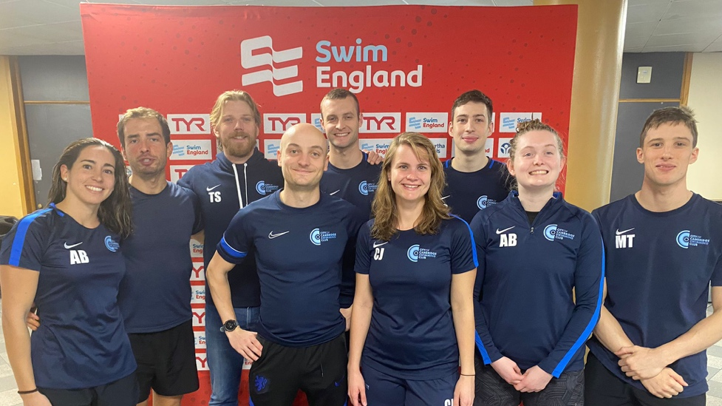

Para Programme
Comprising four squads to cover each area of para swimming:

Para Performance
This squad is for those swimmers who have been through classification, aiming to compete at or already competing at Counties or above.
- These swimmers have access to four training sessions a week and a land training session.
- Some swimmers may also be invited to swim in conjunction with the A-B (Able Bodied) club sessions.
- Focus will be on improving competitive skills and performance appropriate to impairment.
- Medley based training.
- Minimum standards:
- Able to swim distance and strokes appropriate to their classification.
- Attending regular training sessions.
- Attending regular competitions short and/or long course.
- May be on a Swim England or GB Aquatics performance pathway.
- Have good athletic skills and understand the need for: appropriate nutrition, rest & recovery, a variety of training loads, work with their coaches to improve their swim & competition skills.

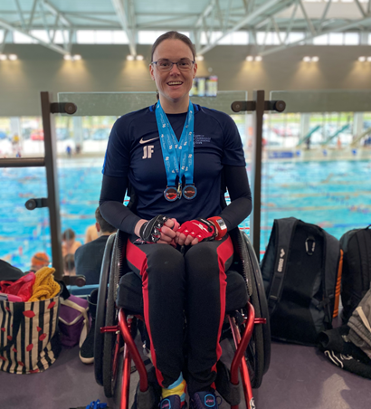

Para Academy
This squad is for those who may have a certificate of exception (CofE) and are anticipating being classified. They will have started taking part in small competitions such as disability meets and mini meets. Swimmers may be invited to Regional training days.
- These swimmers have access to three training sessions per week and may be introduced to land training.
- Focus will be on learning competitive skills and introduction to competitive swimming
- Medley based training.

Minimum standards:
- Able to swim at least three swim strokes to a good level within the limits of their physical or intellectual impairment/s.
- Comfortable entering and exiting the water with/without assistance.
- Willing to develop and try new aquatic skills.

Para Club
This squad is for swimmers who have finished Para Pathway and may or may not wish to be competitive. Who enjoy swimming, and want to continue for fitness and fun. The sessions provided will be coach-led and allowing swimmers to complete distance challenges, multi-stroke practices, fun aquatic skills and games, where appropriate for age and level.

Minimum standards:
- Able to swim 50m non-stop without aids.
- Follow coach instructions.
- Be comfortable in the deep end.
- Enjoy swimming for fitness and fun.

Para Pathway
Swimmers will generally enter the club at this point, some may still be considered being in the FUNdamentals stage and still attending external lessons (swim school or Level Water).
They will not yet be classified or hold a Certificate of Exception.

Minimum standards:
- Able to swim 25m non-stop without aids.
- Be comfortable in the deep end.
- Enjoy being in lessons and show pleasure in being in the water.
- The minimum level we would expect at entry would be stage three or equivalent from a swim school.

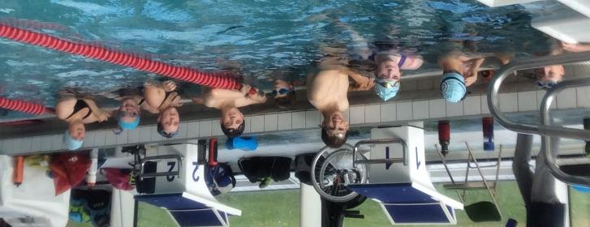

Squad Review Process

The coaching team at CoCSC constantly monitors the attendance and progress of all swimmers across each squad to ensure they can maximize their potential and are in the correct squad that best suits their abilities and commitment to training.

Swimmers are under regular review, with squad movements taking place in September, January, and April or that fits in with the competition cycle and targeted meets. This ensures that swimmers remain in the most suitable squad for their development, while also allowing for continual progression of the squad and the club.

All swimmers will be provided a sufficient period of time in the squad to allow a time of transition, adjustment and time for training and race improvement, unless in exceptional circumstances or attendance criteria not being achieved.

Swimmers must always meet and maintain the required squad attendance and criteria, unless due to exceptional circumstances like injury and illness (that has been communicated and discussed with the coaching team) could lead to the reallocation of an individual’s squad.

Swimmers under 75% in the Performance squads (unless discussed and agreed with the Coaching Team) will be reminded of the commitment levels and standards they have agreed to by accepting a place within the Performance Squads, while they put their place in jeopardy if there are swimmers looking to move into the squad & risk not achieving the progression required.
Swimmers need to demonstrate ongoing progress both in training and competition performance and display the required work ethic and commitment to retain their place in the P3, P2, P1.

Any changes in squad placement will be communicated officially by the club and directly by email.

Swimmers or parents seeking clarification or having questions regarding squad movements can contact the coaching team via email.

