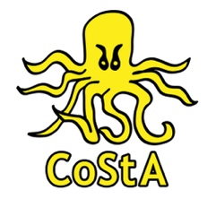
If an incident/accident occurs in a club training session the Coach should follow the Pool Operator's SOP and complete the details below so this can be added to the Club's accident/incident log. Please email the form to headcoach@costaasc.org

Accident/Incident Report Form

Venue
Date and Time of Incident
Full name of Swimmer
Squad
Address and postcode
Parent name and contact number
Coach attending
Description of incident
Did they resume activities
1st Follow up
2nd Follow up

Person Completing Form
Name
Position/relationship to child
Date

