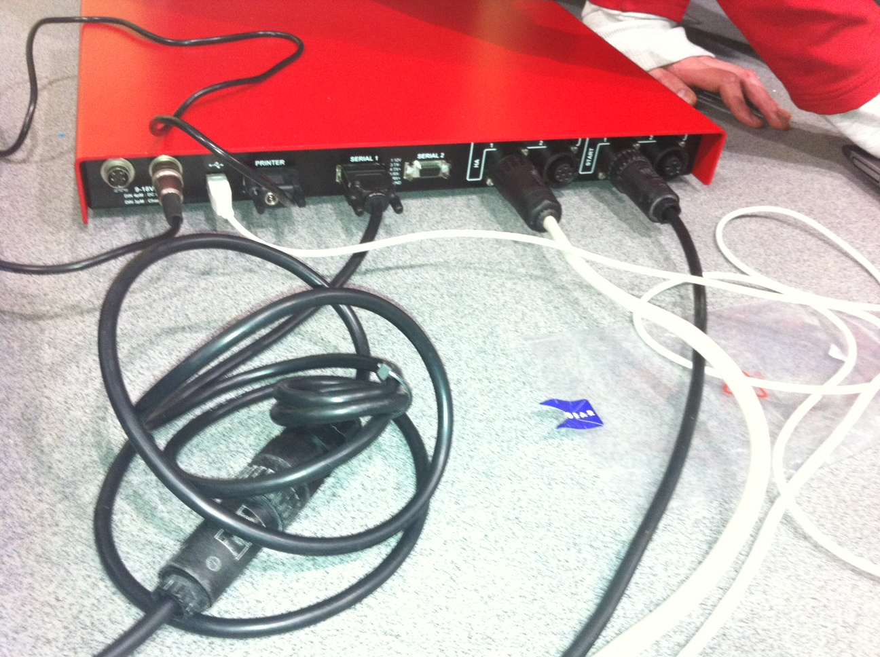
CoStA’s 10m M-F 4 pin extension cable to connect to Scoreboard port under seats
Start cable.Use CoStA’s 10m M-F 4 pin extension cable to connect to Start port under seats
Harness 10m cable to Harness port under seats
Connecting cables to Quantum AQ box at Westminster Lodge
Use centre’s 4 pin to serial lead to connect to CoStA’s 10m M-F 4 pin extension cable below
KEY CABLE. Connects to Quantum laptop to make system live
Printer connection – link to thermal roll printer
Power lead for Quantum box – plugged into power socket

