Alternative car parking when St Albans School car park is not available

St Albans School car park has a finite number of spaces and there are occasions when car parking may not be available on site. Car parking is not guaranteed or included in the club’s hiring agreement.
Please find below a map of some car parking that may be available as an alternative and which are about 5 minutes walk away from the school. When they were last verified these were free after 6.30pm.
Thank you to our friends from the Masters section for recommending these places.
- Gombards Car Park off Selby Avenue AL3 5EN
- London Road Car Park AL1 1NW
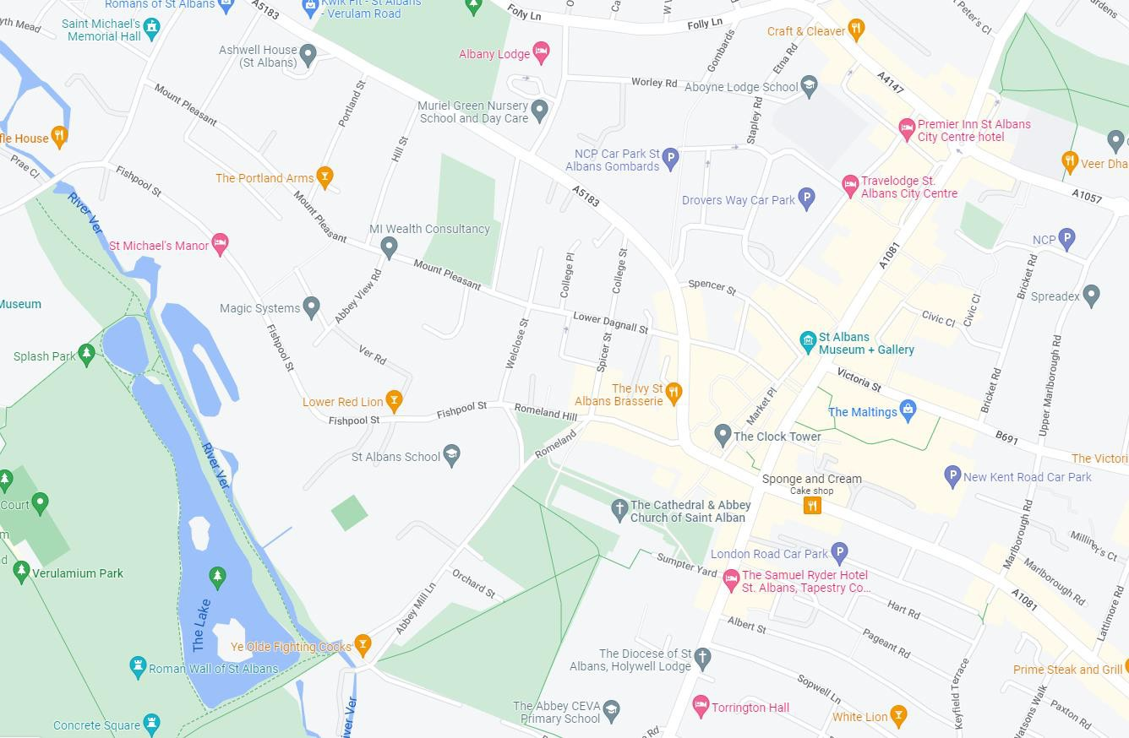
- On road car parking on Abbey View Road (and other surrounding residential roads) – walk down Ver Road and on the public footpath down the side of the Lower Red Lion pub onto Fishpool Street

