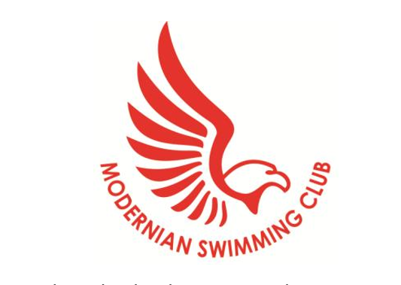
Guidance on Starting Your Periods and Maintain Sport/Swimming
Starting your periods can be a scary thing for any young female but it can be even more challenging for a competitive swimmer. I have been collating bits of advice from some older swimmers about their experiences of starting their periods whilst trying to keep up swimming. The information below is just a guidance and I have added a few links that talk about what happens to your bodies when you are menstruating and why your performance/diet may be different at certain times of the month.

If you are swimming it is a necessity to use tampons to prevent any leaking/bleeding whilst swimming, this can be controversial amongst school friends and parents, and can take a little time to get used to but you are not on your own. Here are some questions I asked older swimmers and their answers:
- What sanitary products do you use?
- Lillets tampons for during sport
- Towels when not doing sport
- Tampax Pearl light at the start and move on to regular when you know how heavy you bleed.

- Do you have any advice for female swimmers who have just started their periods?
- Take regular pain killers
- Ask your mum for help
- Change tampons regularly so you are not worried.
- Practise using tampons and go swimming in public sessions so you get confidence in the water.

- Do you have any tips on when/how to use tampons either at training or galas?
- Put a clean tampon in when you put your race costume on and change it when you take your costume off.
- If you change it in between remember that if your race costume is wet it will be more difficult to put on, maybe have a spare costume just in case.
- Don’t be scared just carry on as normal.

Please remember all of the older swimmers know how you feel and have had to try to swim with tampons. It shouldn’t have to affect your swimming if you don’t want it to.
I have asked some of the older girls who are happy to, to leave their names should any younger swimmers want to talk to somebody who’s been through it. I am also happy to talk to anyone, parent or child if you have any questions or just point you in the right direction if you don’t know who the people are on the list below.
Emily Jones
Eloise Bailey
Emma Howitt
Morgan Allan

https://infograph.venngage.com/p/345508/the-effects-of-the-menstrual-cycle-on-female-athletes
http://liftbigeatbig.com/training-lifting-recovery-during-your-menstrual-cycle/

Georgie Ashdown
Welfare officer

