Lisburn City Swimming Club Trophies

Season 01/09/18 - 31/08/19
Group AA | 2010 and younger
Group A | 2008/2009
Group B | 2007/2006
Group C | 2005/2004
Group D | 2003 and older

 |  | 2016-2017 | 2017-2018 | 2018-2019
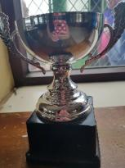 | Minis Girls (AA) Cup  Awarded to winner of Club Championship  Presented by  Barry Clements | Karolina Tomasiewicz | Zara Hopkins
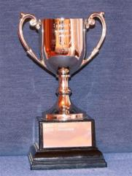 | Minis Boys (AA) Cup  Awarded to winner of  Club Championship  Presented by  Barry Clements | Ben Bickerstaff | Luke Coleman* | Harry McGlashan
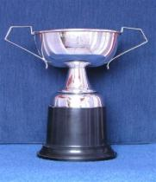 | Girls Group A Trophy  Awarded to winner of  Club Championship  Presented by  Travan Engineering Ltd 1980 | Moya  O’Kane | Emily Coleman* | Zara Hopkins
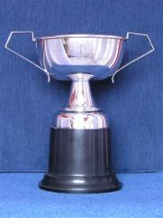 | Boys Group A Trophy  Awarded to winner of  Club Championship  Presented by  Travan Engineering Ltd | Bryn Fitzpatrick | Alfie Shawe | Benjamin Bickerstaffe
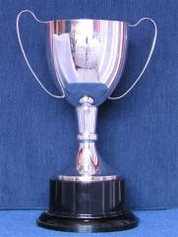 | Junior Girls (B) Trophy  Awarded to winner of  Club Championship  Presented by  Lisburn Lions | Cara Campbell O’Neill | Cara ONeill- Campbell | Moya O’Kane
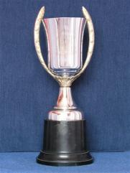 | Junior Boys (B) Trophy  Awarded to winner of  Club Championship  Presented by  Lisburn Lions | Noah Poots | Dylan Registe | Bryn Fitzpatrick
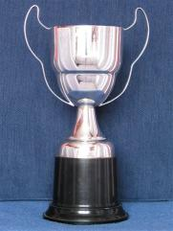 | Girls Group C Trophy  Awarded to winner of  Club Championship  Presented by  Travan Engineering Ltd 1980 | Nadine Pollock | Sasha Quinn / Andrea Cox | Ava McNamara
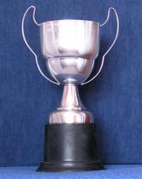 | Boys Group C Trophy  Awarded to winner of  Club Championship  Presented by  Albert Brown B.E.M. | Dylan Griffiths | Daniel Mulholland | Dylan Registe
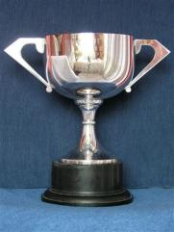 | Senior Boys (D) Trophy  Awarded to winner of  Club Championship  Presented by  Crazy Prices N.I. Ltd | Nathan Jennings | Jamie Alison | Daniel Mulholland
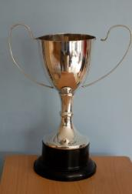 | Senior Girls (D) Trophy  Awarded to winner of  Club Championship  Presented by  McCall Travel, 1975 | Fiona Cash | Sarah McCracken | Andrea Cox
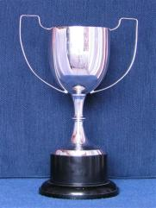 | Alan Lyttle Cup for Boys  Awarded to the male swimmers scoring the most points in the Teletots. In 2011 this became the Aquasprints | Finlay Slattery | Ben Bickerstaff | Harry McGlashan
 | Alan Lyttle Cup for Girls  Awarded to the male swimmers scoring the most points in the Teletots. In 2011 this became the Aquasprints | Cara Campbel O’Neill | Zara Hopkins | Zara Hopkins
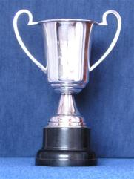 | D. Lambe Cup (female)  2019: Awarded to the female swimmer who scored the most points in finals in the 11-14 Age group at the Ulster LC Championships  Awarded to the female swimmer scoring the most points at the Ulster Age Groups  Presented by  D. Lambe, 1983 | Moya O’Kane | Moya O’Kane | Ava McNamara
 | D. Lamb Cup (male)  2019: Awarded to the male swimmer who scored the most points in finals in the 11-14 Age group at the Ulster LC Championships  Awarded to the male swimmer scoring the most points at the Ulster Age Groups | Dylan Griffiths | Conor Murphy | Benjamin Bickerstaffe
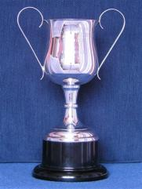 | Keith Buchanan Cup (female)  2019: Awarded to the female swimmer who scored the most points in finals in the 15 & over Age group at the Ulster LC Championships  Awarded to the female swimmer scoring the most points in the Ulster Youth Championship. Initially awarded to Open winner in the Club Championships and subsequently to scorer of most points in PTL  Presented by  Keith Buchanan 1986 | Leah Bethel | Andrea Cox | Andrea Cox
 | Keith Buchanan Cup (male)  2019: Awarded to the male swimmer who scored the most points in finals in the 15 & over Age group at the Ulster LC Championships  Awarded to the male swimmer scoring the most points in the Ulster Youth Championship. Initially awarded to Open winner in the Club Championships and subsequently to scorer of most points in PTL  Presented by  Keith Buchanan 1986 | Nathan Wiffen | Paul Cox | Daniel Wiffen
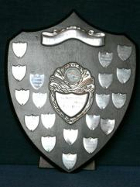 | 400 IM Shield, Male  Awarded to the male swimmer who has the fastest 400IM times in the season | Daniel Wiffen | Daniel Wiffen | Daniel Wiffen
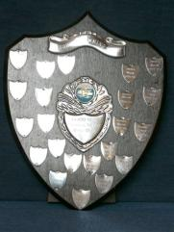 | 400 IM Shield, Female  Awarded to the female swimmer who has the fastest 400IM times in the season | Leah Bethel | Andrea Cox | Andrea Cox
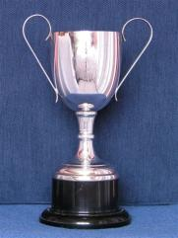 | The Carnreagh Cup  2019: Awarded to the female swimmer who has accumulated the most FINA points in the 200, 400 and 800 and 1500 freestyle taking their fastest times from Summer Nationals, Irish Open, Dave McCullagh and Ulster LC Championships  Awarded to the female swimmer who has accumulated the most German points in the 200, 400 and 800 front crawl  Presented by  Mervyn Acheson | Rachel Bethel | Rachel Bethel* | Ava McNamara
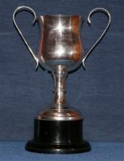 | The Drumscill Cup  2019: Awarded to the male swimmer who has accumulated the most FINA points in the 200, 400 and 800 and 1500 freestyle taking their fastest times from Summer Nationals, Irish Open, Dave McCullagh and Ulster LC Championships  Awarded to the male swimmer who has accumulated the most German points in the 200, 400 and 1500 front crawl  Presented by  Helen Hood | Daniel Wiffen | Daniel Wiffen | Daniel Wiffen
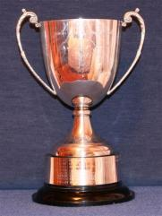 | Jaguar Cup  Awarded to the Fastest Female in the 50 Freestyle in the season | Rachel Bethel | Leah Bethel* | Sasha Quinn
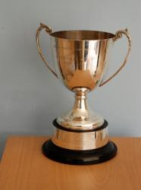 | Jaguar Cup  Awarded to the Fastest Male in the 50 Freestyle in the season | Nathan Jennings | Jamie Alison | Daniel Wiffen
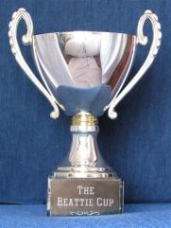 | The Beattie Cup  Awarded to the swimmer who breaks the longest standing SC club record for a recognised distance  Presented by  Jack and Betty Beattie, 1993 | Nathan Jennings | Moya O’Kane | Group D Boys 4x50m Medley relay team  James Alison, Paul Cox, Odhran Mallon, Daniel Wiffen
 | Oldest LC record broken  Awarded to the swimmer who breaks the longest standing LC club record for a recognised distance |  | Sarah McCracken | Daniel Wiffen
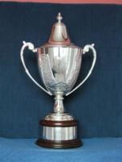 | The Keith Buchanan Memorial Cup  Swimmer of the Year  Presented by  Lisburn City Council 2005 | Rachel Bethel | Rachel Bethel | Daniel Wiffen
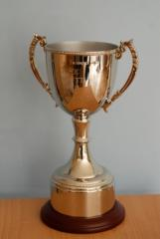 | The Executive Cup  Awarded to winner of female swimmer of the year AA group  Presented by  LCSC Executive June 2011  (replaced LCSC trophy first awarded 2010) | Zara Hopkins | Zara Hopkins | Amelia Stone
 | The Executive Cup  Awarded to winner of male swimmer of the year AA group  Presented by  LCSC Executive June 2011  (replaced LCSC trophy first awarded 2010 | Ben Bickerstaff | Luke Coleman* | Harry McGlashan
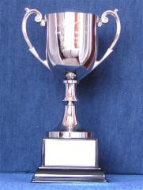 | McCall Cup for Commitment and Attendance (Female)  Awarded to the female swimmer of the year A group.  Previously for commitment and attendance during the season. | Moya O’Kane | Chrissy Hopkins | Sinead McQuillan
 | McCall Cup for Commitment and Attendance (Male)  Awarded to the male swimmer of the year A group.  Previously for commitment and attendance during the season | Bryan Fitzpatrick | Alfie Shawe | Benjamin Bickerstaffe
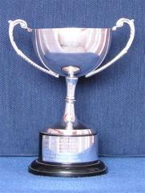 | The Molly Brown Memorial Cup  Awarded to the female swimmer of the year B group.  Previously for the swimmer who makes the greatest contribution to swimming during the season up to B age group.  Presented by  Gilbert Brown B.E.M. in memory of his wife, 1985 | Cara Campbel O’Neill &  Toni Jameson | Ava McNarmara | Moya O’Kane & Jessika Robson
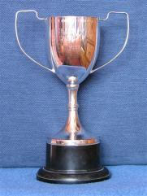 | Richard Mackey Memorial Cup 1986  Awarded to the male swimmer of the year B group.  Previously for the swimmer who makes the greatest contribution to swimming during the season up to B age group.  Presented by Cecil Brown in memory of Charlene Brown’s grandfather, 1986. | Noah Poots | Dylan Registe | Alfie Shawe
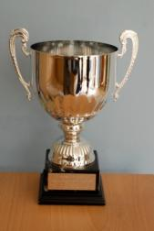 | Lisburn City Swimming Club  Awarded to winner of female swimmer of the year C group  Presented by  LCSC 2010 | Leah Bethel | Andrea Cox | Ava McNamara
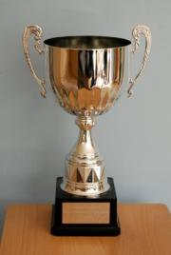 | Lisburn City Swimming Club  Awarded to winner of male swimmer of the year C group  Presented by  LCSC 2010 | Dylan Griffiths | Noah Poots | Dylan Registe
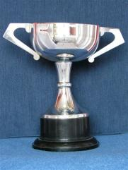 | Speedo Walker Trophy  Awarded to the female swimmer of the year D group.  Previously awarded for making the greatest contribution to swimming in the club in the year.  Presented by  S Walker, June 1982 | Rachel Bethel | Rachel Bethel* | Andrea Cox
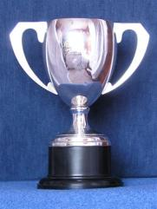 | President’s Trophy  Awarded to the male swimmer of the year D group.  Previously awarded for making the greatest contribution to swimming in the club in the year. | Daniel Wiffen | Daniel Wiffen | Daniel Wiffen
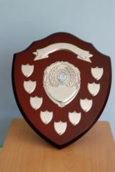 | The Sands Shield  Awarded for greatest improvement in female swimmer AA group  Presented by  The Sands Family 2010 | Evie Lowry | Poppy Jeffers | Matilda Bracken
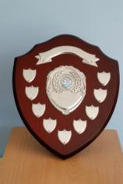 | The Sands Shield  Awarded for greatest improvement in male swimmer AA group  Presented by  The Sands Family 2010 | Cillian Hall | Rory Stanley* | Ross Gray
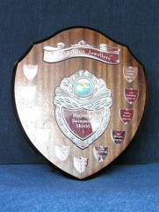 | Perpetual Swimming Shield (Girls)  Awarded for greatest improvement in female A group. Previously awarded for greatest improvement in A group teletots  Presented by  J J Shannon Jewellers | Moya O’Kane | Isobel Lamont / Annie Poots | Erin Fitzpatrick
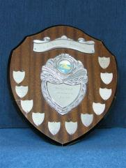 | Perpetual Swimming Shield (Boys)  Awarded for greatest improvement in male A group. Previously awarded for greatest improvement in A group teletots  Presented by  J J Shannon Jewellers | Finlay Slattery | Lewis Fitzpatrick | Cillian Hall
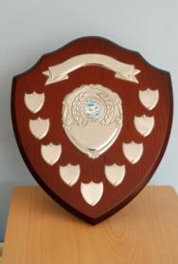 | The Smyth Shield  Awarded for greatest improvement in female swimmer B group  Presented by  The Smyth Shield 2010 | Toni Jameson | Jessika Robson | Yzabelle Pacia
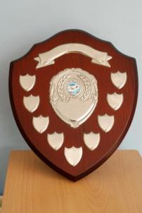 | The Smyth Shield  Awarded for greatest improvement in male swimmer B group  Presented by  The Smyth Shield 2010 | Noah Poots | Dylan Registe | Tom Keys & Bryn Fitzpatrick
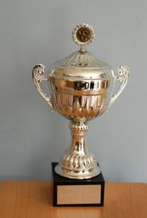 | Lisburn City Swimming club  Awarded for greatest improvement in female swimmer C group  Presented by  LCSC 2010 | Andrea Cox | Sasha Quinn | Toni Jamison
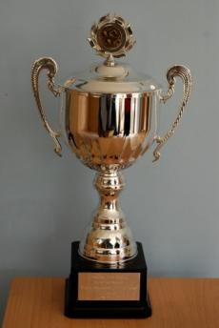 | Lisburn City Swimming club  Awarded for greatest improvement in male swimmer C group  Presented by  LCSC 2010 | Paul Cox &  Dyan Griffiths | Luca McAtarsey | Patrick Ferrie
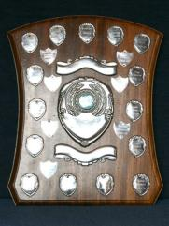 | Ivan Davis Trophy  Awarded for the greatest improvement in female D group Previously for the outstanding novice female and subsequently for female swimmer who make the greatest improvement swimming during the season  Presented by  Alderman Ivan I. Davis, 23/6/84 | Rachel Bethel | Rachel Bethel* | Andrea Cox
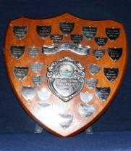 | Mary Peters Shield  Awarded for the greatest improvement in male D group. Previously for the male swimmer who makes the greatest improvement in the season  Presented by  The Mary Peters Health Club, 1981 | Daniel Wiffen | Jamie Alison | Paul Cox
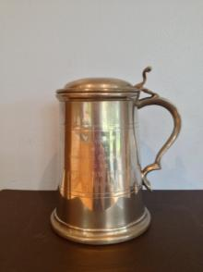 | Lindsay McPherson Tankard  Awarded to the outstanding official or coach of the year; only can be won once  Presented by  Alderman Ivan I. Davis, 23/6/84 | Graham Boyce | Claire Alison | Daniele Lawlor & Ronnie Fleming
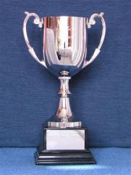 | Iris McCall Memorial Cup for Achievement  Awarded to the greatest achiever in the Swimfit squad.  Previously this was the Club Squad.  Presented in 2004 by the McCall family in memory of Iris McCall | Amy Little | Alice Aboulharb | Jack Gill

NEW AWARDS

Waterpolo player of the year | Katie Griffiths
Diver of the Year
Female Disability Swimmer of the year | Imogen Price
Male Disability Swimmer of the year | Sam Toner

