How to enter a gala
Entering into any gala will be done through TeamUnify. The gala secretary will invite swimmers that are eligible to enter based on the criteria set by the gala organisers.
If you are unsure as to which event you/your child should enter, please speak to the coach.
Please read the gala pack carefully before you decide to enter a gala. The pack will have information such as:

- Where the gala will be held
- When the gala will be held
- Time of the gala (starts and the time you need to be there for warm-up)
- The cost of entering an event in the gala. Please note that the NUELSC will charge an additional 50p per event for to pay for coach(s) attending the gala.
- Any other information relevant to the gala. For example, spectator entry fee, parking etc.

If you want to proceed with entering the gala,
- follow the link and instruction on the email you received (example of e-mail below)
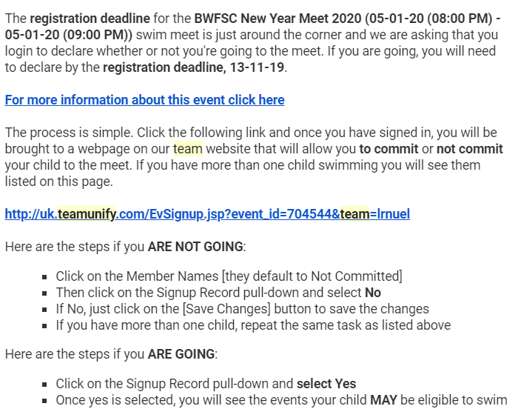
- tick the event(s) that you are qualify to enter
- Save & submit
For help how to sign-up for gala/meets in Team unify:-
- Desktop (website):
https://support.teamunify.com/en/articles/21-parents-sign-up-athlete-for-meet-commit-to-events
- For Ondeck version:
https://support.teamunify.com/en/articles/1345#declare
- Video tutorial: https://support.teamunify.com/en/articles/3 (playlist - meet signup 101)
Please be aware that there will be a deadline to enter gala. The deadline that is set by NUELSC will be earlier than the deadline set by the gala organisers. This is because we have to check, approve (all entries have to be approved by Head Coach/Gala Secretary), amend (if any) and process entries before submission and this takes time and sometimes with some popular gala the space will fill up quickly and the gala organisers reserve the right to close the entry earlier then the deadline set on the gala pack. If you have missed the deadline, unfortunately you will not be able to attend the gala.
Invoice and payment
Once the entries to the meet have been processed, an invoice will be generated through Team Unify and payment will be charged to your debit/credit card.
When you have entered and paid for a Gala and for whatever reason, you are unable to attend, you will NOT be refunded your money. This is a condition that is set by most if not all gala organisers.
Please could you also email, text or ring your coach ASAP so they are aware and can withdraw you/your child from the event. Failure to do by NUELSC could result in a fine to NUELSC by the gala organiser and this fine will be charged to you.
Rejections
The hosting club can reject a swimmer. This is normally because there are too many entries for a particular race.
The list will be sent back to the coach. On this occasion, any rejections will be fully refunded to you.
Nearer to the gala, the gala organiser will send to the club the list of accepted entries. This list will be made available to you.

