Results
- The gala organisers will email the club the official verified results (normally takes around 3-5 days after the gala). We will post the results on the club website.
- Your individual results will be uploaded on the club database (TeamUnify). You can also find your individual best time and ranking on Swim England website.
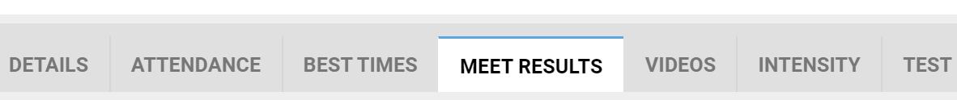
Swim England Ranking website - https://www.swimmingresults.org/12months/

