
Parents:
- Supporting the journey
- Providing opportunities
- Matching swimmer commitment
- Respectful to coaches, volunteers & other parents

Up to Development Squad:
- Commitment to developing new habits
- Having fun

Regional – National Squads:
- Embedding habits
- Seeking feedback
- Continual questioning
- Proactive mindset
- High engagement & attendance levels
- A performance lifestyle
NSSC’s Values: The keys to unlocking our swimmers’ full potential (aka ‘The Newcastle Way’)
“I have the personal drive & commitment to unlock the best version of me”.
Commitment
ment

Up to Development Squad:
- Excited to learn
- Learn from trying

Regional – National Squads:
- Recognise the value of failure
- Understand the importance of the journey
- Relish pressures such as race day
Parents:
- Support the journey
- Non-judgemental
- Focus on the process not the outcome
“I have a positive growth mindset. I see setbacks as opportunities to learn & improve rather than reasons to make excuses, falter or give up”.
Resilience
ment

“I am confident but not boastful, humble in victory, graceful in defeat. I am respectful & thankful to those supporting my journey. I treat others as I would like to be treated myself”.
Up to Development Squad:
- Open to learning
- Good listening skills

Regional – National Squads:
- Coachable
- Positive attitude
- Lead by example
- Can always learn something new
- ‘The Newcastle Way’
Parents:
- Understands & respects the swimmer/coach relationship
- Sets a good example
- Role model at competitions
- Accepting of & supportive of others
Respect
ment

Parents:
- Volunteer for the club
- Unconditional support for the club & its swimmers
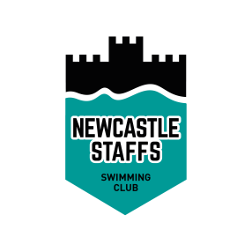

Up to Development Squad:
- Willingness to participate in galas
- Join in with club activities

Regional – National Squads:
- Support teammates
- Show equality
- Eager for selection
- Proud to represent the club
- Mentor next generations
Power of the Team
ment
Together Everyone Achieves More
“Being part of a team, we will perform better and have more fun. Pride in our club. Go Castle!”.

