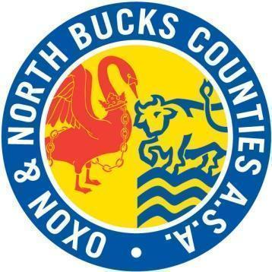
Oxfordshire and North Buckinghamshire Counties ASA Diversity and Inclusion Action Plan (DIAP) 2023-2024

County objective
As a County, our main focus this year is on further development in the knowledge of committee members of diversity and inclusion so that there is common understanding as we move forward.
Objective | Action required | Lead person | Completion date | Review date  June 2024 update where relevant
To ensure a common understanding of diversity and inclusion across the ONB executive committee. | The positions of Chair, Vice Chair, Secretary, Welfare Officer and Lead Team Managers to undertake the Swim England Foundations of Inclusivity CPD.  Course link  https://www.swimming.org/ios/course-information/foundations-of-inclusivity/ | OMS Secretary | July 2024 | Completed for those posts that were filled. This objective will be in the 24-25 plan given the number of new executive committee members.
To better reflect our County by encouraging more diversity in the ONB executive committee. | Promote the ONB executive committee amongst the members and allow shadowing of posts as per the ONB ASA succession plan statement. | Chair | July 2024 | This has been partially met given the significant challenges on filling key posts. The promotion of the ONB executive committee amongst the members has taken place. Shadowing of posts has not. The new structure for Chair, Vice Chair and Welfare will allow for shadowing and succession planning.
To further ensure the County Championships accommodate the additional needs of swimmers, officials and volunteers. | Ensure officials who are deaf or hard of hearing can fully officiate according to their judge level.  Appropriate adjustments for marshalling are in place.  Provide seating for officials who cannot stand for periods of time. | Officials Secretary  Swimming  Championships Secretary | December 2024  February 2024 | Completed.  Completed

