Completing a risk assessment - Guidance
A risk assessment should be produced for each activity and discipline where any hazards are present that could cause harm to members of the county or the public. Consideration needs to be given as to the level of coach delivering the activity and the risks associated with that decision. Any change in normal delivery needs to be recorded and reviewed.

- Firstly, break the activity down into steps.
- Think through each step, considering what the hazard(s) are - enter each hazard on a new line in the first column.
- Also include in the first column the potential harm to people and/or property that the hazard could cause.
- In the second column write what you are already doing to reduce the level of risk.
- In the next two columns respectively, enter a score from 1 to 5 (where 1=least; 5=most) for the likelihood of the hazard causing harm and the severity of harm it could cause.
- Now multiply those two scores to get the Risk Rating in column 5. The table to the right shows the action that should be taken.
- Consider what could be done to reduce the level of risk and enter it in column 6, specifying who is responsible and setting a target date for completion in the next two columns respectively. Once this has been done, the risk assessment should be reviewed. The target date will depend on the risk rating.
- Risk Rating Action:

 |  | 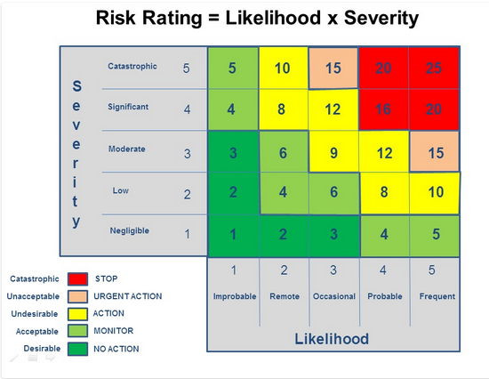 |  |  |  |  |  |  | Risk Rating Action:  1-3: No Action  4-7: Monitor  8-12: Action Required  13-19: Urgent Action Required  16-25: Stop Activity Immediately
 | County: |  |  |  |  | Location:
 | Activity: |  |  |  |  | Assessor’s Name & role within club: |  |  |  |  |  |  |  |  | Date assessed:
 | What are the hazards;  1. Who might be harmed 2. How might they be harmed? |  |  | What are you already doing? |  | Risk Rating = L x S |  |  |  |  |  |  | What else do you need to do to manage and reduce this risk? |  | Action by whom? |  | Action by when? |  |  | Date Completed
 |  |  |  |  |  | Likelihood  L: 1-5 |  | Severity  S: 1-5 |  |  | Risk  0-25
(Score Likelihood & Severity from 1 to 5: Likelihood – 1 = Improbable, 5 = Frequent; Severity – 1 = Negligible, 5 = Catastrophic)

