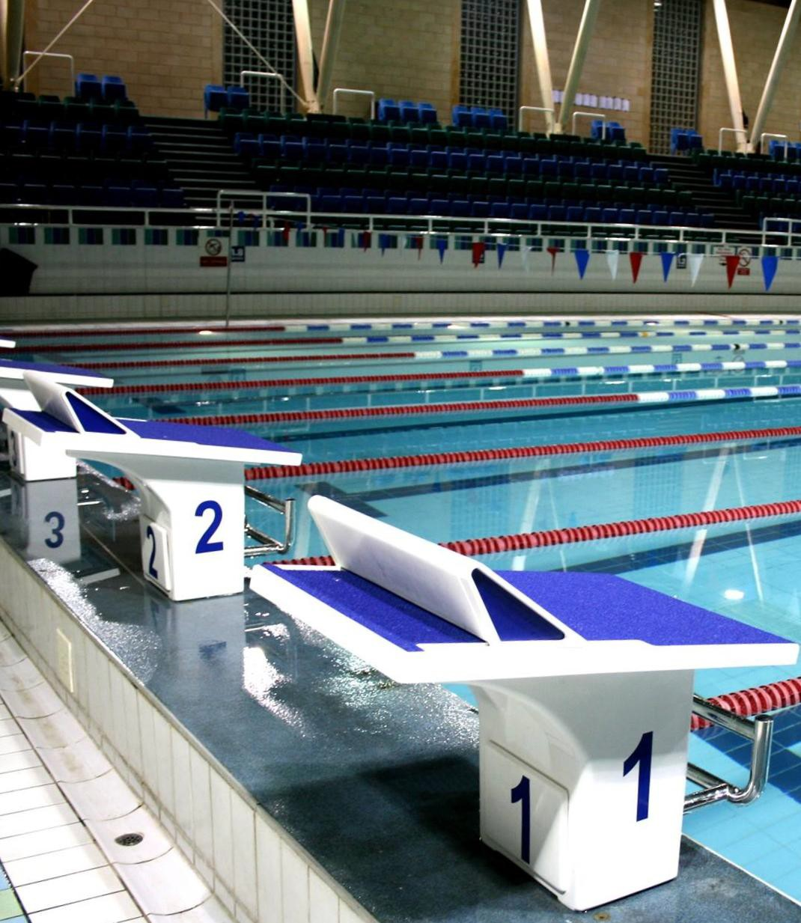Parkside Swimming Pools, Cambridge.
C i t y o f C a m b r i d g e S w i m m i n g C l u b – C a m b r i d g e S p r i n g O p e n 2 0 2 6

Cambridge Spring

Open 2026
Level 3 No 3ER260603

27th, 28th & 29th March 2026

City of Cambridge Swimming Club

City of Cambridge Swimming Club Cambridge Spring Open 2026 (Licence number: 3ER260603)

27 ^{th}, 28 ^{th} & 29 ^{th} March 2026

Affiliated to the Swim England East Region Under Swim England Technical Rules of Swimming

Venue: Parkside Swimming Pool, Gonville Place, Cambridge, CB1 1LY Pool: 8 Lane, 25m Pool, Electronic Timing, Olympic standard blocks.
Backstroke ledges and a secondary strobe will also be available.

Age Groups: 9, 10, 11, 12, 13, 14, 15, 16 and over. For event restrictions see qualifying times table.
Age group is age at 29nd March 2026.

Awards: Heat declared winners with awards to top three in each age group.
Heats will run slowest to fastest seeded times Spot prizes in each event.
Events: 50m, 100m and 200m all strokes, 400m Freestyle and 200m and 400m IM. Fees: £7.50 per event for club entries via Sportysys
£8 per event for individual online entries Spectators: £6 per session, £10.00 per day.
Entries: Entries will be accepted via Sportsys file or online individual form ONLY. This is a first come first serve meet.
NT swimmers allowed, but estimated times must be provided.

Closing Date: Friday 6th March 2026.

Any amendments to our Meet Conditions will be communicated on our website as soon as we learn of them.

This is a first come first serve meet.
Enquiries can be e-mailed to meets@cocsc.org.uk

Meet Programme

Session 1 Friday 27th March
Warm-up 6.00pm Start 6:45 pm

101 | 400m IM | Female
102 | 400m IM | Male/Open
103 | 50m Backstroke | Female
104 | 50m Backstroke | Male/Open
105 | 50m Freestyle | Female
106 | 50m Freestyle | Male/Open

Session 2  Saturday 28th March |  | Session 4  Sunday 29th March
Warm-up 12.00pm Start 1.00pm |  | Warm-up 12.00pm Start 1.00pm
201 100m Freestyle Female | 401 | 100m Butterfly | Male/Open
202 100m Freestyle Male/Open | 402 | 100m Butterfly | Female
203 200m IM Female | 403 | 200m IM | Male/Open
204 200m Butterfly Male/Open | 404 | 200m Freestyle | Female
205 200m Butterfly Female | 405 | 200m Freestyle | Male/Open
206 50m Breaststroke Male/Open | 406 | 50m Breaststroke | Female

Session 3 Saturday 28th March
Warm-up TBC Start TBC

Session 5 Sunday 29th March
Warm-up TBC Start TBC

301 | 50m Fly | Female | 501 | 400m Freestyle | Male/Open
302 | 50m Fly | Male/Open | 502 | 400m Freestyle | Female
303 | 100m Breaststroke | Female | 503 | 100m Backstroke | Male/Open
304 | 100m Breaststroke | Male/Open | 504 | 100m Backstroke | Female
305 | 200m Backstroke | Female | 505 | 200m Breaststroke | Male/Open
306 | 200m Backstroke | Male/Open | 506 | 200m Breaststroke | Female

Timings noted above are indicative and may alter slightly. Final timings will be confirmed shortly before the meet.

Meet Rules and Information

General Conditions
- This Competition is licensed by Swim England and will be held under Swim England Regulations, Swim England Technical Rules of Swimming and the following Meet Conditions.
- Entrants must be Swim England registered Category Compete, belong to an affiliated club and enter in the name of one club .
- The meet promoter has the right to amend the program or timings to ensure the smooth running and fairness of the event.
- The overall meet promoter is Anne Williams however a different person may be designated as promoter for each session on the day. Questions regarding this meet should be directed, in the first instance, to the promoter at meets@cocsc.org.uk.
- Any matter not covered by these conditions will be determined by the Promoter and Referee, subject to Swim England Regulations and Technical Rules of Racing

Age Groups
- Competitors’ ages shall be as of 29th March 2026.
- The age groups for each event will be 9, 10, 11, 12, 13, 14, 15, 16 and over.

Fees
- Race entry fee is £7.50 per event when entered as a team (Sportsys file).
- Individual online entry is £8 per event (via individual entry link).
- Spectator fees are £6 per session or £10 per day.
Coach/Team Manager passes are £30.00 per weekend (with lunch) or £20 per weekend (without lunch). Chaperone passes for para swimmers are free and do not include food.

Awards
- Medals will be awarded to the top three in each age group in each event based on heat declared winner.
- Spot prizes will be awarded to randomly selected heat winners. A spot prize heat will be identified prior to the start of the
race with a ringing bell. All spot prizes will be awarded at the promoter’s discretion.

Entries
- Entry forms and payment must be received by the Promoters before midnight on Friday 6th March 2026 and must be fully and correctly completed, or else they may be rejected.
- All entries of three or more swimmers must be made via club entry. Electronic SPORTSYSTEMS Entry Manager files are available on request by e-mail to meets@cocsc.org.uk or from the club website at Spring Open meet page.
- Entries will only be accepted once payment has been received.
- The list of accepted and rejected entries will be published/available for download on the Spring Open meet page at the latest two weeks prior to the competition. It is the competing club/swimmer’s responsibility to check this list for accuracy and advise immediately of any mistakes or changes that are required.

Individual entries
- Individual entries must be made via an online form, linked here. Please check first if your club is entering before submitting an individual entry.
- The parents/guardians of swimmers who enter a meet on an individual basis (i.e. their entry has not been organised by a club) are responsible for the supervision of their children, either directly or indirectly via a nominated adult.
- Individual entry swimmers under 18 must sit with their parent/nominated adult in the spectators’ gallery between sessions
and not in the poolside areas allocated to clubs unless a) their responsible adult is a TM with a purchased poolside pass or
b) they have asked and prearranged that Cambridge can “adopt” them at the meet. This request can only be accepted by
Cambridge subject to having the correct ratio of swimmers/coaches/TMs.

Qualifying times and entry standards
- All entry times must meet the qualifying times and criteria stated on the qualifying times below. NT swimmer will be accepted, but estimated times must be provided in place of NT. NT/YES times risk being rejected.
- Swimmers in possession of a Swim England Certificate of Swimming Disability or whose Swim England membership record details a disability sport class are welcome to enter the competition with a time slower than the lower limit standard. An entry time must be provided.

Over-subscription and rejections
- This is a first come first serve meet.
- Competitors may be rejected if the meet is oversubscribed in order to meet license time guidelines.
- The last club(s) and/or last individual swimmer to enter will be rejected first.

- In the interest of safety and to ensure the smooth running of the competition the promoter reserves the right to limit the number of overall entries and the number of heats in any event to maintain a balanced programme. If the whole competition or any individual event is oversubscribed, entries will be rejected proportionally across the defined age groups.
- In the event that entries are rejected, fees will be refunded by a single payment to club in question. Individual entries will be refunded to the individual's bank account.

Reserve list
- If the meet is oversubscribed, a reserve list might be offered, at the promoter’s discretion. Swimmers whose entries are initially rejected may be invited to be on the reserve list by emailing the meet promoter. Anyone on the reserve list must be within the qualifying times. The period for application will close 5 days after publication of the initial list of accepted and rejected entries. If swims become available, they will be offered to those on the reserve list, but swims cannot be guaranteed. Entry fees from reserves that do not swim at the meet will be refunded after the meet.

Withdrawals and refunds
- Swimmers must withdraw from any events that they no longer wish to swim. All swimmers informed of having accepted entries will be deemed as competing unless they have informed the promoter that they do not wish to swim.
- Each club should have their own record of swimmers entered, and swimmers unable to compete must be withdrawn.
- Clubs who submitted an entry file will have been sent a Swim-Meet withdrawal link, please use this link for withdrawals. Swimmers should contact their clubs to be withdrawn. Individual entries should contact the meet promoter.
- Any on-the-day-withdrawals must be made by coaches or the club representative any time up to 5 minutes after the start of each warm-up for the relevant session.
- No refunds will be made for withdrawals after the the registration deadline (or the date the meet is closed to registration if if it gets full and is closed earlier), other than for injury or illness with a medical certificate. Any competitor that withdraws on medical grounds will not be permitted to participate in any events for the remainder of that session.

Fines
- Any swimmer failing to report to the marshalling area for their event, and subsequently missing their event will be fined
£10 which must be paid before they can join any other events they have been entered into.

Coaches and team managers
- Coaches/Team Managers will be allowed on poolside if wearing a pre-purchased pass. These passes include admittance to the poolside for all sessions. There is an option that also includes lunch on the day.
- Coaches and Team Managers must be club trained personnel and clubs are asked to maintain the recommended ratio of helpers to swimmers in line with Swim England Team manager, Coach and Chaperone Policy. Untrained parents without DBS or Safeguarding clearance are not allowed on poolside.
- Clubs are reminded that it is their responsibility to ensure that swimmers entered under their name are supervised, at all times, by coaches/ team managers/chaperones in compliance with the Swim England Team manager, Coach and Chaperone Policy.

Pool information and Starts
- The pool length is 25 metres, 8 lanes with anti-wave ropes and electronic timing and the depth of the pool is 1.2m at the shallow end and 1.8m at the deep end. Dives into depths between 1.2m and 1.35 metres are allowed from the poolside or starting block, as long it is not more than 0.75m above the water. If the water is between one metre and 1.2 metres, a poolside dive will be permitted providing it is not from more than 0.4 metres above the surface. All starts and changes during relay races are into 1.35m of water.
- In accordance with with the Swim England guidance of 8/12/2022 it is not permitted to dive at the shallow end of the pool. All races will start at the deep end; there are no relay events in this gala.
- Backstroke starting ledges may be used at the discretion of the meet promoter.
- A secondary strobe will be available and in use at this meet.
- All events will be seeded on submitted times, and all heats will be spearheaded. The first three swimmers in each event in each age group will receive awards.
- Over the top starts may be used at the referees’ discretion.

Warm-up
- Warm up protocol: Strictly no diving during any warm-up sessions, odd lanes will swim clockwise (1, 3, 5, 7) even lanes (2, 4, 6, 8) will swim Anti clockwise. All swimmers must leave the water by the side of the pool and not over the timing pads. Coaches must manage the lanes their swimmers are using during the warm-up sessions. Guidance will be given by the meet announcer and warm up marshals.

Officials
- CoCSC welcome all officials including trainees. Officials can register directly via swim-meet: click here to sign up.

Photography
- In accordance with the Swim England Safeguarding Policy all parents or carers of swimmers under the age of 18 who wish to take photo, or video images are requested to focus on their own child as much as reasonably possible and to avoid including other children in those images, particularly if those images are being shared with family and friends through social media platforms. Should you have any concerns about photography or filming at this event then please bring them to the attention of the Meet Promoter in attendance.
- The use of any mobile device or camera in any of the changing areas is strictly forbidden.

Spectators
- Limited seating poolside will be available for Coaches and swimmers. No additional seating is permitted poolside or in the gallery.
- The promoters reserve the right to refuse admission to any competitor, participant, coach or spectator

Results
- Results will be available on the results link. This link will be distributed before/at the meet.

Safety
- The promoters do not accept responsibility for any property damage, theft or loss thereof.
- For Health and Safety reasons only small rucksack bags will be allowed poolside. Lockers are available (refundable £1 coin required). Pool staff will remove any large obtrusive bags.
- Access to poolside is restricted to competitors for the session, coaches/team managers with a poolside pass, technical officials and appointed volunteers. Parents are not permitted access to poolside.
- Glass items are not allowed on poolside.

Data Protection
- By submitting and accepting entries to the meet, consent is hereby given, as required by the Data Protection Act 2018, to the holding of personal information on computer. Personal data handled such as name, club, recorded and entered times may be made public during or after the meet.

Transgender Competition Policy
- Entries will be made using Female and Open/Male competition categories in accordance with the Swim England Transgender and Non-binary Competition Policy on 1 September.
- The Female category is for birth sex females in accordance with Swim England’s Transgender and Non-Binary Competition
Policy. By entering the ‘Female’ category, a swimmer confirms that their birth sex is female.

Para Swimming Conditions

The conditions outlined above shall apply to all para swimmers except were varied by any of the following conditions.

- Swimmers with S1- S15 classifications will be accepted.
- All para swimmers must have an internationally authorised classification.
- Competitors must be registered members of Swim England.
- Personal care attendants will be permitted for swimmers in all disability classes.
- A swimmer may have both a coach and a personal care attendant present.
- The competition format will be based on disability inclusion within the able-bodied programme. Swimmers will be integrated on a time-banded basis in all events.
- Positions will be determined by each swimmer’s times relative to the world record in their own classification.
- Para swimmers will be included but not placed within the results for the appropriate age group in the able-bodied competition unless their entry times meet the qualifying times for the able-bodied competition. They will also be included in the multi-class results and placed within those results according to their equivalent times.
- Winners of all events will be heat declared.
- Competition to be run under IPC Swimming swim rules.
- Medals shall be awarded on a multi-class basis to 1st, 2nd and 3rd place in each event.

Qualifying Times
Upper Qualifying time limits are “No faster than Times” meaning only swimmers with entry times equal to or slower than the qualifying limit may enter the event. Qualification times must have been achieved at licensed meets since 1st January 2025, converted to 25m pool if necessary. All entry times will automatically be checked against British Rankings for validity.

If the meet is oversubscribed your entry may be rejected even if meet the qualifying times.
Entries with “No Time” will be accepted, but estimated times must be provided in place of NT.

Age group is age at 29th March 2026.

MALE/OPEN
“Upper Qualifying time limits” (short course or long course converted times accepted)
 | 9yrs | 10yrs | 11yrs | 12yrs | 13yrs | 14yrs | 15yrs + | 16yrs +
50m Free | 00:30.00 | 00:30.00 | 00:30.00 | 00:27.00 | 00:25.00 | 00:23.00 | 00:22.00 | 00:21.00
100m Free | 01:05.00 | 01:05.00 | 01:05.00 | 01:00.00 | 00:55.00 | 00:52.00 | 00:50.00 | 00:50.00
200m Free | 02:30.00 | 02:30.00 | 02:30.00 | 02:15.00 | 02:06.00 | 01:58.00 | 01:55.00 | 01:50.00
400m Free | N/A | 05:00.00 | 05:00.00 | 04:50.00 | 04:40.00 | 04:20.00 | 04:10.00 | 03:55.00
50m Fly | 00:32.00 | 00:32:00 | 00:31:00 | 00:28.00 | 00:27.00 | 00:25.00 | 00:24.00 | 00:23.00
100m Fly | 01:20.00 | 01:20.00 | 01:18.00 | 01:12.00 | 01:06.00 | 01:00.00 | 00:57.00 | 00:55.00
200m Fly | N/A | 03:30.00 | 03:20.00 | 03:00.00 | 02:40.00 | 02:20.00 | 02:10.00 | 02:00.00
50m Back | 00:33.00 | 00:33.00 | 00:32.00 | 00:30.00 | 00:29.00 | 00:26.00 | 00:25.00 | 00:24.00
100m Back | 01:18.00 | 01:18.00 | 01:16.00 | 01:10.00 | 01:05.00 | 01:00.00 | 00:58.00 | 00:55.00
200m Back | 02:55.00 | 02:55.00 | 02:55.00 | 02:35.00 | 02:25.00 | 02:15.00 | 02:10.00 | 02:00.00
50m Breast | 00:38.00 | 00:38.00 | 00:36.00 | 00:34.00 | 00:32.00 | 00:30.00 | 00:28.00 | 00:27.00
100m Breast | 01:30.00 | 01:30.00 | 01:25.00 | 01:20.00 | 01:15.00 | 01:10.00 | 01:05.00 | 01:02.00
200m Breast | 03:10.00 | 03:10.00 | 03:00.00 | 02:50.00 | 02:40.00 | 02:30.00 | 02:25.00 | 02:20.00
200m IM | N/A | 02:55.00 | 02:55.00 | 02:40.00 | 02:25.00 | 02:15.00 | 02:10.00 | 02:00.00
400 IM | N/A | 06:20.00 | 06:20.00 | 06:00.00 | 05:30.00 | 05:10.00 | 05:00.00 | 04:40.00

FEMALE
“Upper Qualifying time limits” (short course or long course converted times accepted)
 | 9yrs | 10yrs | 11yrs | 12yrs | 13yrs | 14yrs | 15yrs + | 16yrs +
50m Free | 00:30.00 | 00:30.00 | 00:30.00 | 00:27.00 | 00:26.00 | 00:25.00 | 00:24.00 | 00:23.00
100m Free | 01:08.00 | 01:08.00 | 01:06.00 | 01:02.00 | 00:59.00 | 00:55.00 | 00:55.00 | 00:54.00
200m Free | 02:30.00 | 02:30.00 | 02:30.00 | 02:20.00 | 02:15.00 | 02:05.00 | 02:05.00 | 02:00.00
400m Free | N/A | 05:20.00 | 05:20.00 | 05:00.00 | 04:50.00 | 04:30.00 | 04:30.00 | 04:20.00
50m Fly | 00:33.00 | 00:33:00 | 00:33:00 | 00:30.00 | 00:30.00 | 00:27.00 | 00:26.00 | 00:25.00
100m Fly | 01:20.00 | 01:20.00 | 01:20.00 | 01:15.00 | 01:10.00 | 01:05.00 | 01:04.00 | 01:02.00
200m Fly | N/A | 03:30.00 | 03:30.00 | 03:00.00 | 02:40.00 | 02:30.00 | 02:20.00 | 02:10.00
50m Back | 00:33.00 | 00:33.00 | 00:33.00 | 00:30.00 | 00:30.00 | 00:28.00 | 00:27.00 | 00:27.00
100m Back | 01:20.00 | 01:20.00 | 01:20.00 | 01:10.00 | 01:08.00 | 01:04.00 | 01:03.00 | 01:02.00
200m Back | 02:55.00 | 02:55.00 | 02:55.00 | 02:35.00 | 02:30.00 | 02:20.00 | 02:20.00 | 02:15.00
50m Breast | 00:38.00 | 00:38.00 | 00.38.00 | 00:35.00 | 00:34.00 | 00:33.00 | 00:32.00 | 00:31.00
100m Breast | 01:30.00 | 01:30.00 | 01:30.00 | 01:23.00 | 01:19.00 | 01:15.00 | 01:13.00 | 01:10.00
200m Breast | 03:15.00 | 03:15.00 | 03:15.00 | 03:00.00 | 02:55.00 | 02:45.00 | 02:40.00 | 02:30.00
200m IM | N/A | 02:55.00 | 02:55.00 | 02:40.00 | 02:30.00 | 02:20.00 | 02:20.00 | 02:15.00
400 IM | N/A | 06:20.00 | 06:20.00 | 06:00.00 | 05:30.00 | 05:20.00 | 05:15.00 | 05:00.00

Officials Request Form

CoCSC welcome all officials including trainees.

We have an on-line signing up page, you just need your Swim England number: https://swim-meet.com/OfficialsSignup/Cambridge/
Please click on the link above to select the sessions that you can help with. Add any mentoring requests and we will do our best to accommodate.
The CoCSC Expenses Policy can be viewed here.

Any additional questions please email officials@cocsc.org.uk

Parking

Parking and traffic in Cambridge can be very busy, so allow enough time to get to the pool. Please be aware that Parkside Pool is in the centre of Cambridge, neither GLL nor CoCSC are responsible for the cost of car parking.

The closest parking is Queen Anne Car Park next to Parkside pools (Queen Anne Terrace car park - Cambridge City Council

Other options (all located approximately 10-15 minutes’ walk from the pool):
- Cambridge Railway Station (pre-booking: https://www.ncp.co.uk/find-a-car-park/car-parks/cambridge-station-g-anglia/)
- Adam and Eve street car park
- Gwydir Street car park
- Grafton Centre car park
- Grand Arcade car park

All are located approximately 10-15 minutes’ walk from the pool. For information including live parking updates and spaces go to https://www.cambridge.gov.uk/car-parks-map

Park and Rides is another option (https://cambridgeparkandride.info/)

The train station is only a 10 minute walk from Parkside Pools if you decide to take the train.

