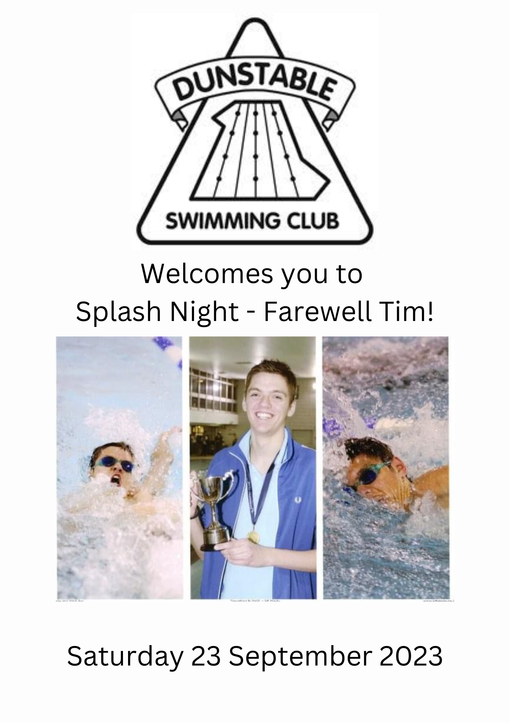
Management Committee
Chairman: Sarah Cooper
Vice Chairman: Rowan Flitton
Director of Swimming: Doug Hose
Assistant Head Coach: Ellie King
Treasurer: Maureen Wilde
Club Secretary: Lauren Grice
Membership Secretary: Liz Tarsey
Open Meet Secretary: Jodie Armstrong
Internal Gala Secretary: Louise Pantazi
Welfare Officer: Kerrie Brandrith
Welfare Assistant: Karin Grice
Parent Liaison: Helen Fowler
Publicity Officer: Kirstie Riches
Fundraising: Jo Hearn
Fixtures Secretary: Rowan Flitton
Officials Co-ordinator: Alison Sanders
Parent Member: VACANT
Thank you to everyone who has put their name down to help tonight, it really does make a huge difference and helps make the night run smoothly.
If you would like to help out at future events, or would like to come and join the committee, please stop one of us and have a chat! We are all very friendly, and it would be great to have some new faces at committee meetings! We are looking for two parents to become parent members on the committee – there is not a set role for you, you just come along to the committee meetings!

Dunstable Swimming Club
Splash Night

Saturday 23rd September 2023

The Dunstable Centre, Court Drive, Dunstable, LU5 4JD

Warm up 5.30 pm - Start 6.00pm

CONDITIONS OF ENTRY

Closing date for all entries: Friday 1 September 2023

The Gala will be swum under Swim England Laws and Technical Rules and to the Swim England Open Meet Licensing Criteria

- All entrants must be fully paid up members of Dunstable Swimming Club and be Category 1 or 2 members of Swim England.

- Entries must be submitted on forms available sent to members via email. If a time has been achieved previously it MUST be entered; failure to do so may cause rejection of entry. Please write name, event number, stroke, distance and time (if any achieved) clearly to avoid confusion.

- Entry fee - £3.50 per event - payable at time of entry. Entry can by paid by cash at one of the desks during training, or online direct to the Club bank account.

- Ages are as at 31 December 2023

- All events are Timed Finals and will be seeded according to the time submitted. Competitors will swim in heats (slowest first). At the completion of each event and after all times have been recorded, swimmers will be divided into age groups as shown below and positions awarded within each age group.
Academy, 9 years, 10 years, 11 years, 12 years, 13 years, 14 years, 15 years, 16 years and over.

- On the evening of the meet, swimmers should arrive at the pool by 5.00pm and sign the register to confirm their attendance before entering the changing rooms. Swimmers wishing to withdraw from an entered event should notify the Stewards before warm up. They should remain with the Stewards and other swimmers throughout the gala and should be available to swim at least two events before their own.

- In the event of the gala becoming oversubscribed, entries will be accepted on a first come first served basis.

- Entries that do not comply with the above conditions will be refused.

- The pool is 25m and anti-wave devices will be in place.

- Results will be posted on the club website and will be supplied to British Swimming for entry into the national ranking database.

- In accordance with Swim England Child Safeguarding Policies and Procedures, any parents or carers of swimmers under the age of 18 who wish to take photographic or video images are requested to focus on their own child as much as reasonably possible and to avoid including other children in those images. Should you have any concerns about photography or filming please bring them to the attention of the promoter.

- All participants must observe the safety precautions in operation at The Dunstable Centre. Neither the Promoter nor Dunstable Swimming Club will be responsible for any loss or damage occurring during this meet.

- Entries to the meet will be held on a computer and consent, as required by the Data Protection Act 2018 to the holding of personal information on computer, will be deemed to have been given by the submission of the entry. Personal data will be available for inspection during the Meet on application to the Promoter.

- The Female category is for birth sex females in accordance with Swim England's Transgender and Non-Binary Competition Policy. By entering the 'Female' category, a swimmer confirms that their birth sex is female. Entries will be made using Female/ Male competition categories, as these are the recognised categories at this time. You will notice a transition into the use of Female and Open/Male as the new competition categories following the launch of the Swim England Transgender and Non-binary Competition Policy on 1 September.

- Any matter not covered by these conditions will be determined by the Promoter and Referee, subject to Swim England Laws, Regulations and Technical Rules of Racing.

Programme of Events
Arrival 5.00pm
Warm Up 5.30pm
Start 6.00pm
EVENT NUMBER | EVENT
01/02 | 100m Butterfly
03/04 | 50m Butterfly
Special Event | Alumni 50m Butterfly
05/06 | 25m Breaststroke
07/08 | 50m Breaststroke
Special Event | Alumni 50m Breaststroke
09/10 | 25m Backstroke
11/12 | 50m Backstroke
Special Event | Alumni 50m Backstroke
13/14 | 100m Freestyle
Special Event | Alumni 100m Individual Medley
15/16 | 25m Freestyle
17/18 | 50m Freestyle
Special Event | Alumni 50m Freestyle
Special Event | Coaches Race!

PLEASE NOTE
All participants must observe the safety precautions in operation at The Dunstable Centre. Neither the Promotor nor Dunstable Swimming Club will be responsible for any loss or damage occurred during this meet.
In accordance with ASA Child Protection guidelines, anyone wishing to take photographs or video, using any image capturing device (including but not limited to mobile phones, tablets & cameras) must adhere to the clubs guidance regarding posting on social media.
THE TAKING OF PHOTOGRAPHS AND VIDEO IN THE CHANGING ROOMS IS NOT PERMITTED IN ANY CIRCUMSTANCES

Tonight’s events will conclude with a goodbye presentation from the Committee to Tim, along with a very special performance by the swimmers!

We would kindly ask that everyone please stay until the end to applaud Tim for his many years of dedication to the Club.


Message from Doug Hose Director of Swimming
Tim has been an immense presence in the club and has guided it with a steady hand through some very turbulent times, covid, extended pool closure, devastating welfare issues, any one of which could have seen the club fold.
It is testament to his leadership that DSC not only survived but has progressed and thrives with a strong cohort of coaches, a driven committee a willing band of officials and a winning group of swimmers.
Sincere best wishes for the future, you will out perform in whatever you turn your hand to. 😊


Message from Sarah Cooper – Chair – THANK YOU!!

I have thought long and hard about what to write here to say thank you and goodbye to Tim, and each time the words just do not seem to do Tim justice.
The time and sacrifice you have given to the club cannot be underestimated! The hours at the pool, travelling up and down the country to support our swimmers, planning sets and team galas, and not to mention the countless phone calls and whatsapp conversations that have gone on over the years! You supported the club through a 3 year pool refurb to then be faced with Covid, all with a spring in your step and a smile on your face! (most of the time!!)
You have impacted the lives of hundreds of swimmers over the years, and I hope you remember your time with us with fondness and a smile…..now that you have time to sit and think!
On behalf of everyone at DSC we wish you the very best in your new adventure and look forward to many updates from the other side of the pond. We will miss you!
Tim, my coach, my colleague and more importantly, my friend. thank you.

EVENT 1 Female 100m Butterfly
1 | Aimee SANDERS | 11 |  |  | ........
2 | Libby FOWLER | 15 |  |  | ........
3 | Libby FLITTON | 11 |  | 1:42.35 | ........
4 | Oliwia ZADLO | 13 |  | 1:35.40 | ........
5 | Evie ARMSTRONG | 11 |  | 1:27.45 | ........
6 | Grace ARMSTRONG | 14 |  | 1:17.00 | ........
7 | Amber FLITTON | 14 |  | 1:15.46 | ........
EVENT 2 Open/Male 100m Butterfly
1 | Luke TRULL | 11 |  |  | ........
2 | Hanz Dylan MARCELO | 12 |  | 1:29.00 | ........
3 | Luke HURLEY | 16 |  | 1:19.77 | ........
4 | George HEARN | 13 |  | 1:18.27 | ........
5 | James SHAW | 15 |  | 1:14.45 | ........
EVENT 3 Female 50m Butterfly
1 | Cora PAYNE | 9 |  |  | ........
2 | Dominika GRYGO | 15 |  |  | ........
3 | Darcie THOMAS | 12 |  |  | ........
4 | Gwen KNIPE | 12 |  | 56.44 | ........
5 | Darcy DEAR | 12 |  | 49.45 | ........
6 | Minudi WELLAPPULI | 13 |  | 49.07 | ........
7 | Isabella GEARY | 12 |  | 49.02 | ........
8 | G CROZIER-LITTLE | 13 |  | 43.69 | ........
9 | Imogen RADCLIFFE | 12 |  | 40.86 | ........
10 | Natalia LODZINSKA | 15 |  | 38.68 | ........
11 | Alexandra STACHURA | 14 |  | 37.37 | ........
12 | Isabella PANTAZI | 13 |  | 36.63 | ........
13 | Hannah SWAN | 16 |  | 35.84 | ........
14 | Libby FOWLER | 15 |  | 34.81 | ........
15 | Bryony MATHIAS | 16 |  | 33.06 | ........
16 | Jessica MEDLICOTT | 16 |  | 31.35 | ........



EVENT 4 Open/Male 50m Butterfly
1 | Tao PALMER | 12 |  |  | ........
2 | Ethan TREW | 8 |  |  | ........
3 | Sam BRADSHAW | 11 |  |  | ........
4 | Zachary LUDWELL | 10 |  |  | ........
5 | Reuben BIJUM | 10 |  |  | ........
6 | George WOODLOCK | 15 |  | 1:05.60 | ........
7 | Patryk KRECZKOWSKI | 10 |  | 56.94 | ........
8 | Matthew HORTON | 14 |  | 54.44 | ........
9 | Noah BRAZEL-HAWKINS | 12 |  | 48.07 | ........
10 | Nathaniel PANTAZI | 11 |  | 43.83 | ........
11 | Georgios GIALOPSOS | 15 |  | 42.34 | ........
12 | James MOORE | 13 |  | 42.28 | ........
13 | Hanz Dylan MARCELO | 12 |  | 38 | ........
14 | Stewart BUTLER | 13 |  | 36.66 | ........
15 | George HEARN | 13 |  | 35.4 | ........
16 | Luke HURLEY | 16 |  | 33.62 | ........
17 | Beau GREEN | 16 |  | 32.82 | ........
18 | Oliver BRADSHAW | 16 |  | 32.5 | ........
19 | James SHAW | 15 |  | 32.47 | ........
20 | Dominic STACHURA | 16 |  | 29.98 | ........
21 | Joseph GRICE | 20 |  | 27.06 | ........

SPECIAL EVENT
Alumni Female 50m Butterfly Alumni Year


- Bianka Misikova 2016
- Ellie King 2023
- Isabella Porzio 2018
- Jodie Armstrong 1995
- Millie Dudley 2020
- Rue Hackett 2018
- Veronika Popow 2023

SPECIAL EVENT
Alumni Open/Male 50m Butterfly Alumni Year

- Daniel Tuffnell 2021
- Elliot Kefford 2019
- Eryk Sokolowski 2016
- Joshua Hamm 2020
- Myles Mathias 2023
- Oliver Hibbitt 2016
- Ryan Roberts 2023
- Thomas Fantini Simpson 2019
- William Hamm 2020

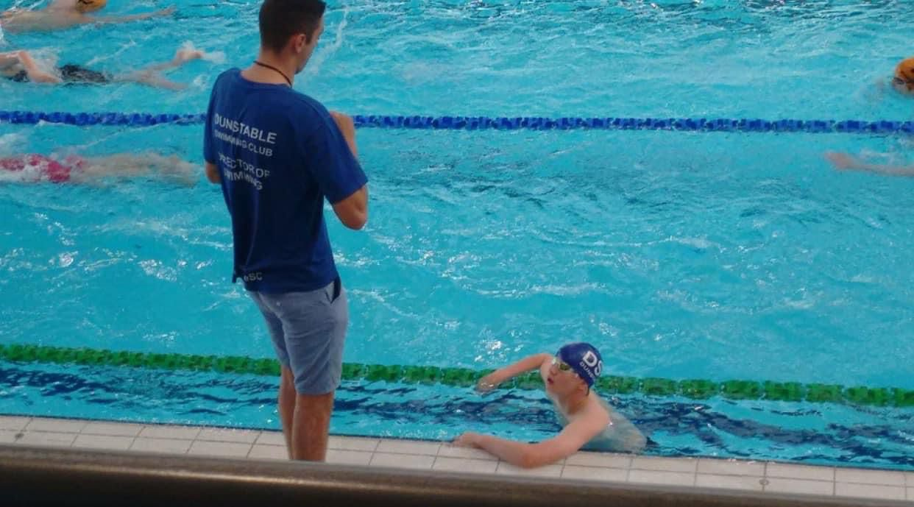

EVENT 5 Female 25m Breaststroke
1 | Zoe DARLINGTON | 8 |  |  | ........
2 | Layla LOCKWOOD | 10 |  |  | ........
3 | Mara BABICI | 10 |  |  | ........
4 | Ayda OKOLI | 11 |  |  | ........
5 | Lily MARTINEZ | 10 |  |  | ........
6 | Francesca COBB | 8 |  |  | ........
7 | Ava MACH | 8 |  | 41.2 | ........
8 | Arabella COBB | 10 |  | 36.79 | ........
EVENT 6 Open/Male 25m Breaststroke
1 | Jude BRADDON | 11 |  |  | ........
2 | Ektoras GIALOPSOS | 8 |  |  | ........
3 | Philippe MARCELO | 8 |  |  | ........
4 | Zachary LUDWELL | 10 |  |  | ........
5 | Tudor POGAR | 9 |  |  | ........
6 | Liam TWINING | 10 |  |  | ........
7 | Alfred MARTINEZ | 8 |  |  | ........
8 | Dylan DEAR | 10 |  |  | ........
9 | Reuben LEE | 10 |  | 44.75 | ........
10 | William HORTON | 11 |  | 29.8 | ........

EVENT 7 Female 50m Breaststroke
1 | Zofia WOJTACHINO | 11 |  |  | ........
2 | Aoife SEARS | 10 |  |  | ........
3 | Lily MARTINEZ | 10 |  |  | ........
4 | Anya STIMPSON | 12 |  |  | ........
5 | Evie KIELY | 14 |  |  | ........
6 | Dominika GRYGO | 15 |  |  | ........
7 | Cerys COOPER | 11 |  |  | ........
8 | Darcie THOMAS | 12 |  |  | ........
9 | Arabella COBB | 10 |  | 1:26.16 | ........
10 | G CROZIER-LITTLE | 13 |  | 1:16.00 | ........
11 | Isla Rose BIJUM | 10 |  | 1:09.50 | ........
12 | Poppy MAKIN | 11 |  | 1:04.22 | ........
13 | Edie RAWSON | 12 |  | 1:03.65 | ........
14 | Jemima GREEN | 9 |  | 1:01.84 | ........
15 | Cora PAYNE | 9 |  | 1:00.51 | ........
16 | Gwen KNIPE | 12 |  | 1:00.22 | ........
17 | Minudi WELLAPPULI | 13 |  | 59.34 | ........
18 | Isabella GEARY | 12 |  | 57.96 | ........
19 | Charlotte MAGUIRE | 24 |  | 56.5 | ........
20 | Kiara FOSTER | 10 |  | 54.53 | ........

21 | Diana DAVIDESCU | 14 |  | 51.88 | ........
22 | Madison BROWN | 14 |  | 50.63 | ........
23 | Imogen RADCLIFFE | 12 |  | 50.3 | ........
24 | Darcey CRAWLEY | 14 |  | 49.95 | ........
25 | Grace NEAL | 15 |  | 48.72 | ........
26 | Connie FLITTON | 12 |  | 48.5 | ........
27 | Darcy DEAR | 12 |  | 47.91 | ........
28 | Teresa CLARK | 12 |  | 46.1 | ........
29 | Libby FLITTON | 11 |  | 43.66 | ........
30 | Bryony MATHIAS | 16 |  | 42.37 | ........
31 | Amber FLITTON | 14 |  | 42.1 | ........
32 | Isabella PANTAZI | 13 |  | 40.39 | ........
33 | Hannah SWAN | 16 |  | 40.29 | ........
34 | Skylar ALDERSON | 17 |  | 39.3 | ........
35 | Libby FOWLER | 15 |  | 38.55 | ........
36 | Jessica MEDLICOTT | 16 |  | 38.08 | ........
EVENT 8 Open/Male 50m Breaststroke
1 | Theo KIELY | 12 |  |  | ........
2 | Benjamin KENYON | 11 |  |  | ........
3 | Sam BRADSHAW | 11 |  |  | ........
4 | Tudor POGAR | 9 |  | 1:29.32 | ........
5 | Jayden DEL BASSO | 9 |  | 1:08.58 | ........
6 | William HORTON | 11 |  | 1:08.25 | ........
7 | Ethan TREW | 8 |  | 1:06.16 | ........
8 | Patryk KRECZKOWSKI | 10 |  | 1:06.06 | ........
9 | Tao PALMER | 12 |  | 1:02.60 | ........
10 | Luke TRULL | 11 |  | 51.58 | ........
11 | Nathaniel PANTAZI | 11 |  | 50.93 | ........
12 | Matthew HORTON | 14 |  | 47.63 | ........
13 | Georgios GIALOPSOS | 15 |  | 45.6 | ........
14 | Noah BRAZEL-HAWKINS | 12 |  | 44.8 | ........
15 | Liam MURRAY | 17 |  | 44.52 | ........
16 | Stewart BUTLER | 13 |  | 44.19 | ........
17 | George HEARN | 13 |  | 42.54 | ........
18 | Beau GREEN | 16 |  | 41.09 | ........
19 | Luke HURLEY | 16 |  | 39.63 | ........
20 | James SHAW | 15 |  | 35.52 | ........
21 | Oliver BRADSHAW | 16 |  | 34.5 | ........

SPECIAL EVENT
Alumni Female 50m Breaststroke Alumni Year

- Amelia Porzio 2018
- Anna Newton 2015
- Ellie King 2023
- Isabella Porzio 2018
- Rue Hackett 2018
- Thea Brazel Hawkins 2022

SPECIAL EVENT
Alumni Open/Male 50m Breaststroke Alumni Year

- Greg Akroyd 1991
- Michael Judd 2022
- Ryan Currell 2011
- Ryan Roberts 2023
- Sam Mead 2018
- Simon Green 2002
- Will Richards 2018
- William Hamm 2020

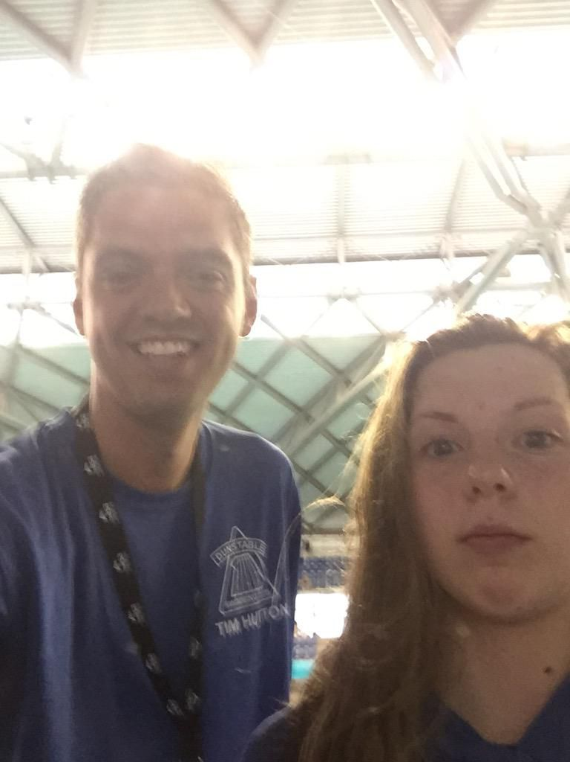

EVENT 9 Female 25m Backstroke
1 | Francesca COBB | 8 |  |  | ........
2 | Layla LOCKWOOD | 10 |  |  | ........
3 | Ayda OKOLI | 11 |  |  | ........
4 | Zoe DARLINGTON | 8 |  |  | ........
5 | Arabella COBB | 10 |  | 28.84 | ........
6 | Ava MACH | 8 |  | 28.11 | ........
EVENT 10 Open/Male 25m Backstroke
1 | Liam TWINING | 10 |  |  | ........
2 | Arthur WOODLOCK | 9 |  |  | ........
3 | Ektoras GIALOPSOS | 8 |  |  | ........
4 | Tudor POGAR | 9 |  |  | ........
5 | Dylan DEAR | 10 |  |  | ........
6 | Philippe MARCELO | 8 |  |  | ........
7 | Alfred MARTINEZ | 8 |  |  | ........
8 | Jude BRADDON | 11 |  |  | ........
9 | Jayden DEL BASSO | 9 |  | 30.22 | ........
10 | William HORTON | 11 |  | 27.05 | ........
EVENT 11 Female 50m Backstroke
1 | Evie KIELY | 14 |  |  | ........
2 | Darcey CRAWLEY | 14 |  |  | ........
3 | Dominika GRYGO | 15 |  |  | ........
4 | Anya STIMPSON | 12 |  |  | ........
5 | Cerys COOPER | 11 |  |  | ........
6 | Aoife SEARS | 10 |  |  | ........
7 | Zoe KIELY | 14 |  |  | ........
8 | Kiara FOSTER | 10 |  | 54.53 | ........
9 | Edie RAWSON | 12 |  | 54.31 | ........
10 | Gwen KNIPE | 12 |  | 50.21 | ........
11 | Cora PAYNE | 9 |  | 50.15 | ........
12 | Charlotte MAGUIRE | 24 |  | 50.05 | ........
13 | Teresa CLARK | 12 |  | 48.84 | ........
14 | Jemima GREEN | 9 |  | 47.95 | ........
15 | Jessica NEAL | 12 |  | 45.62 | ........
16 | Stef MARIN | 14 |  | 45.27 | ........
17 | Grace NEAL | 15 |  | 45.23 | ........
18 | Madison BROWN | 14 |  | 44.95 | ........
19 | Bethany SWAN | 13 |  | 44.62 | ........
20 | Darcy DEAR | 12 |  | 44.23 | ........
21 | G CROZIER-LITTLE | 13 |  | 42.86 | ........
22 | Imogen RADCLIFFE | 12 |  | 41.47 | ........
23 | Connie FLITTON | 12 |  | 41.17 | ........
24 | Natalia LODZINSKA | 15 |  | 40.34 | ........
25 | Alexandra STACHURA | 14 |  | 39.81 | ........
26 | Isabella PANTAZI | 13 |  | 38.65 | ........
27 | Bryony MATHIAS | 16 |  | 36.05 | ........
28 | Skylar ALDERSON | 17 |  | 35.79 | ........
29 | Amber FLITTON | 14 |  | 34.03 | ........
30 | Jessica MEDLICOTT | 16 |  | 33.11 | ........

EVENT 12 Open/Male 50m Backstroke
1 | Ethan TREW | 8 |  |  | ........
2 | Benjamin KENYON | 11 |  |  | ........
3 | Arthur WOODLOCK | 9 |  |  | ........
4 | Sam BRADSHAW | 11 |  |  | ........
5 | Jayden DEL BASSO | 9 |  | 53.34 | ........
6 | Patryk KRECZKOWSKI | 10 |  | 52.7 | ........
7 | Tao PALMER | 12 |  | 48.75 | ........
8 | George WOODLOCK | 15 |  | 47.26 | ........
9 | Eryk ZADLO | 11 |  | 44.83 | ........
10 | Noah BRAZEL-HAWKINS | 12 |  | 41.94 | ........
11 | George HEARN | 13 |  | 40.53 | ........
12 | James MOORE | 13 |  | 40.5 | ........
13 | Georgios GIALOPSOS | 15 |  | 40.28 | ........
14 | Oliver BRADSHAW | 16 |  | 36.19 | ........
15 | Luke HURLEY | 16 |  | 35.22 | ........
16 | Beau GREEN | 16 |  | 33.62 | ........
17 | George WALLIS-SMITH | 18 |  | 33.51 | ........
18 | James SHAW | 15 |  | 33.26 | ........

SPECIAL EVENT
Alumni Female 50m Backstroke Alumni Year

- Ellie King 2023
- Jess Kefford 2023
- Kate Hair 2007
- Lauren Simpkins 2016
- Veronika Popow 2023

SPECIAL EVENT
Alumni Open/Male 50m Backstroke Alumni Year

- Aris Giannakou 2008
- Callum Shepherd 2020
- Elliot Kefford 2019
- Eryk Sokolowsi 2016
- Finn Meenan 2019
- Joshua Hamm 2020
- Oliver Ellison 2021
- Ryan Roberts 2023
- Simon Green 2002
- Tim Hutton 2009
- Walter Hackett 2021
- William Hamm 2020
- Zak Aithsine 2016
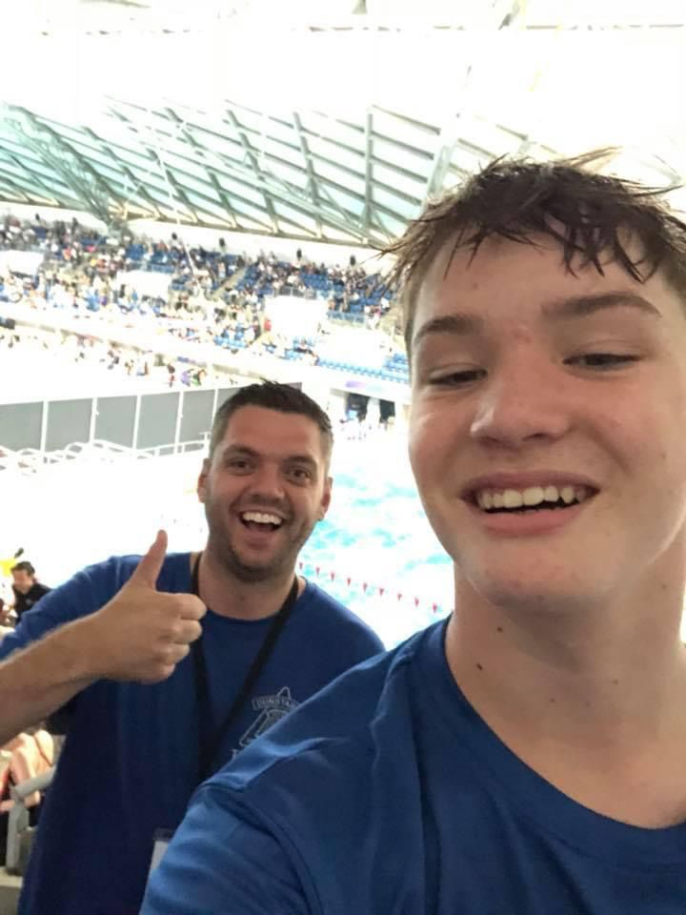

EVENT 13 Female 100m Freestyle
1 | Darcie THOMAS | 12 |  |  | ........
2 | Poppy MAKIN | 11 |  | 1:46.56 | ........
3 | Gwen KNIPE | 12 |  | 1:41.50 | ........
4 | Edie RAWSON | 12 |  | 1:38.20 | ........
5 | Cora PAYNE | 9 |  | 1:34.63 | ........
6 | Jemima GREEN | 9 |  | 1:32.24 | ........
7 | Darcy DEAR | 12 |  | 1:31.66 | ........
8 | Diana DAVIDESCU | 14 |  | 1:31.59 | ........
9 | Isabella GEARY | 12 |  | 1:31.22 | ........
10 | Madison BROWN | 14 |  | 1:23.98 | ........
11 | Stef MARIN | 14 |  | 1:22.73 | ........
12 | G CROZIER-LITTLE | 13 |  | 1:21.92 | ........
13 | Charlotte MAGUIRE | 24 |  | 1:21.17 | ........
14 | Darcey CRAWLEY | 14 |  | 1:21.00 | ........
15 | Libby FLITTON | 11 |  | 1:17.43 | ........
16 | Imogen RADCLIFFE | 12 |  | 1:16.66 | ........
17 | Evie ARMSTRONG | 11 |  | 1:13.92 | ........
18 | Connie FLITTON | 12 |  | 1:13.10 | ........
19 | Aimee SANDERS | 11 |  | 1:11.82 | ........
20 | Aimee SANDERS | 11 |  | 1:11.82 | ........
21 | Grace ARMSTRONG | 14 |  | 1:09.42 | ........
22 | Skylar ALDERSON | 17 |  | 1:09.03 | ........
23 | Isabella PANTAZI | 13 |  | 1:08.90 | ........
24 | Amber FLITTON | 14 |  | 1:06.00 | ........
EVENT 14 Open/Male 100m Freestyle
1 | Theo KIELY | 12 |  |  | ........
2 | Nathaniel PANTAZI | 11 |  | 1:20.99 | ........
3 | Matthew HORTON | 14 |  | 1:20.91 | ........
4 | Luke TRULL | 11 |  | 1:19.13 | ........
5 | James MOORE | 13 |  | 1:18.77 | ........
6 | Georgios GIALOPSOS | 15 |  | 1:16.31 | ........
7 | Noah BRAZEL-HAWKINS | 12 |  | 1:14.81 | ........
8 | Hanz Dylan MARCELO | 12 |  | 1:12.00 | ........
9 | George HEARN | 13 |  | 1:09.00 | ........
10 | Luke HURLEY | 16 |  | 1:06.65 | ........
11 | Beau GREEN | 16 |  | 1:03.52 | ........
12 | Dominic STACHURA | 16 |  | 1:01.30 | ........
13 | James SHAW | 15 |  | 1:00.17 | ........
14 | Joseph GRICE | 20 |  | 54.34 | ........

SPECIAL EVENT
Alumni Female 100m IM Alumni Year

- Amelia Porzio 2018
- Ellie King 2023
- Isabella Porzio 2018
- Kate Hair 2007

SPECIAL EVENT
Alumni Open/Male 100m IM Alumni Year

- Aris Giannakou 2008
- Elliot Kefford 2019
- Greg Akroyd 1991
- Joshua Hamm 2020
- Ryan Roberts 2023
- Thomas Fantini Simpson 2019
- Walter Hackett 2021
- William hamm 2020

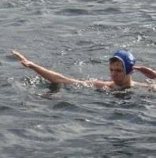

EVENT 15 Female 25m Freestyle
1 | Francesca COBB | 8 |  |  | ........
2 | Layla LOCKWOOD | 10 |  |  | ........
3 | Lily MARTINEZ | 10 |  |  | ........
4 | Mara BABICI | 10 |  |  | ........
5 | Zoe DARLINGTON | 8 |  |  | ........
6 | Ava MACH | 8 |  | 27.34 | ........
7 | Arabella COBB | 10 |  | 21.89 | ........
EVENT 16 Open/Male 25m Freestyle
1 | Tudor POGAR | 9 |  |  | ........
2 | Alfred MARTINEZ | 8 |  |  | ........
3 | Arthur WOODLOCK | 9 |  |  | ........
4 | Zachary LUDWELL | 10 |  |  | ........
5 | Dylan DEAR | 10 |  |  | ........
6 | Jude BRADDON | 11 |  |  | ........
7 | Ektoras GIALOPSOS | 8 |  |  | ........
8 | Philippe MARCELO | 8 |  |  | ........
9 | Liam TWINING | 10 |  |  | ........
10 | Reuben LEE | 10 |  | 29.28 | ........
11 | William HORTON | 11 |  | 27.56 | ........
12 | Jayden DEL BASSO | 9 |  | 24.81 | ........
EVENT 17 Female 50m Freestyle
1 | Zoe KIELY | 14 |  |  | ........
2 | Cerys COOPER | 11 |  |  | ........
3 | Zoe DARLINGTON | 8 |  |  | ........
4 | Dominika GRYGO | 15 |  |  | ........
5 | Layla LOCKWOOD | 10 |  |  | ........
6 | Layla LOCKWOOD | 10 |  |  | ........
7 | Zofia WOJTACHINO | 11 |  |  | ........
8 | Aoife SEARS | 10 |  |  | ........
9 | Lily MARTINEZ | 10 |  |  | ........
10 | Evie KIELY | 14 |  |  | ........
11 | Arabella COBB | 10 |  |  | ........
12 | Ayda OKOLI | 11 |  |  | ........
13 | Anya STIMPSON | 12 |  |  | ........
14 | Isla Rose BIJUM | 10 |  | 49.66 | ........
15 | Kiara FOSTER | 10 |  | 46.69 | ........
16 | Kiara FOSTER | 10 |  | 46.69 | ........
17 | Minudi WELLAPPULI | 13 |  | 44.93 | ........
18 | Teresa CLARK | 12 |  | 44.9 | ........
19 | Jemima GREEN | 9 |  | 42.98 | ........
20 | Poppy MAKIN | 11 |  | 42.71 | ........
21 | Cora PAYNE | 9 |  | 41.82 | ........
22 | Gwen KNIPE | 12 |  | 41.5 | ........
23 | Diana DAVIDESCU | 14 |  | 39.82 | ........
24 | Madison BROWN | 14 |  | 38.92 | ........
25 | Darcey CRAWLEY | 14 |  | 37.4 | ........
26 | G CROZIER-LITTLE | 13 |  | 37.16 | ........
27 | Darcy DEAR | 12 |  | 36.9 | ........
28 | Charlotte MAGUIRE | 24 |  | 36.8 | ........
29 | Bethany SWAN | 13 |  | 36.79 | ........
30 | Stef MARIN | 14 |  | 36.56 | ........
31 | Imogen RADCLIFFE | 12 |  | 34.57 | ........
32 | Natalia LODZINSKA | 15 |  | 34.25 | ........
33 | Connie FLITTON | 12 |  | 33.86 | ........
34 | Grace NEAL | 15 |  | 33.75 | ........
35 | Libby FLITTON | 11 |  | 33.7 | ........
36 | Hannah SWAN | 16 |  | 32.13 | ........
37 | Alexandra STACHURA | 14 |  | 32.1 | ........
38 | Aimee SANDERS | 11 |  | 31.45 | ........
39 | Aimee SANDERS | 11 |  | 31.45 | ........
40 | Skylar ALDERSON | 17 |  | 30.78 | ........
41 | Libby FOWLER | 15 |  | 30.75 | ........
42 | Isabella PANTAZI | 13 |  | 30.6 | ........
43 | Amber FLITTON | 14 |  | 30.17 | ........
44 | Bryony MATHIAS | 16 |  | 30.05 | ........
45 | Jessica MEDLICOTT | 16 |  | 27.78 | ........

EVENT 18 Open/Male 50m Freestyle
1 | Alfred MARTINEZ | 8 |  |  | ........
2 | Theo KIELY | 12 |  |  | ........
3 | Benjamin KENYON | 11 |  |  | ........
4 | Arthur WOODLOCK | 9 |  |  | ........
5 | Reuben LEE | 10 |  | 1:08.00 | ........
6 | William HORTON | 11 |  | 57.12 | ........
7 | Ethan TREW | 8 |  | 50.47 | ........
8 | Jayden DEL BASSO | 9 |  | 48.12 | ........
9 | Patryk KRECZKOWSKI | 10 |  | 44.78 | ........
10 | Tao PALMER | 12 |  | 44.4 | ........
11 | Reuben BIJUM | 10 |  | 43.91 | ........
12 | George WOODLOCK | 15 |  | 40.62 | ........
13 | James MOORE | 13 |  | 35.98 | ........
14 | Matthew HORTON | 14 |  | 35.78 | ........
15 | Eryk ZADLO | 11 |  | 35.27 | ........
16 | Noah BRAZEL-HAWKINS | 12 |  | 34.06 | ........
17 | Georgios GIALOPSOS | 15 |  | 33.44 | ........
18 | Hanz Dylan MARCELO | 12 |  | 33.2 | ........
19 | Liam MURRAY | 17 |  | 31.81 | ........
20 | Stewart BUTLER | 13 |  | 30.71 | ........
21 | George HEARN | 13 |  | 30.25 | ........
22 | Beau GREEN | 16 |  | 28.91 | ........
23 | Luke HURLEY | 16 |  | 28.67 | ........
24 | George WALLIS-SMITH | 18 |  | 27.79 | ........
25 | Oliver BRADSHAW | 16 |  | 27.72 | ........
26 | James SHAW | 15 |  | 27.69 | ........
27 | Dominic STACHURA | 16 |  | 26.99 | ........
28 | Joseph GRICE | 20 |  | 25.17 | ........

SPECIAL EVENT
Alumni Female 50m Freestyle Alumni Year

- Amelia Porzio 2018
- Bianka Misikova 2016
- Ellie King 2023
- Jess Kefford 2023
- Kate Hair 2007
- Lauren Simpkins 2016
- Rhianne Carrick 2022
- Rue hackett 2018
- Vicky Barber 1999

SPECIAL EVENT
Alumni Open/Male 50m Freestyle Alumni Year

- Aris Giannakou 2008
- Callum Shepherd 2020
- Daniel Tuffnell 2021
- Elliot Kefford 2019
- Eryk Sokolowski 2016
- Finn Meenan 2019
- Greg Akroyd 1991
- Joshua Hamm 2020
- Michael Judd 2022
- Myles Mathias 2023
- Oliver Ellison 2021
- Oliver Hibbitt 2016
- Ryan Currell 2011
- Ryan Roberts 2023
- Sam Mead 2018
- Simon Green 2002
- Thomas Fantini Simpson 2019
- Tim Hutton 2009
- Walter Hackett 2021
- Will Richards 2018
- William Hamm 2020
- Zak Aithsine 2016

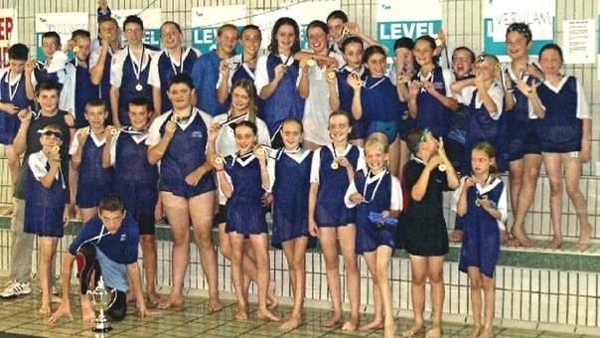

Thank you to all our Alumni swimmers who came back to DSC for our special event!
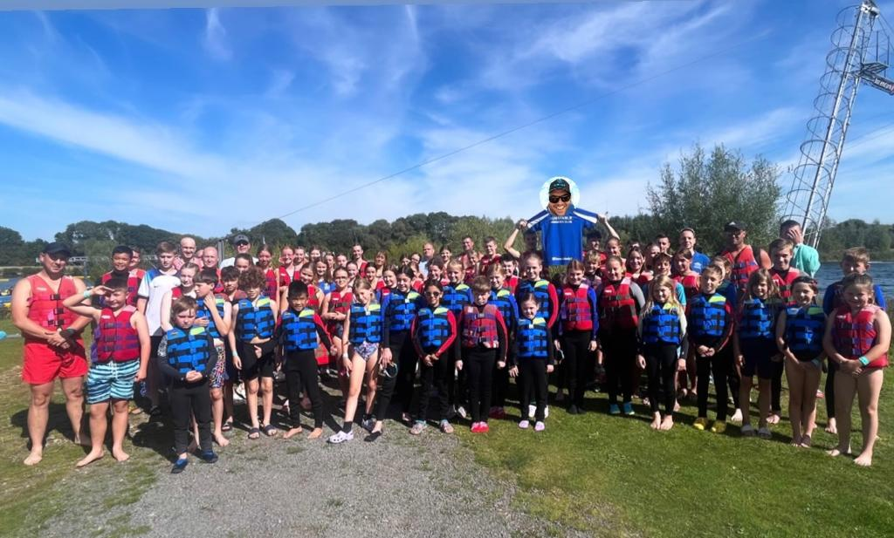
Abigail Weston | Millie Dudley
Amelia Porzio | Myles Mathias
Anna Newton | Oliver Ellison
Aris Giannakou | Oliver Hibbitt
Bianka Misikova | Ollie O'Connor
Callum Shepherd | Rhianne Carrick
Daniel Tuffnell | Rue Hackett
Ellie King | Ryan Currell
Elliot Kefford | Ryan Roberts
Eryk Sokolowski | Sam Mead
Finn Meenan | Simon Green
Greg Akroyd | Thea Brazel Hawkins
Isabella Porzio | Thomas Fantini Simpson
Jess Kefford | Tim Hutton
Jodie Armstrong | Veronika Popow
Joshua Hamm | Vicky Barber
Kate Hair | Will Richards
Lauren Simpkins | William Hamm
Michael Judd | Zak Aithsine

Goodbye Tim & Good Luck!

