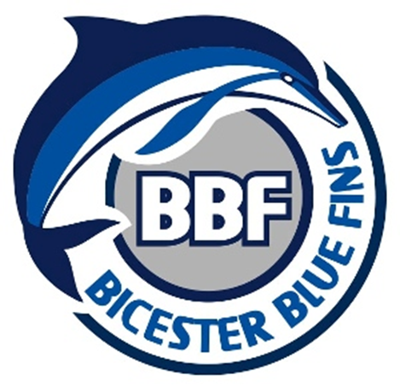
Code of Conduct
Parents and Guardians

As a parent/guardian of a Member (under 18 years of age) at BBF, you are required to agree to this code of conduct.

As a parent/guardian you have the right to:
- Be assured that your child is safeguarded at all times during activity with
BBF
- Know who the Welfare Officer are and how to contact them.
- Be informed of Wavepower and appropriate safeguarding and welfare reporting procedures.
- Know that any concerns about your child’s welfare will be listened and responded to.
- Know that anyone training or looking after your child at a club activity has the appropriate qualifications, checks and training.
- Be informed of any problems or concerns relating to your child raised by their coach.
- Know how to access the club policies, rules and procedures including the club complaints process and who to contact.
- Provide your consent or otherwise for photography and trips away.

As a parent/guardian of a Club Member (under 18 years of age) we expect you to:
- Make sure your child has the correct kit for training and competitions.
- Ensure your child arrives to sessions on time and is picked up promptly.
- Let the club know if you’re running late to collect your child, if your child is going home with someone else or you have made alternative arrangements.
- Complete all consent, contact and medical forms and update us straight away if anything changes.
- Respect the decisions made by your child’s coach but understand you have the right to raise any concerns regarding your child. We will arrange a mutually convenient time so you can talk to their coach, to the welfare officer or a committee member.
- Remember that children get a wide range of benefits from participating in one of our sports, including making friends, having regular exercise and developing new skills. It’s not all about winning.
- Not enter poolside or interrupt training or competitions unless in an emergency situation.
- Talk to your child and ensure they understand the rules of the club and the sport.
- Ensure your child understands the Athlete Code of Conduct.

We expect certain standards of behaviour from all club members as well as parents/guardians/grandparents.

By agreeing to this Code of Conduct you agree to:

- Behave positively as a spectator at training or competitions and treat others with respect.
- Give encouragement to your child well and provide support when they are struggling.
- Respect and celebrate differences in the club and not discriminate against anyone else on the grounds of gender, race, sexual orientation, faith, ability, or any other relevant characteristic.
- Respect anyone competing for other teams at competitions.
- Respect all volunteers, committee members, coaches and teachers at BBF.
- Understand that the use of abusive or inappropriate language, bullying, physical violence or any other behaviour which hurts others will not be tolerated at the club.
- Report any incidents of abuse, bullying or other unacceptable behaviour to the Welfare Officer, even if you’re just a witness.

Breaches of this Code of Conduct will result in disciplinary action being taken against you by the club committee and any behaviour which may be a criminal offence will be reported to the Police and any other relevant authority, by the Clubs officers.
Continued breaches of this code of conduct by a parent/guardian (whether a member or not) may require the club to stop your child’s continued participation in BBF activity

Name of child/children
Signature of parent/guardian
Date:

