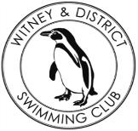
Chantal’s W&DSC Head Coach Highlights January Report2020
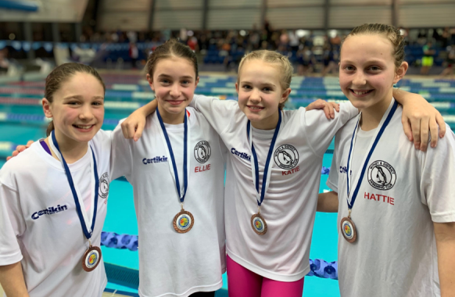

New club records:
Jess and Hattie and girls age group relays!
Well done all

Good luck at ONB County champs in Feb:
Ellie Browne
Ellie Blake
James Bunyard
Sammy Cartwright
Georgia Duff
Camille Duff
Alice Dyson
Ella Edwards
Annaliese Elford
Katie Franklin
Iris Fraser
Maddie Good
Lucy Howarth
Hugo Jinks
Sophie Jarvis
Cameron Jarvis
Rory Jones
Ben Kinahan
Ethan Lefort
Beth Lefort
Hattie Lever
Bertie Lever
Lauren Mellings
Jessica Miller
Rosie Mullins
Harriet Mullins
Jonathan Opalczewski
Eleanor Perks
Isaac Perks
William Phair
Henry Purcell
Cameron Richards
Sienna Saunders
Erin Stewart
Maya T.Saldana
Ava White
Freya Warriner

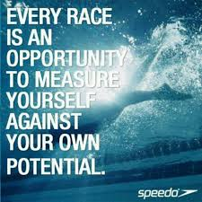

Good luck to all swimmers in Diddy heats on 28th Feb and 1st March!

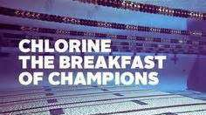


Congratulations County top 8 positions in 400’s:
Eleanor, Jess, Sienna, Erin, Ethan, Annaliese, Hattie, Katie, Maya, Ellie, Lauren, Rosie, Isaac, William, Jonathan, Hugo, Henry

No evening training Sunday 9th Feb due to Academy time trials
ONB County age group 10-12 + 13/14yrs relay teams:

