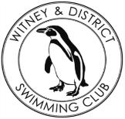
Chantal’s W&DSC Head Coach Highlights July/Aug Report 19
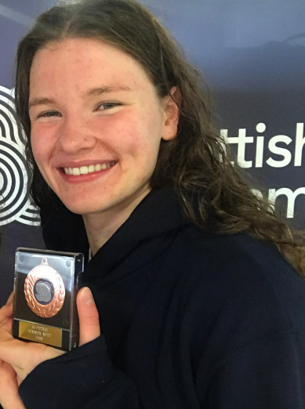
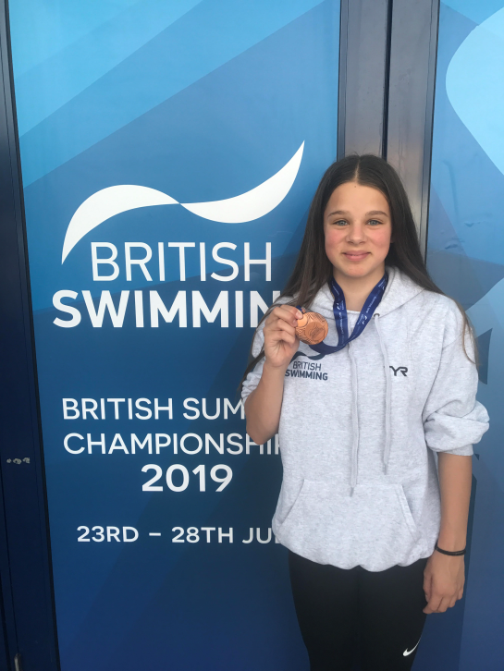
Well done at Summer Nationals!!
Georgia Duff – Scottish Nationals (bronze)

Eleanor Perks – British Nationals (bronze)

Ella Edwards & Lauren Mellings – Welsh Nationals (finals for both)

Hugo Jinks
-Open Water Nationals

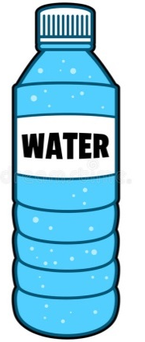
W
E
L
C
O
M
E
B
A
C
K

Make sure you have planned and handed in your 2019-20 goal form!

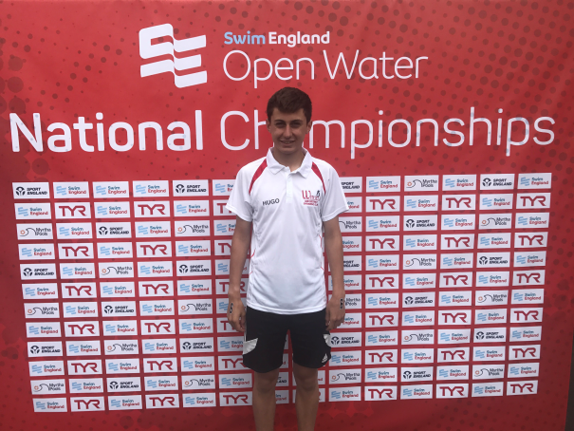

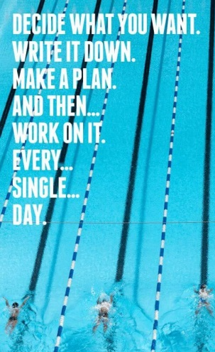
Pre pool is 10mins before pool training!!!!!

Make sure you have all your correct training kit for the new season!!
Fins, kick board, pull buoy, snorkel, finger paddles, hand paddles, thera-band,spare hats+goggles, skipping rope, roller

Club Championships
Entries close 1st September
Friday 20th September – 200 bk/100 fc
Saturday 20th September – 200 fc/100 brs
Sunday 22nd September – IM/400 fc/100 bk
Monday 23rd September – 200 fly
Friday 27th September – 200 brs/100 fly
Saturday 28th September – 50’s
Sunday 29th September – IM/400 fc/100bk
Monday 30th September – 200 IM

Gala’s coming up…..
7th Sept – home relay gala
14th Sept – Braunstone gala
14th Sept – MKJL RD 3
12th Oct – NAL RD 1
9th Nov – NAL RD 2
14th Dec – NAL RD 3
Club champ finals – 23/24th Nov
Good luck everyone!!

