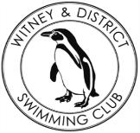
Chantal’s W&DSC Head Coach Highlights June Report2019
Well done to the following swimmers who attended the West Oxfordshire Sports Awards and were awarded GLL Sports Foundation awards:
County Awards:
Erin Stewart, Sammy Cartwright,
Regional Awards:
Lauren Mellings, Ella Edwards, Georgia Duff, Jess Miller, Eleanor Perks, Ellie Browne, Maddie Good, Camille Duff, Lucy Howarth

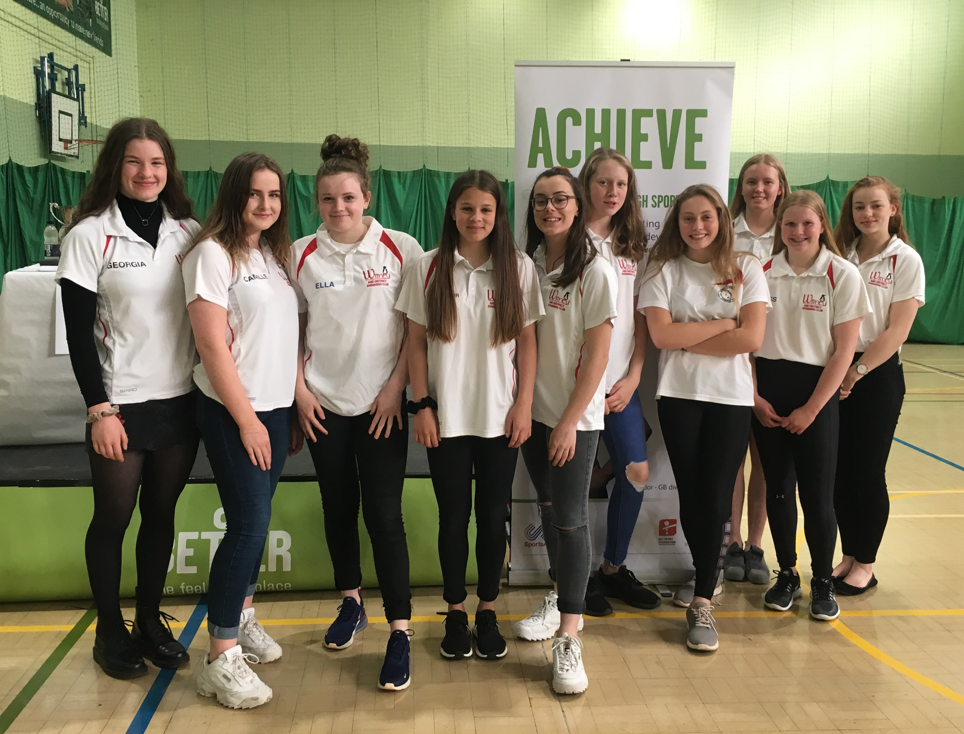
Good luck at Nationals!!
Georgia Duff – Scottish Nationals (12-14th July)

Eleanor Perks – British Nationals (23rd – 28th July)

Ella Edwards & Lauren Mellings – Welsh Nationals (29th July – 2nd August

Wellingborough Gala 11/u age group winners!
Ellie Blake, Beth Lefort, Ella Purcell, Katie Franklin
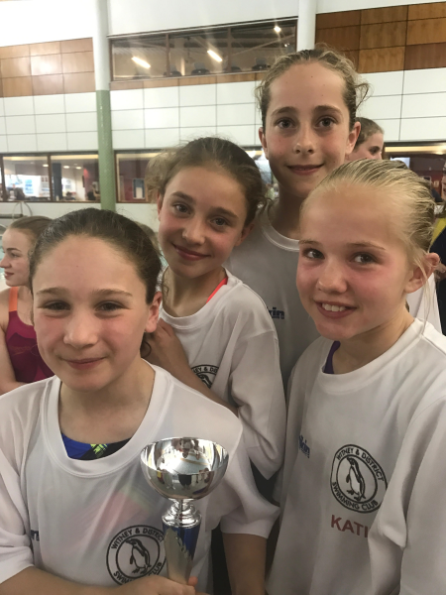

Great racing at all gala’s and open meets in June – been a busy month!!

Masters Success:
Congratulations to Janka and Darren for their GLL Sports Foundation Training awards.
Photo in their GB kit as they received this to support their training for the World Transplant Championships 17-24 August in Newcastle where they will be swimming for Team GB.
Congratulations to Lynne for winning a bronze medal at the recent British Masters Championships in the 70-74yrs age group 100m Backstroke.

Don’t forget to check summer training hours – end on Wednesday 31st July and restart Thursday 29th August.

Good luck to swimmers at regional open water champs:
Hugo Jinks, Steffi Jinks, Megan Howe

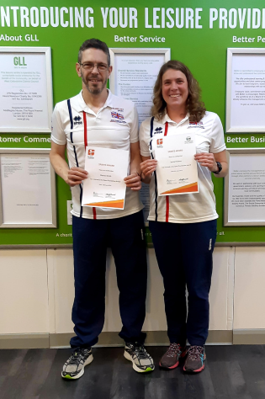
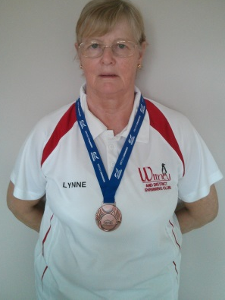
New records broken in June:

Eleanor Perks - 15/u and Open 200m IM SC - Maxwell meet
James Bunyard - Open 50m BRS SC - Hatfield

