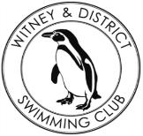
Chantal’s W&DSC Head Coach Highlights Nov+Dec Report 19
Winter regionals results
Ella, Georgia, James, Eleanor, Ellie and Maddie all competed in the open Swim South East Winter regionals. With James and Eleanor both making finals, and Eleanor a bronze medal!

Good luck ONB Distance/Age group relay events!
1500m FC - Saturday 11th Jan
800m FC – Saturday 18th Jan
400M IM/FC – Sunday 26th Jan
Girls age group relays – Saturday 18th Jan
Boys age group relays – Saturday 11th Jan

Club championship finals
Skins winners –Eleanor and James
Club records – Ben K and Katie F
Club champ records – Eleanor, Katie F, Henry, Erin, Jonathan, Ben K


ONB County Champs
40 swimmers
28 relays
266 individual swims
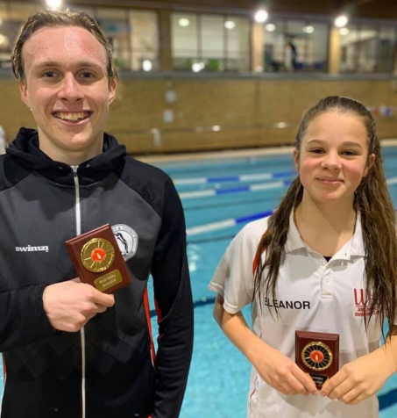
Happy
HAPPY NEW YEAR!
New
Year! Year!

Winter Nationals
Ella and Jess both competed in Welsh Winter meet a range events with Ella achieving a final in the 200m Fly.
Eleanor (200m Brs)
and James (50m FC)
competed in
Swim England
Winter meet

110 swimmers took part in W&DSC fun xmas gala – Christmas medal and chocolate for all!!!
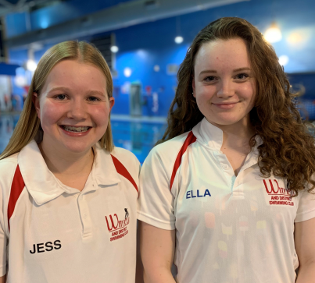
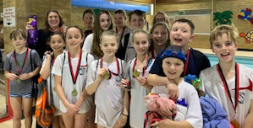

Jazz Carlin visits!

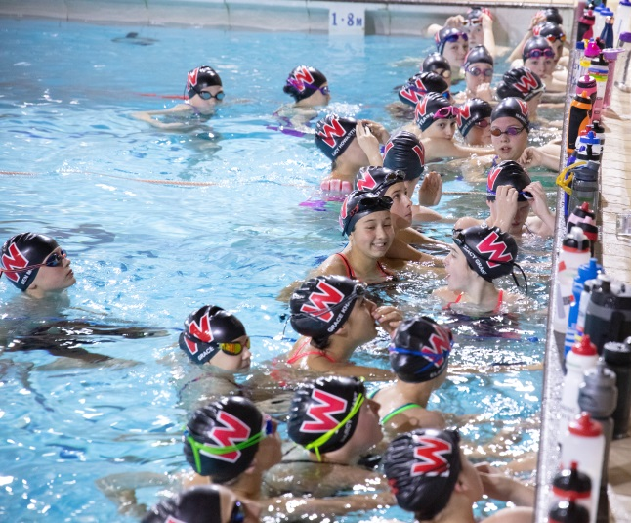
National Arena League success!!
Coming 3rd in final round so 14th in Premier
Division!

