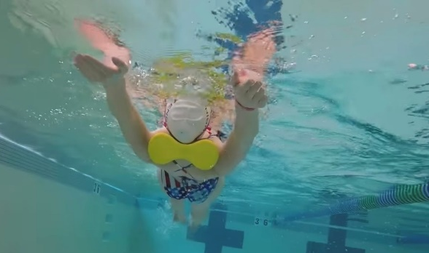
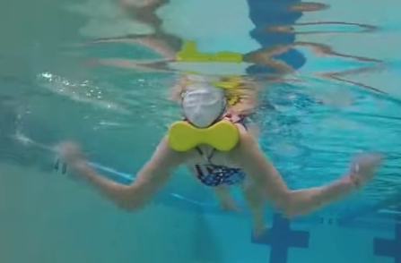

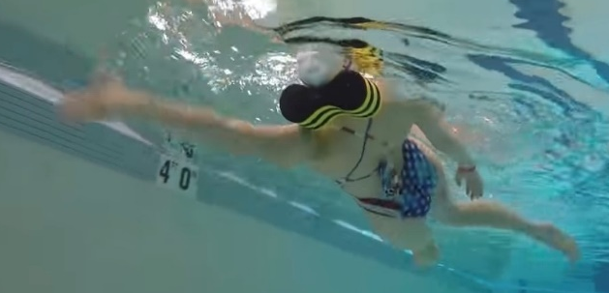
HOW and WHY?
- Pullbouy behind neck/head on backstroke
- Keeps head still
- Rotation through shoulders/hips
- Correct head position
- Can do kick, scull, drill, full
Pillow backstroke
W&DSC
Advent Calendar Drills
10th December

