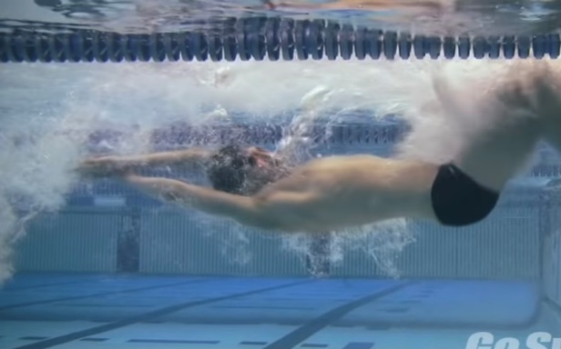
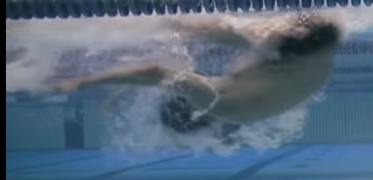
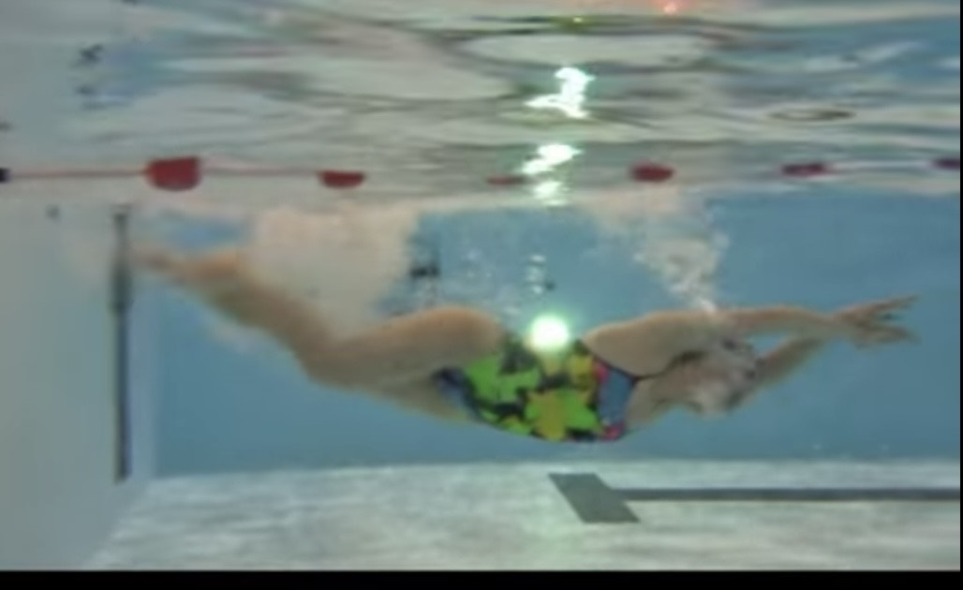

HOW and WHY?
- Turn at flags rather than wall
- No push off from wall
- Faster turn rotation – closer tuck body position
- Still do underwater phase to get moving
- Stogner underwater phases
- Maintain speed
- Can do on all strokes
Invisible Turns
W&DSC
Advent Calendar Drills
11th December

