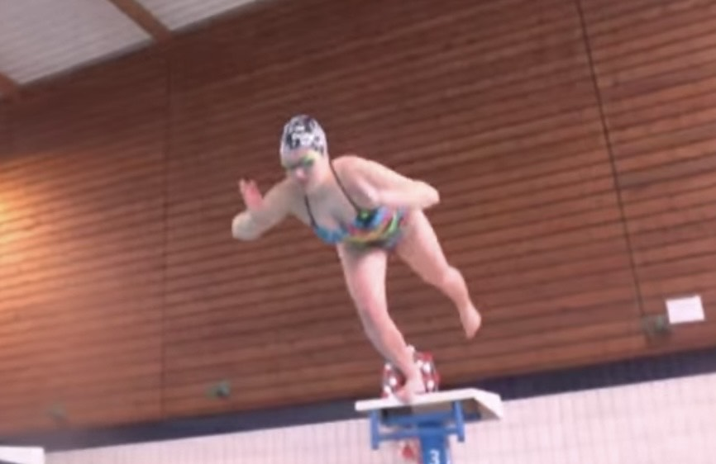
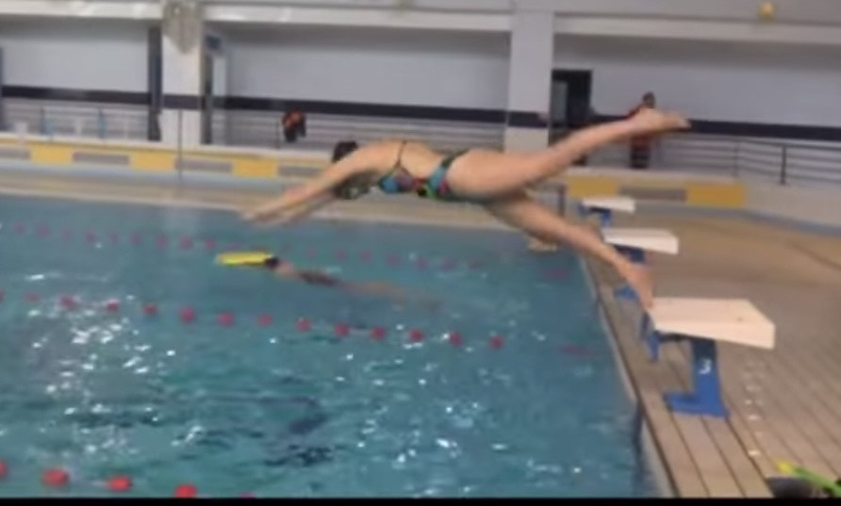
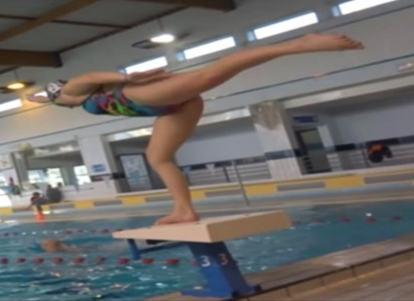
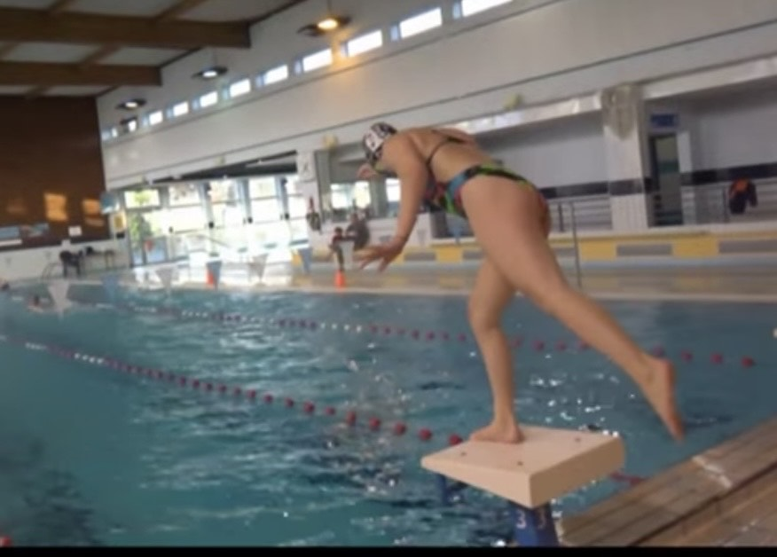

HOW and WHY?
- Balance work
- Power for pushing off one leg
- Control of core
- Driving start with arms
- Getting into streamline body position
- Bend front leg for push

One legged Dives
W&DSC
Advent Calendar Drills
12th December

