
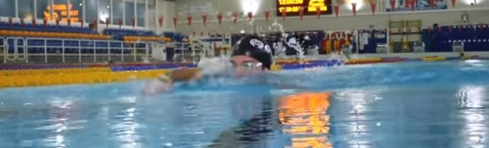
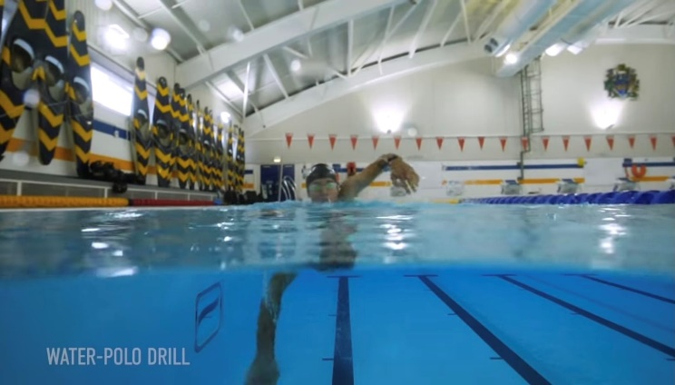
W&DSC
Advent Calendar Drills
1st December
HOW and WHY?
- Head up FC – eyes look forward, chin on water
- Head stays still
- Kick hard or legs will drop
- Can focus on hand entry as can see!
- High elbow
- Low hand action to water
- Leading wrist in hand action
- Minimise cross over of arms
- Arms are faster and more powerful

Water Polo Frontcrawl

