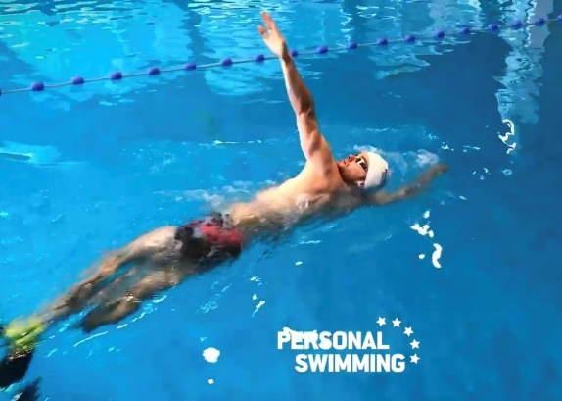
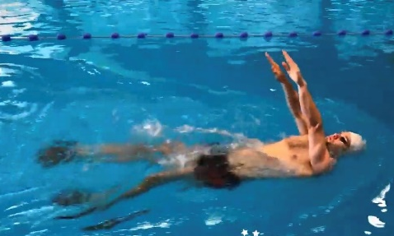
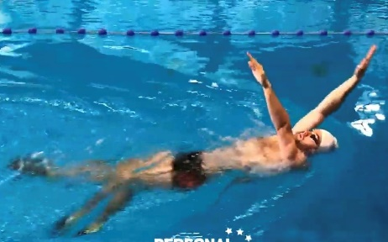

Backstroke vertical catch up
HOW and WHY?
- Fins on to help keep body position up
- Head position still and high
- Kick hard to strengthen kick as well
- Engage core and keep hips up
- Keep one arm up vertical and straight
- Body rotation as reach up vertical
- Single arm round – strong under water pull action
- Swap arms each arm cycle
This is a hard drill!
W&DSC
Advent Calendar Drills
2nd December

