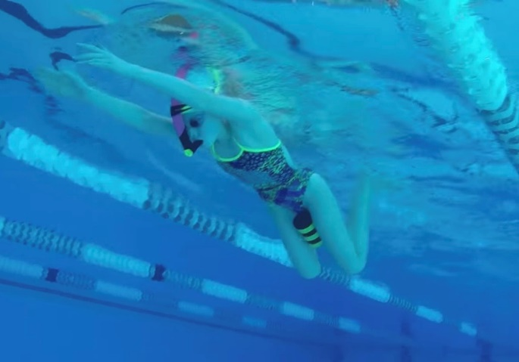
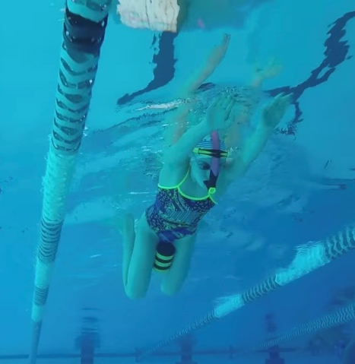
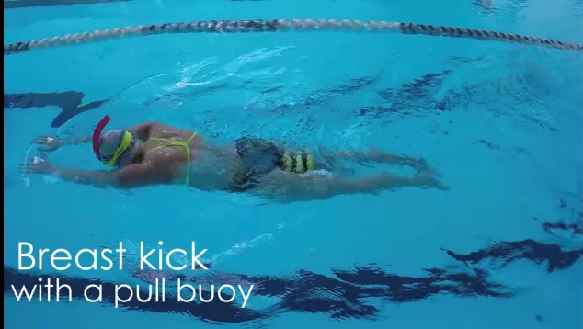

HOW and WHY?
You can do this drill as a BRS kick only drill or as full stroke.
- Can use snorkels
- Pull buoy put between thighs
- Perform BRS kick keeping pull buoy between legs
- If it pops out then knees are opening too far apart on kick
- Aim to keep knees narrow on kick
- Knees slightly wider than hips and feet slightly wider than knees
- Kick back and not out
- Keeps a balanced kick

Breaststroke kick with pull buoy
W&DSC
Advent Calendar Drills
3rd December

