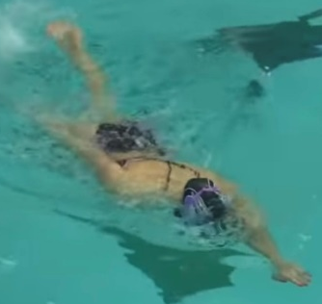
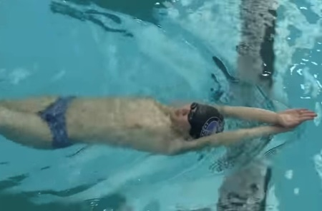
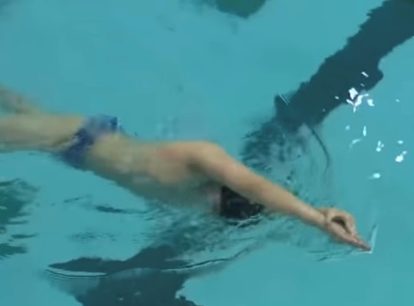
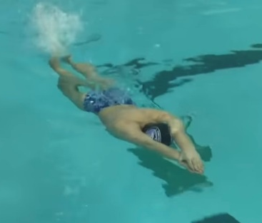
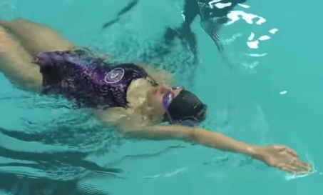
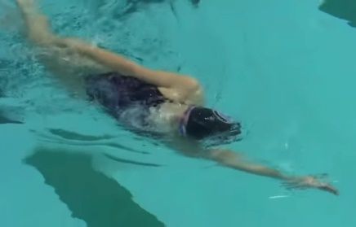

HOW and WHY?
Firstly do in streamline body position (above), progress to lateral position (below)
- Start on front and roll onto back then roll back onto front in same direction (don’t go round in circle!)
- 12 kicks on front, roll, 12 kicks on back, roll
- Roll onto lateral arm
- Initiate roll from hips
- Head and arms still
- Engage core to keep body straight
- Continual kick, no pause on roll
- Head positions on front (down + little forward) and back (chin up)
- Keep hips up on both positions

FC + BK kick body positions + rotations
W&DSC
Advent Calendar Drills
4th December

