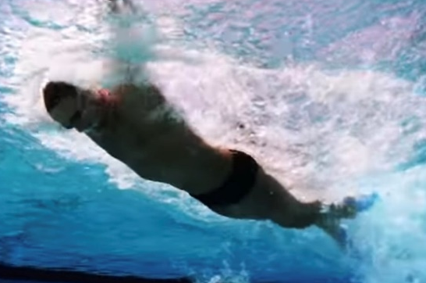
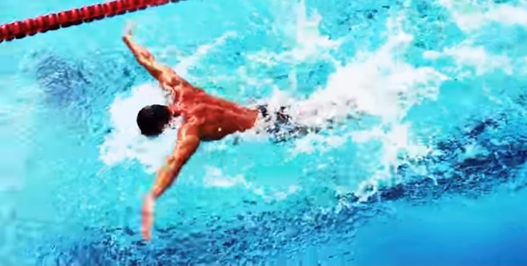
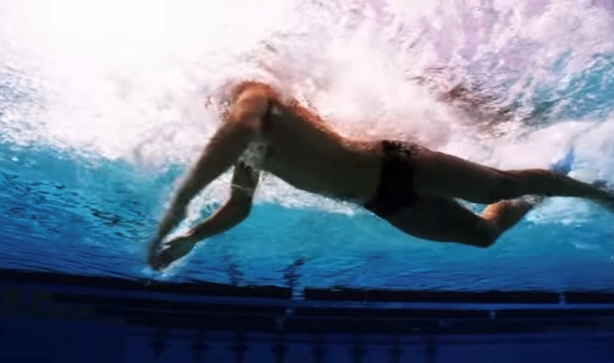
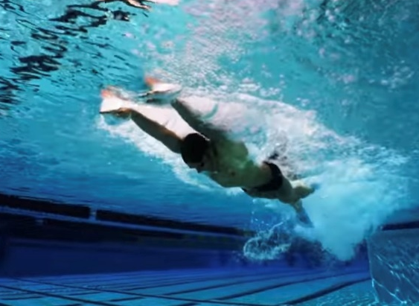

HOW and WHY?
Can wear fins, then progress to no fins
- Focusses on breathing low to the water
- Continual and fast FC kick
- Continual and fast arm rate
- Breath every stroke
- Chin on water, pull head up through top of head
- Push head down quickly after breath
- Don’t lift chest up to breath
- Positive impact on speed especially of arms and head action after the breath
- Surge forward after breath from FC kick and speed of putting head down
- Strong leg kick
Butterfly with FC kick
W&DSC
Advent Calendar Drills
5th December

