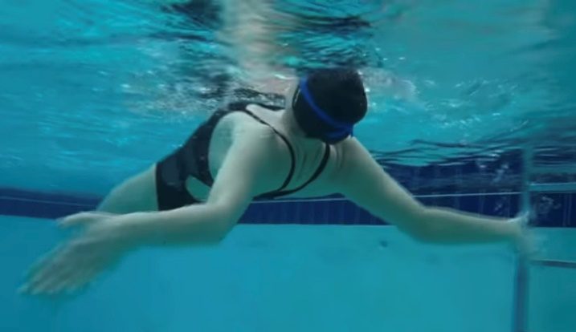
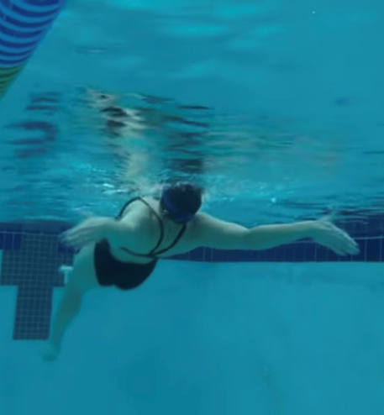
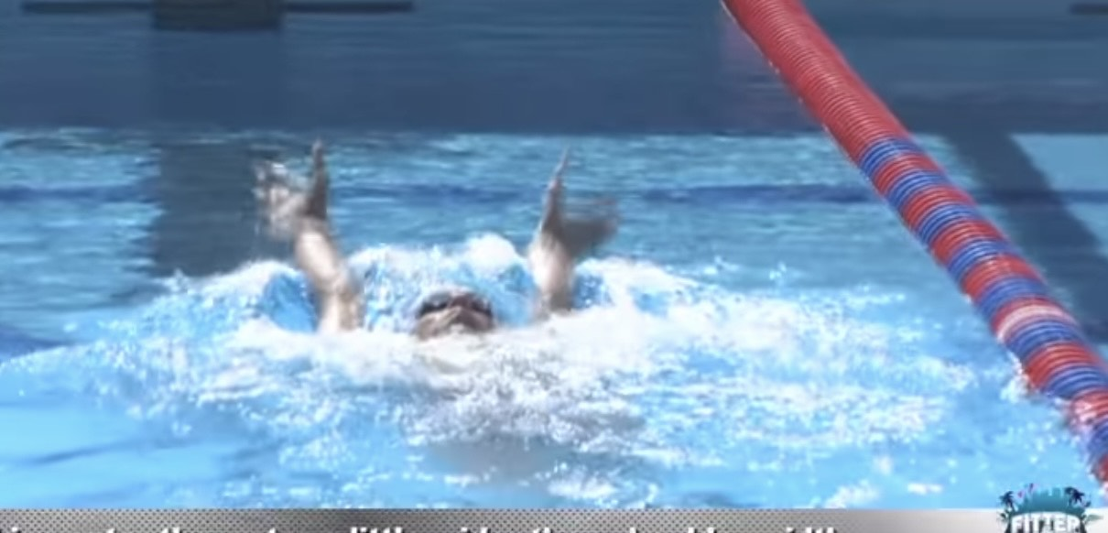
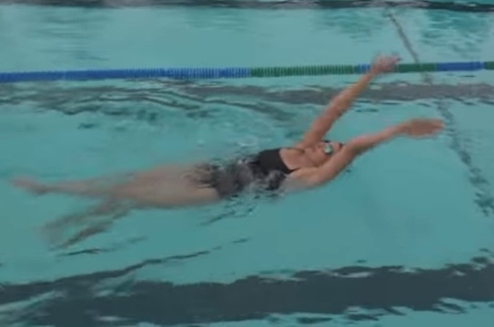

HOW and WHY?
- Both arms at the same time and enter water just a little wider than shoulder distance
- Normal BK kick to stay stable
- Works on hand positioning, placement and pull all the way through the stroke
- Shallow pull and parallel to body
- Deep bend in elbows for stronger push
- Palms facing towards feet, finger tips point outwards to side
- There will be no rotation so focus on catch into pull
- Thumbs exit, little finger entry into catch
Double arm backstroke
W&DSC
Advent Calendar Drills
6th December

