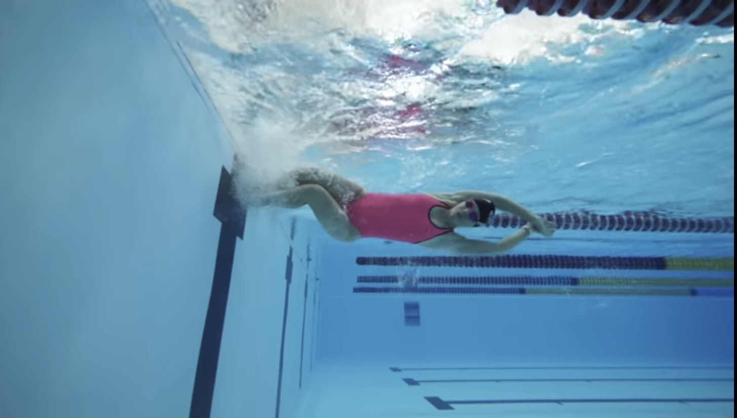
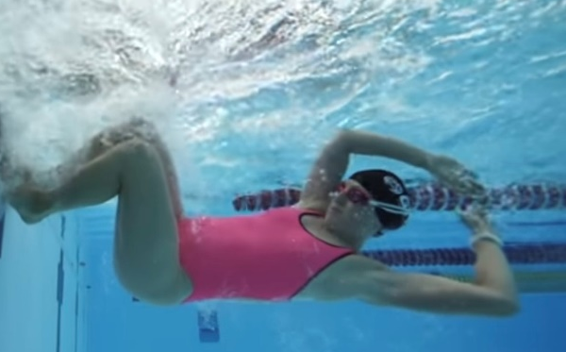
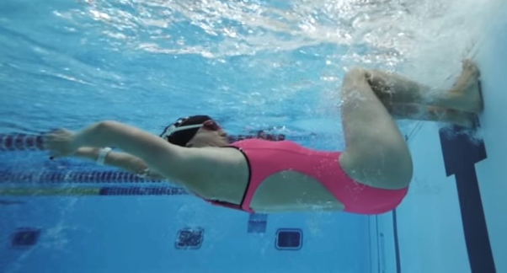

W&DSC
Advent Calendar Drills
7th December
HOW and WHY?
- FC and BK turns
- Land feet on wall and hold position on wall (feet stick to wall) for 3 secs before pushing off
- Time to check feet placement and body position
- Gives a stronger push off wall
- Can correct arm position to get into tight streamline
- Knees at 90 degrees
Sticky Turns

