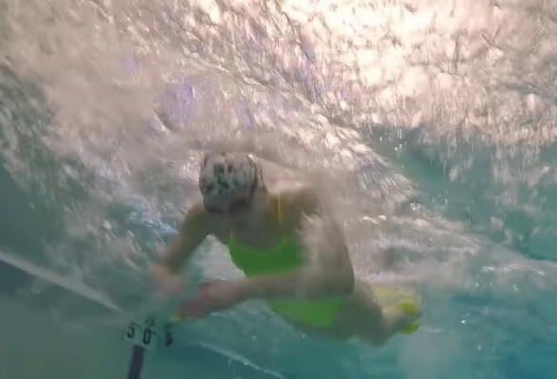
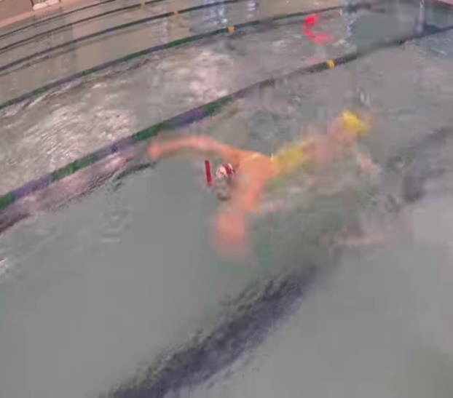
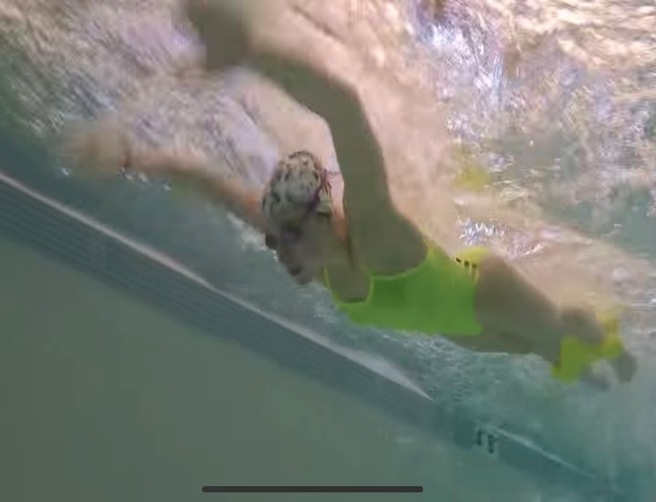

Power Fly Pull – strength
HOW and WHY?
- Focus on good catch and strong pull
- Keeping head low (can do with snorkel) to keep level
- Accelerate pull through and push back
- Complete whole pull or arms will drag on top of water
- No undulation – keep hips and legs still to focus on pull
- Fine ankle pull buoy the best
W&DSC
Advent Calendar Drills
8th December

