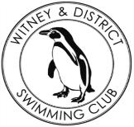
Chantal’s W&DSC Head Coach Highlights April Report 2018
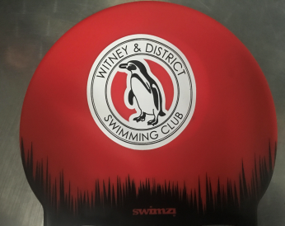
New Witney training hats!
Well done to the Chilterns League rd 3 team!
Came 5th overall in the league
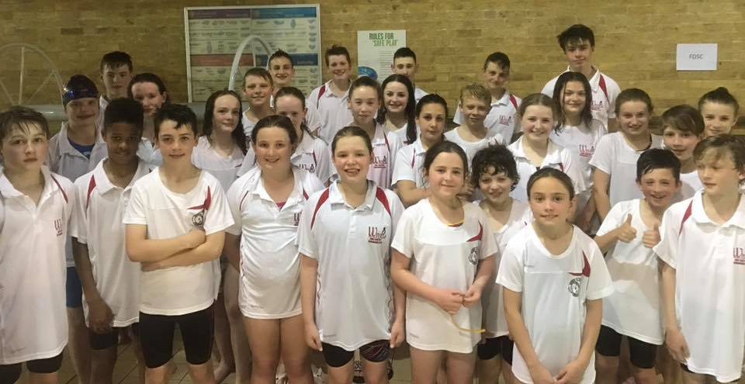

Good luck to the swimmers sitting exams!

New April Club records:
Ella Edwards – 15/u SC 200mIM
Jonathan Opalczewski – 13/u SC 100 IM
Maya T-S – 11/u LC 50 BK, FLY, 200 BRS
Eleanor Perks – 13/u LC 200m Brs

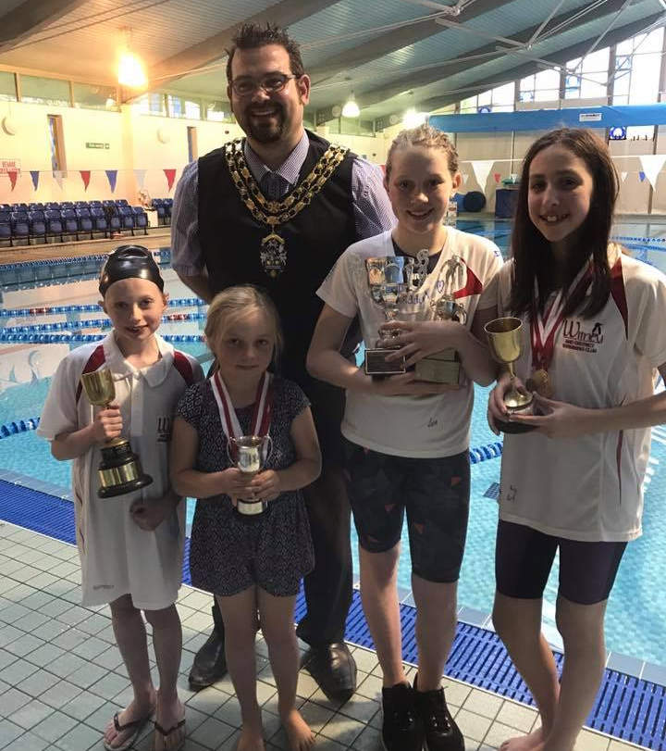
Diddy Championship finals:
8 Club champ records, 2 club records, over 140 PB’s!
Well done everyone!

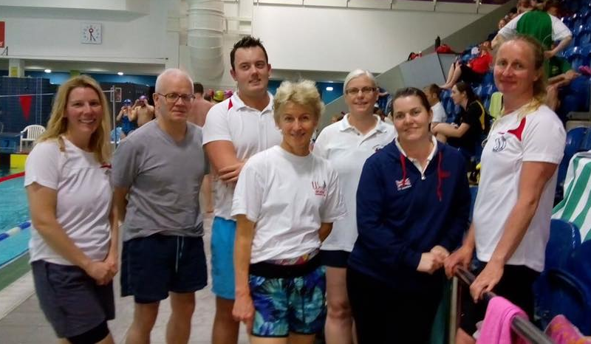

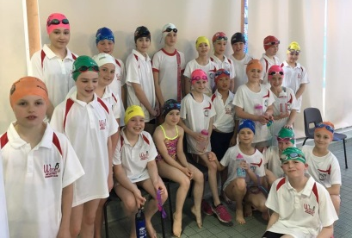
Swimathon 2018!
88 swimmers aimed to do 221,000m – but did way more!!

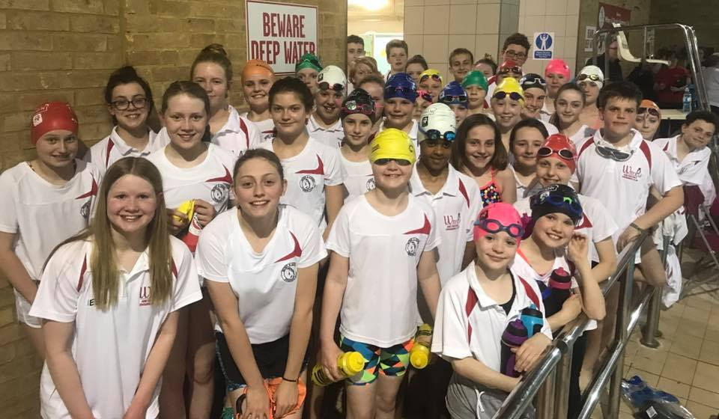
Masters success at Gloucester Open meet!
Good luck to the following swimmers competing at Swim South East Regionals in May:
Ella Edwards Eleanor Perks
Lauren Mellings Jessica Miller
Ellie Browne Reuben Coppuck
Maddie Good Erin Stewart
Georgia Duff Jonathan Opalczewski
Ben Kinahan Lucy Howarth
Maya T-S

