
Chantal’s W&DSC Head Coach Highlights April Report2019
Don’t forget to sign up for land training – Juniors and Seniors!
Thank you captains!
Ben and Ellie presenting Diddy finals medals and trophies
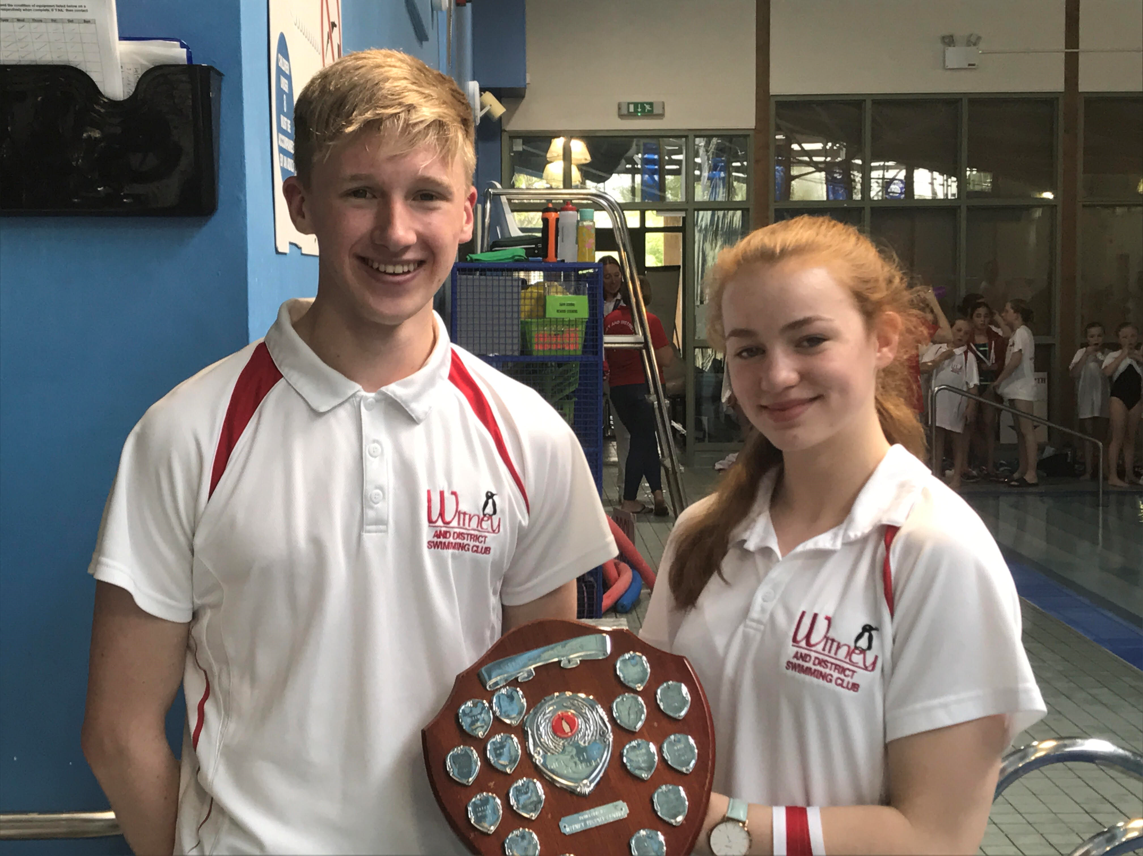
Welsh Nationals Success!



Chiltern’s League Winners!
Coming 2nd in the gala but winning the league overall.
Steffi and Cameron collecting trophy
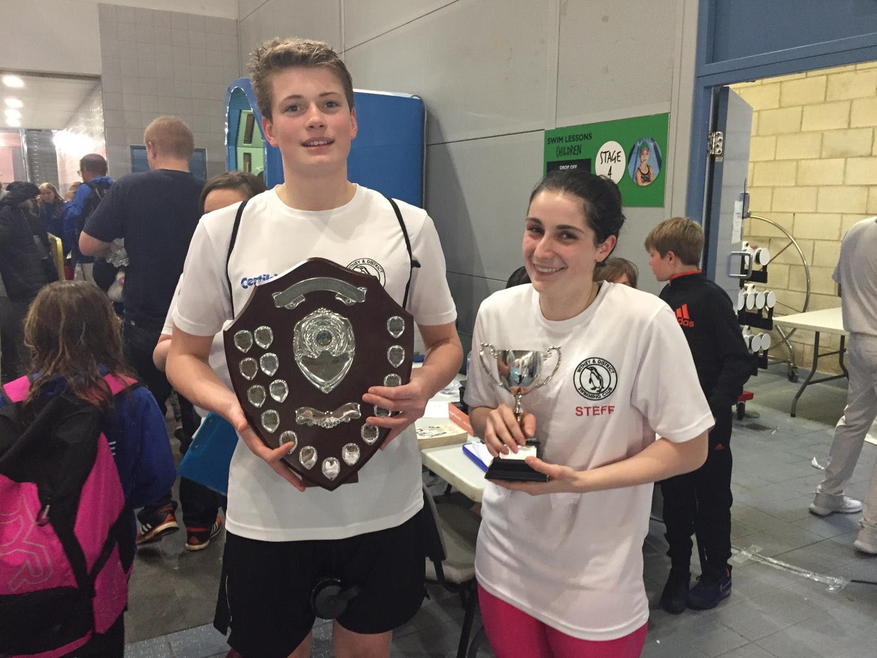

ONB development day
Beth, Hattie and Katie at 12yrs ONB Development camp
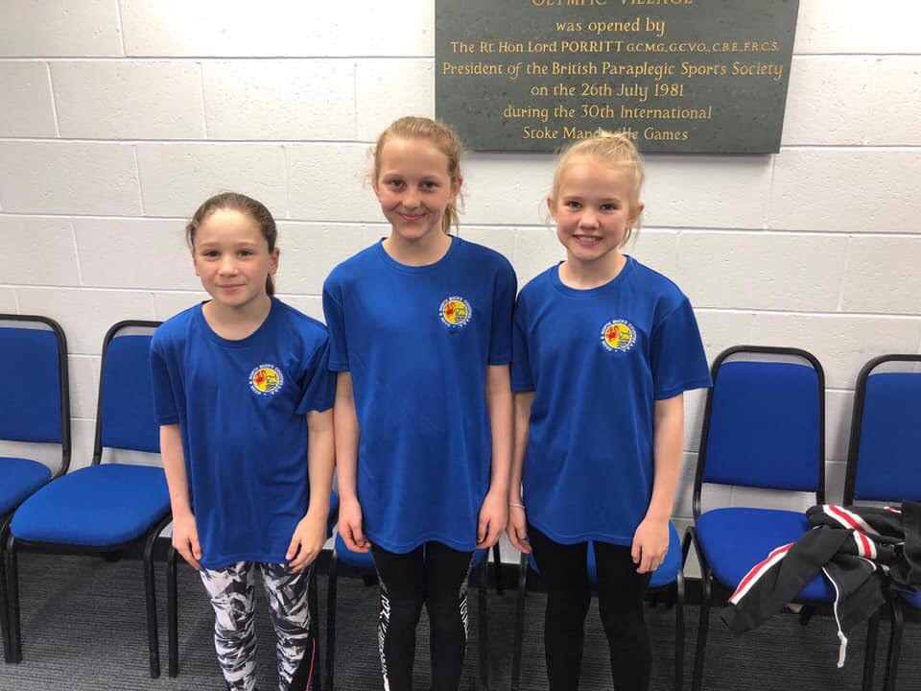

Diddy Championships Special Trophies:
Special trophies awarded to:
Henry Purcell, William Phair, William Archibald, Mollie Crierie Evans, Katie Franklin
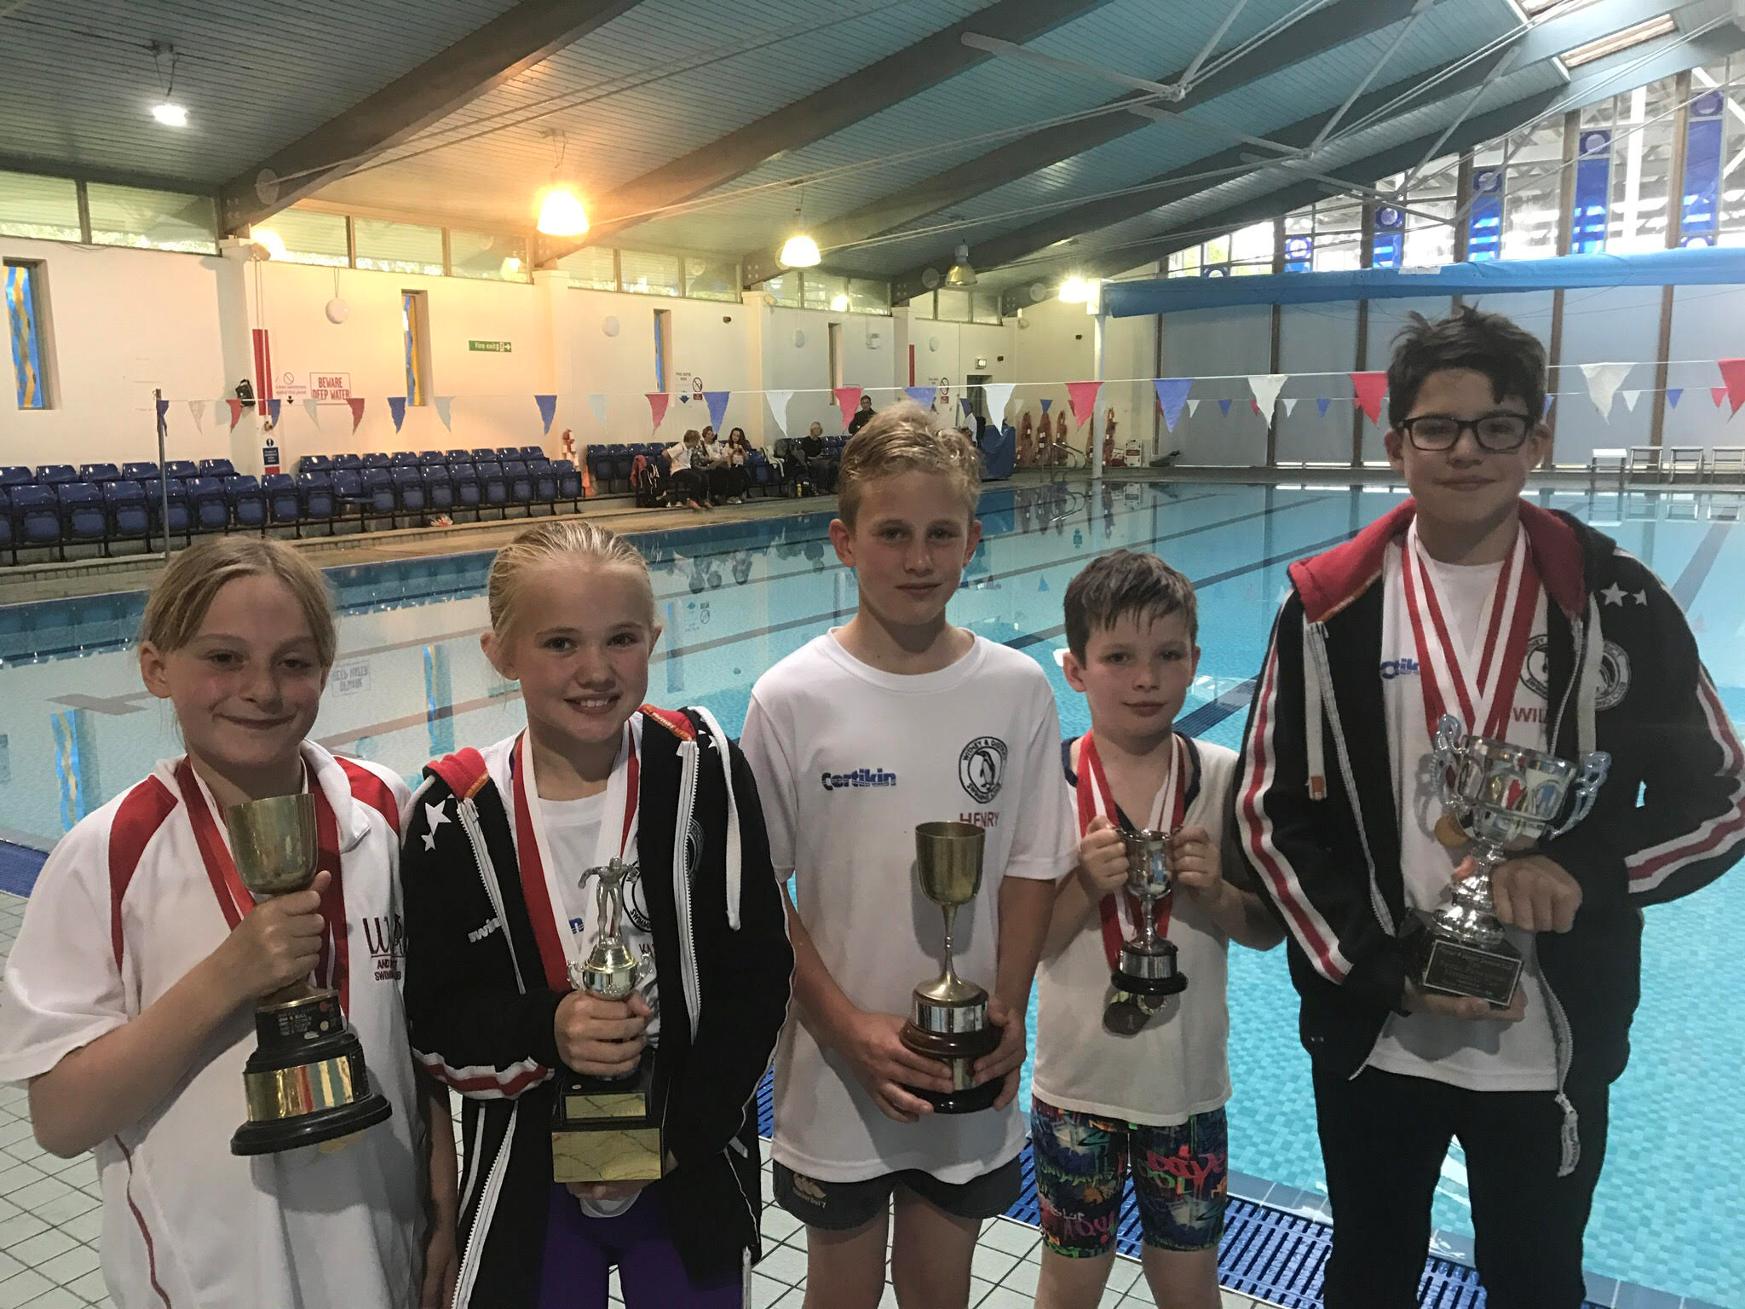
New records broken in April:

Jess Miller - 13/u 800m FC SC - Gloucester
Reuben Coppuck - 13/u 100m BRS LC - Welsh Nationals
Jess Miller - 13/u 200m, 400m, 1500m FC LC - Welsh Nationals
Hattie Lever - 11/u 200m BK LC - Luton
Eleanor Perks 13/u 100 Fly + 50 FC LC, Wycombe

Diddy Championship Records - set at Finals
Maya Thorsdottir-Saldana 12yrs 100m BRS, 100m BK, 100m FLY, 100m FC
Henry Prucell 10yrs 100m IM, 50m FC, 50m BRS, 50m BK
William Phair 12yrs 100m BK, 100m FC
Katie Franklin 11yrs 50m FC, 50m BK

