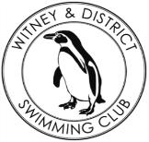
Chantal’s W&DSC Head Coach Highlights
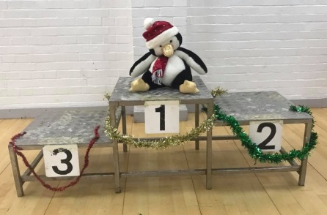
December Report 2017
Goodbye and good luck in America to the Khazir family – Malik, Grace, Michelle and Zac
Success at NAL!
6th Place in Division 2 West Midlands. Best since 2004!

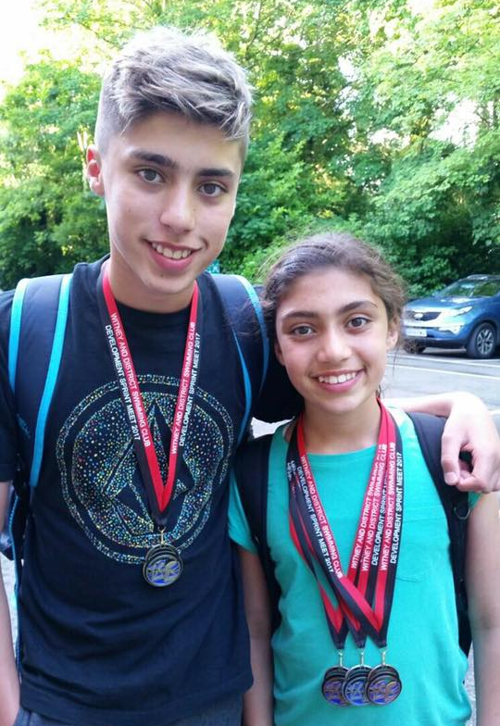
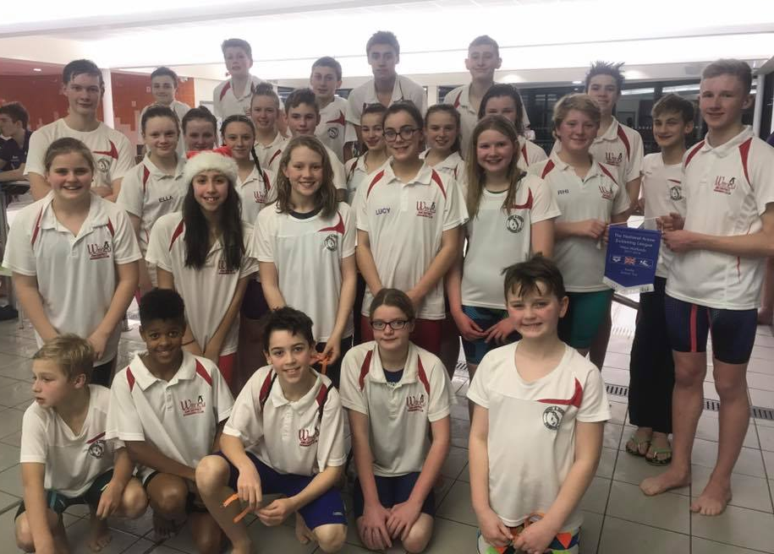
New Club Relay records:
11U 4x50m Medley – Sienna, Maya, Erin, Sophie
15U 4x50m FC – Maddie, Georgia, Ellie, Ella
15U 4x50m Medley – Lauren, Ellie, Georgia, Maddie
Open 6x50m FC – Maddie, Georgia, Lauren, Ella, Rhi, Ellie

Development day, presentations and Christmas social fun!
Captains Ben and Rhiannon collecting the finalists award

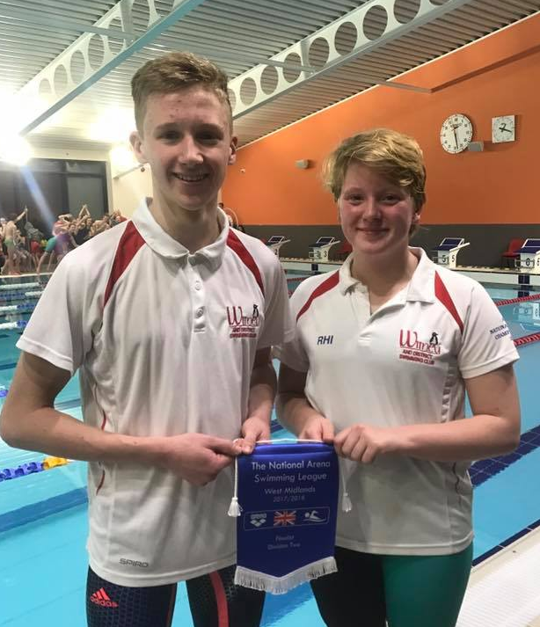
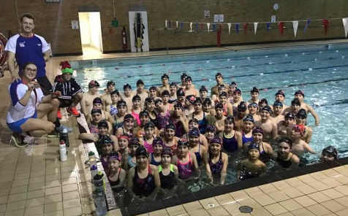
Good luck at ONB County Distance Events in Jan:
1500m FC – Hugo
800m FC – Steffi, Lauren, Camille, Jess, Ella
400m FC – Hugo, Dexter, Ellie, Sammy, Camille, Ella, Steffi, Lauren, Jess, Rosie, Eleanor, Sienna, Erin, Maya
400m IM – Hugo, Reuben, Ellie, Sammy, Camille, Lauren, Jess, Rosie, Eleanor, Sienna, Erin

