

Chantal’s W&DSC Head Coach Highlights
February Report2018
Medal winners at Wycombe Duel long course meet:
Well done to the swimmers who escaped the snow and made it to Oxford Development meet 4!
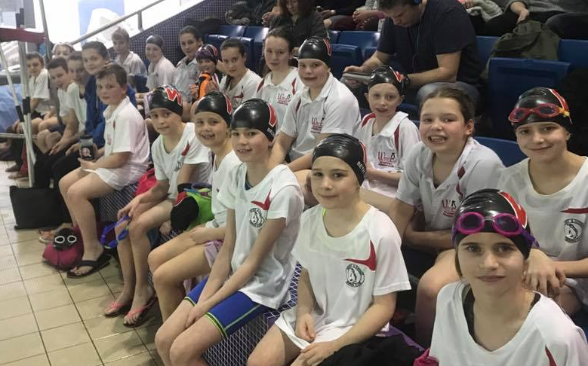

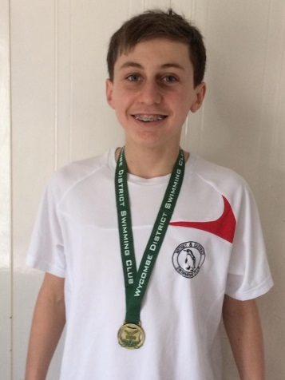
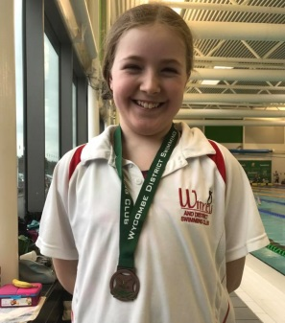
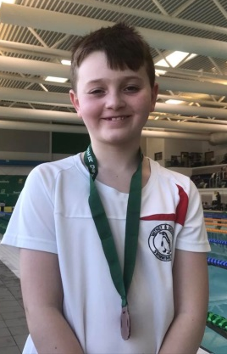
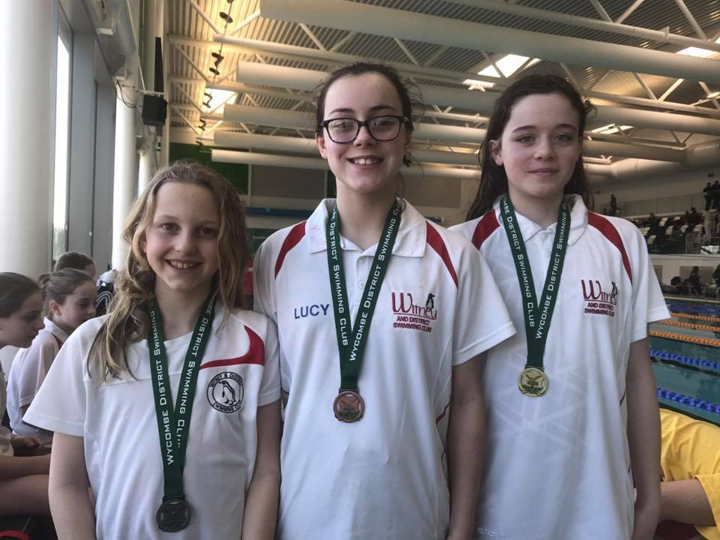
New Feb Club records:
Dexter Townsend – 9yrs 200m FC and BK
Hattie Lever – 9yrs 50m, 100m, 200m FC
Maya T-S – 11/u 200m BK
Lauren Mellings – 15/u 200m BK
Georgia Duff – open 50m BK
Ben Kinahan – open 200m IM
Girls 16/u 4x50m Med relay – Lauren, Ellie, Ella, Maddie
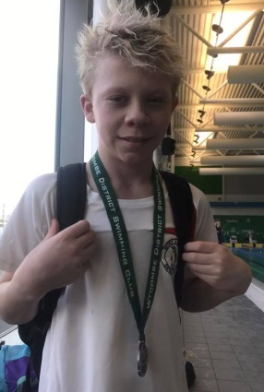

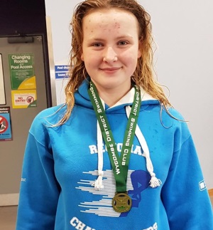
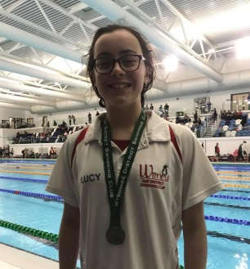

Georgia 2nd Junior ONB Champion in 50m BK
Club Points at ONB County Championships:
Every time a swimmer/relay places in the top 8 the club gets team points. The team points is split into 2 sections – Junior which is 10-13yrs and total team from all age groups
You can see a big increase in points in the last years.
Year Junior 13/u Total club
2016 9th 61.5pts 7th 151pts
2017 7th 68pts 9th 150pts
2018 7th 172pts 8th 323.5pts

