
Chantal’s W&DSC Head Coach Highlights January Report2018

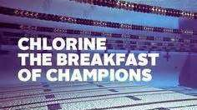
Busy month of junior galas and the start on ONB County Championships!

New Club records:
Dexter Townsend – 9yrs 400m FC
Camille Duff – 13/u 400m FC

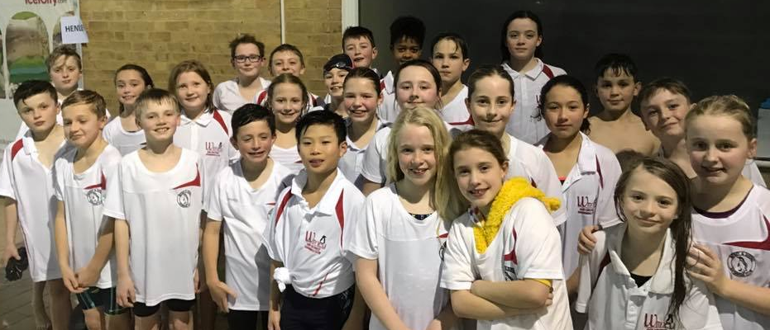
Good luck at ONB County champs in Feb:
Irene Aguado
Ellie Browne
Sammy Cartwright
Tia Collett
Reuben Coppuck
Camille Duff
Georgia Duff
Ella Edwards
Katie Franklin
Maddie Good
Lucy Howarth
Hugo Jinks
Rory Jones
Ben Kinahan
Ethan Lefort
Bertie Lever
Hattie Lever
Lauren Mellings
Jessica Miller
Rosie Mullins
Jonathan Opalczewski
Eleanor Perks
Rhiannon Saunders
Sienna Saunders
Erin Stewart
Maya Thorsdottir-Saldana
Dexter Townsend


Coaches are pleased with training attendance in Jan and strong focus on skills and stroke work.

No evening training Sunday 11th Feb due to Academy time trials

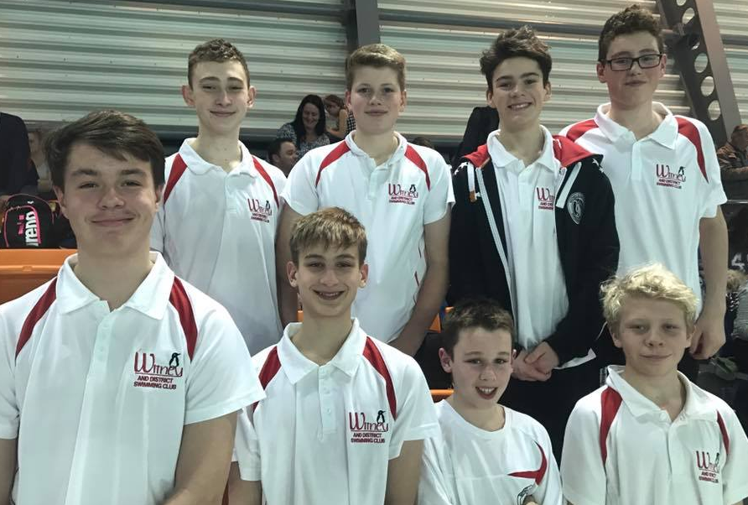
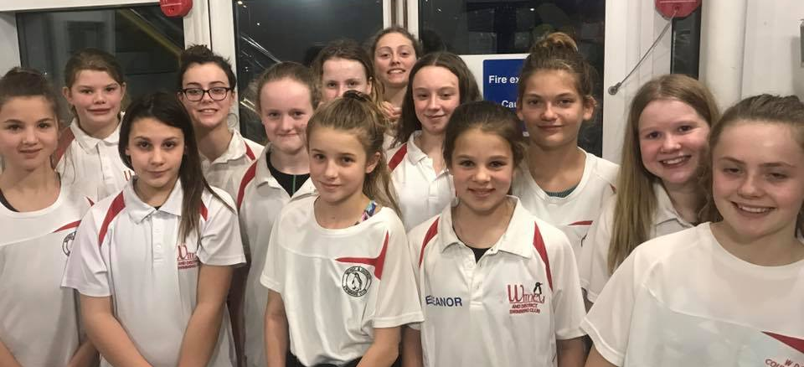
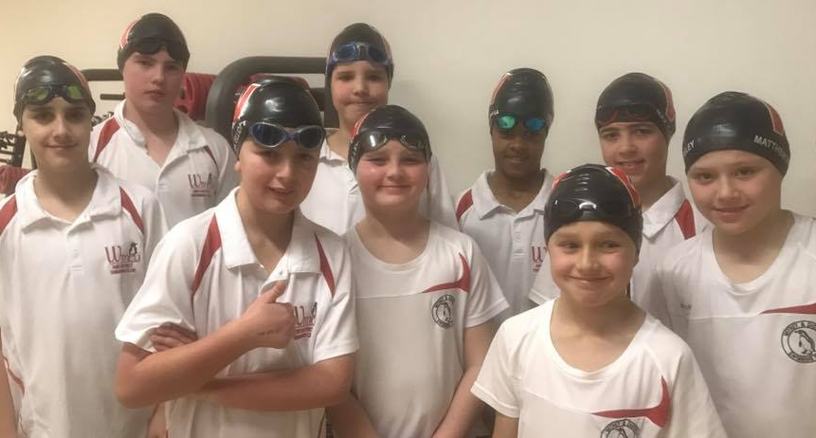
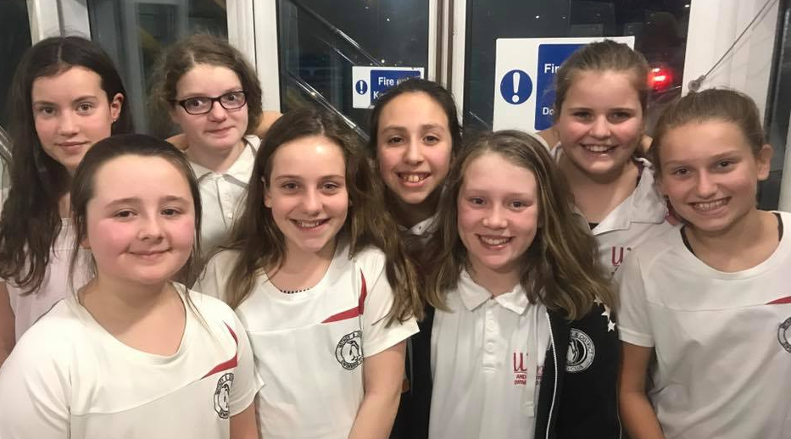
ONB County age group 11/12 + 13/14yrs relay teams:

