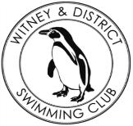
Chantal’s W&DSC Head Coach Highlights January Report2019
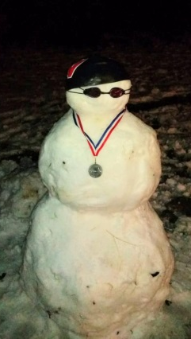
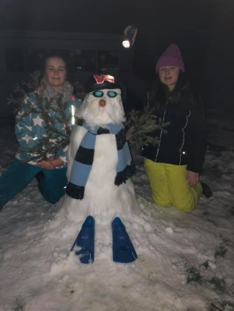

Busy month of junior gala, Cov OM, and the start on ONB County Champs!
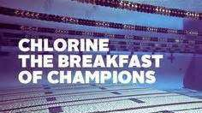

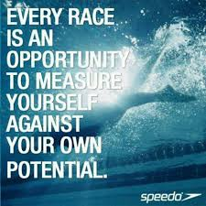
Good luck at ONB County champs in Feb:
Ellie Browne
Ellie Blake
James Bunyard
Sammy Cartwright
Tia Collett
Reuben Coppuck
Georgia Duff
Alice Dyson
Ella Edwards
Katie Franklin
Maddie Good
Lucy Howarth
Hugo Jinks
Sophie Jarvis
Rory Jones
Ben Kinahan
Ethan Lefort
Beth Lefort
Hattie Lever
Lauren Mellings
Jessica Miller
Rosie Mullins
Harriet Mullins
Jonathan Opalczewski
Eleanor Perks
William Phair
Henry Purcell
Cameron Richards
Rhiannon Saunders
Sienna Saunders
Erin Stewart
Maya Thorsdottir-Saldana
Ava White

Save the date – Sunday 3rd March – W&DSC Skills development day



Congratulations County top 8 positions in 400’s:
Eleanor, Jess, Ellie, Erin, Sienna, James, Hattie, Katie, Maya, Ellie, Lauren, Reuben

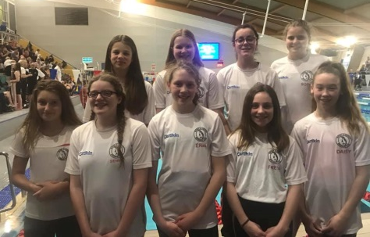
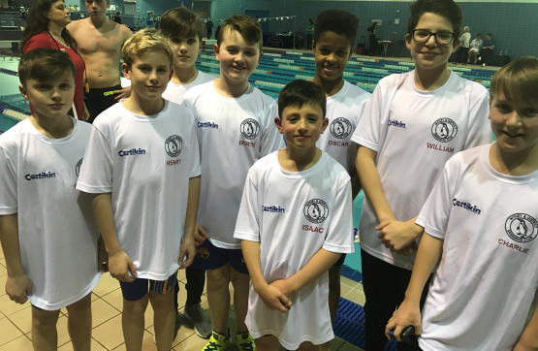
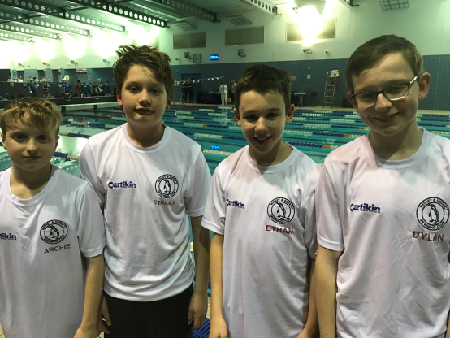
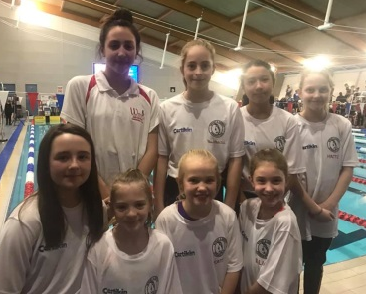
No evening training Sunday 17th Feb due to Academy time trials
ONB County age group 10-12 + 13/14yrs relay teams:

