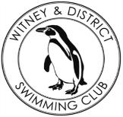
Chantal’s W&DSC Head Coach Highlights July/Aug Report 18

W
E
L
C
O
M
E
B
A
C
K
New July/Aug Club records:
Ella Edwards – 15/u LC 100 Fly
Jess Miller – 13/u LC 400 FC
Well done to swimmers who got their exam results!

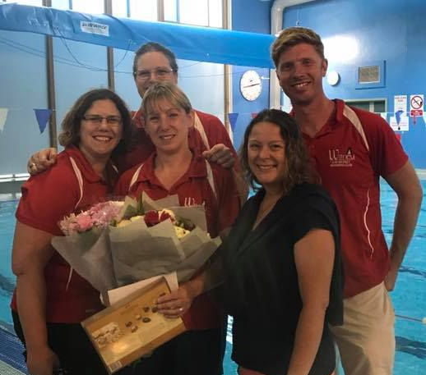
Thank you Michelle! We will miss you lots!

Good luck back at school! Remember to plan your homework and food ready for training

Make sure all swimmers have all correct equipment and spares (hats googles, swim kit) ready for the new season! Plus land training kit for pre pool which is 10mins before pool training!

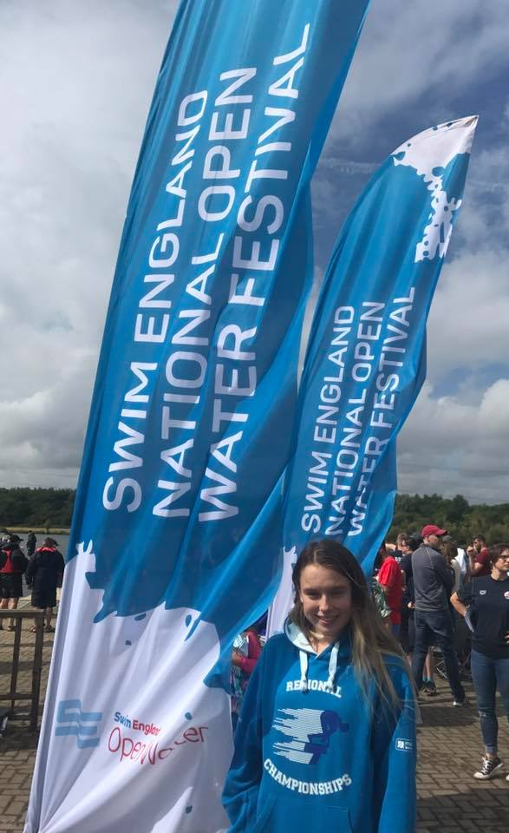
Well done to Maddie at English Open water Nationals – 23rd in the 16yrs 5k

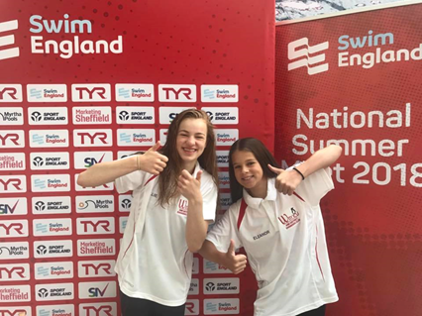
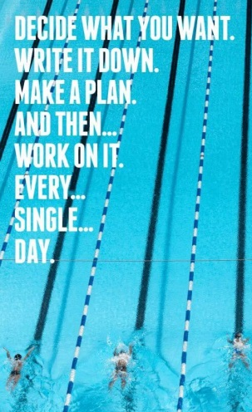

Well done to Jess and Ella at Welsh summer nationals!
Ella 50m BRS – 12th
100m FLY – FINAL 5th
200m FLY – FINAL 6th
200m IM – 11th
50m FLY – 12th
Jessica 400m FC –12th
200m FC –12th
100m FC –11th
100m BK – 11th
200m IM –25th

Well done to Ellie and Eleanor at English Summer nationals!
Eleanor 100m BRS – 18th
200m BRS – FINAL 7th
Ellie 200m BRS – 15th

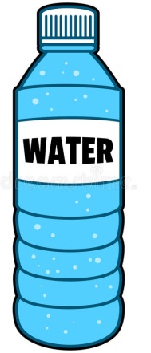
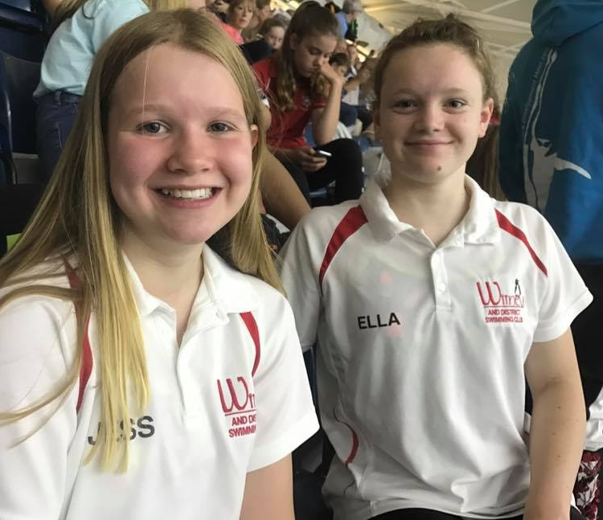
Don’t forget NAL dates:
Sat 14th Oct
Sat 10th Nov
Sat 8th Dec
Let’s go A team!!

Club champs are 21 -24th Sept and 28 – 1st Oct. Good luck!

