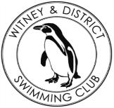
Chantal’s W&DSC Head Coach Highlights June Report 2018
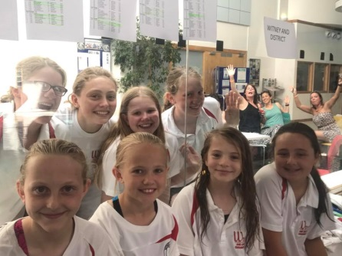
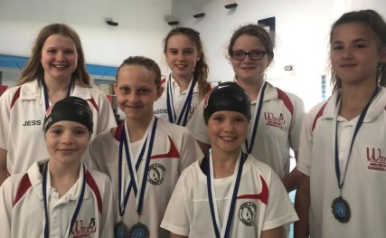
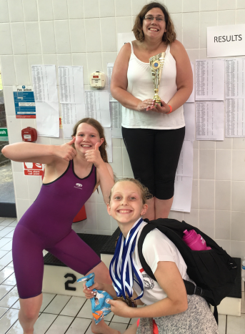
Well done to the swimmers who raced at Braunstone sprint meet – top visiting club!

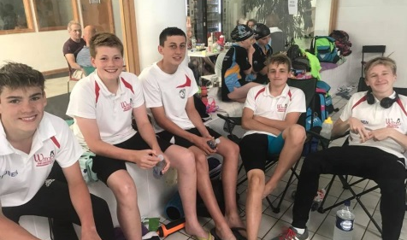

New June Club records:
Jonathan Opalczewski – 13/u LC 100 FC, SC 100 IM
Maddie Good – 15/u LC 1500m FC
Maya T-S – 11/u SC 50 BRS, 200 BK, 50 FLY
Eleanor Perks – 13/u SC 200m Brs

More to come in July???????

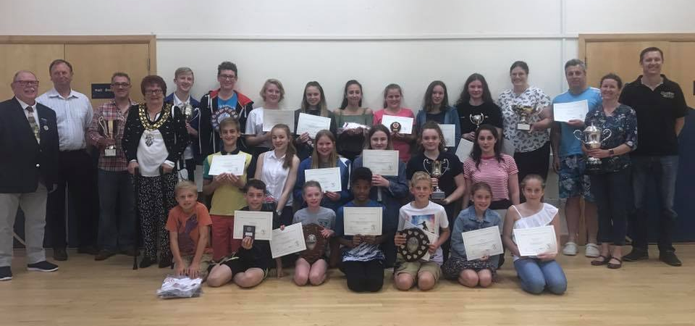


Well done to all the AGM award winners both swimmers and adults.
New 2018/19 captains:
Ellie + Ben K
Maya + Finn
Nearly summer holidays!!
Training ends Sunday 29th July and restarts Monday 27th August

Fun inflatable session
Sunday 22nd July WLC
Check the times for each squad

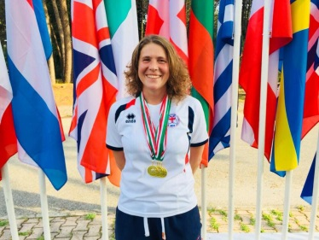
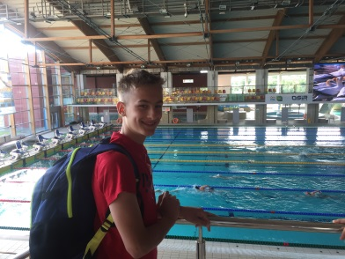
Well done to Jonathan who competed at Polish Nationals
Don’t forget to do your 2018-19 goal form!
Make sure your parents book in an end of season progress meeting with lead coaches. Sign up on WLC notice board.

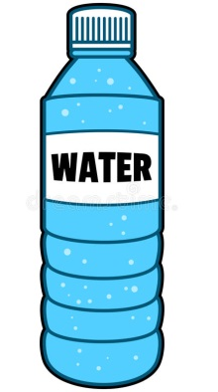
Keep hydrated in hot weather – drink plenty of water!
Good luck to the following swimmers who will be competing at Summer Nationals:
Welsh: English:
Ella Edwards Eleanor Perks
Lauren Mellings Ellie Browne
Jessica Miller

