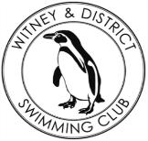
Chantal’s W&DSC Head Coach Highlights March Report 2018
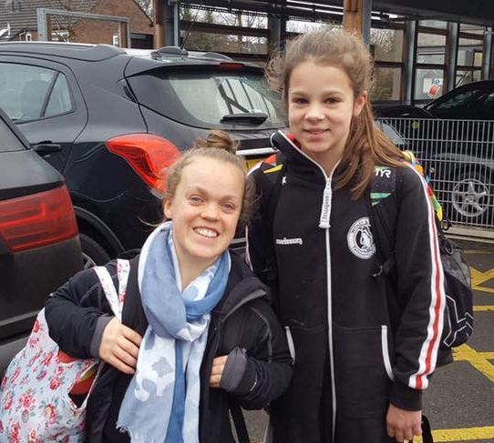
Well done to Georgia, Camille, Jess, Lauren and Ella who competed at Scottish and Welsh National championships at Easter
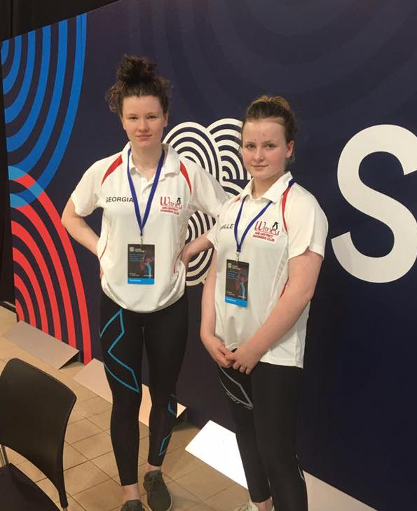
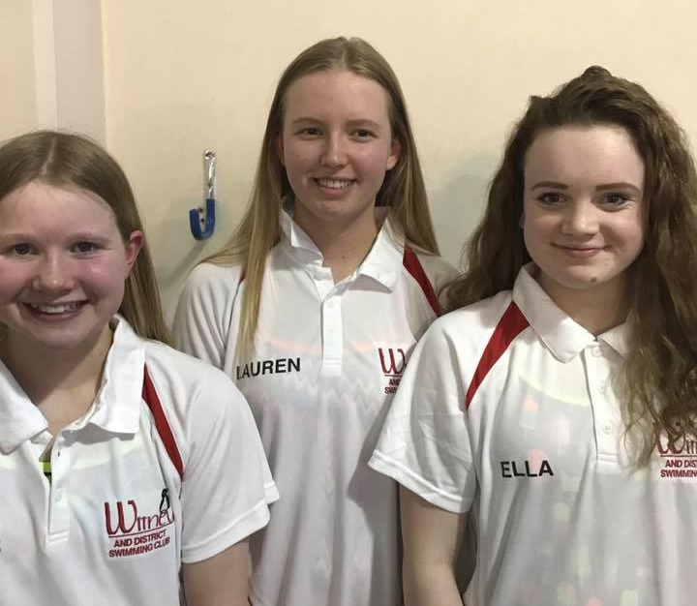
Well done William for his medals and PB’s at GB Deaf Gala

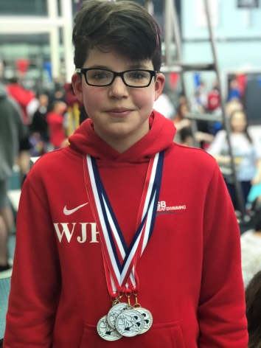
Eleanor meets Ellie Simmonds at Wycombe meet!

New March Club records:
Eleanor Perks – 13/u LC 200m BRS
Jonathan Opalczewski – 13/u SC and LC 50m Fly
Hattie Lever – 9yrs LC 200m IM, 100 BK, 100 FC
Camille Duff – 13/u LC 200m FLY
Hugo Jinks – 15/u LC 1500m FC
Lucy Howarth – 13/u LC 100m FLY
Jessica Miller – 13/u LC 400m FC



Swimming starts 5th April!

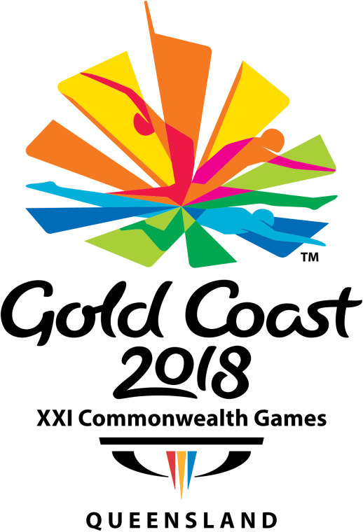
Coaches are happy with…….
Swimmers mind set to work hard and push themselves to be better and stronger.
Keep working on…..
Strong SL fly kick!

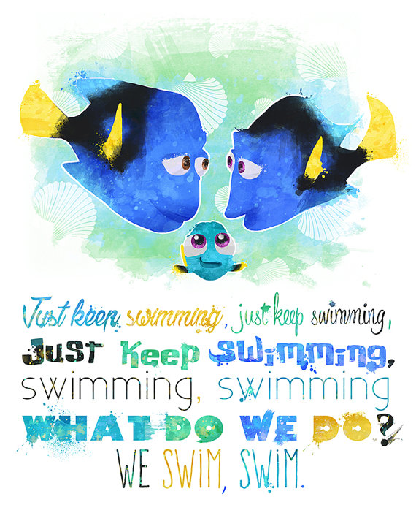
Diddy Championship records:
Dexter Townsend – 100 IM, 50 FC, 50 BK
Katie Frankin – 100 IM, 50 FLY, 50 FC, 50 BK
Bertie Lever – 100 IM
Maya T-S – 100 IM, 50 FLY, 50 BK
Swimming starts 5th April!

