
Chantal’s W&DSC Head Coach Highlights March Report2019
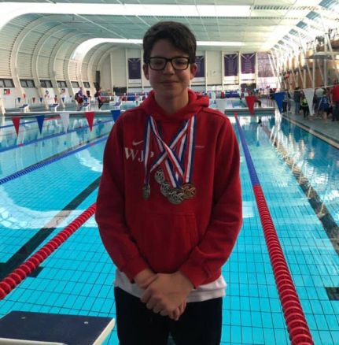
Well done William for his 4 medals at GB Deaf Gala in Loughborough
Time Trials 2019 Schedule
Friday 10th May 7 - 9pm WLC
400m FC or 400m IM
Friday 17th May 7 – 9pm WLC
200m Breaststroke
Sunday 19th May 9 – 10.30am CLC
200m Backstroke
Sunday 19th May 5.30 – 7.30pm WLC
200m Frontcrawl
Monday 20th May 7.30pm WLC onwards
200m Butterfly
All swimmers from AGE 1,2,3, YOUTH 1,2,3 must attend.
Performance swimmers are to also attend but will do a race pace on their form 200m.
Sunday 7th July
4.30 – 6pm WLC
Academy 1,2,3 – All strokes & 100m IM
Development 1,2,3,club – 100m IM (if wish to do 200m IM then arrive at for 6pm session)
6 – 7.30pm WLC
Age Group/Youth – 200m or 400m IM



Good luck to all sitting GCSE’s

Great fun was had by all at the development day with Amy Smith and Joe Roebuck

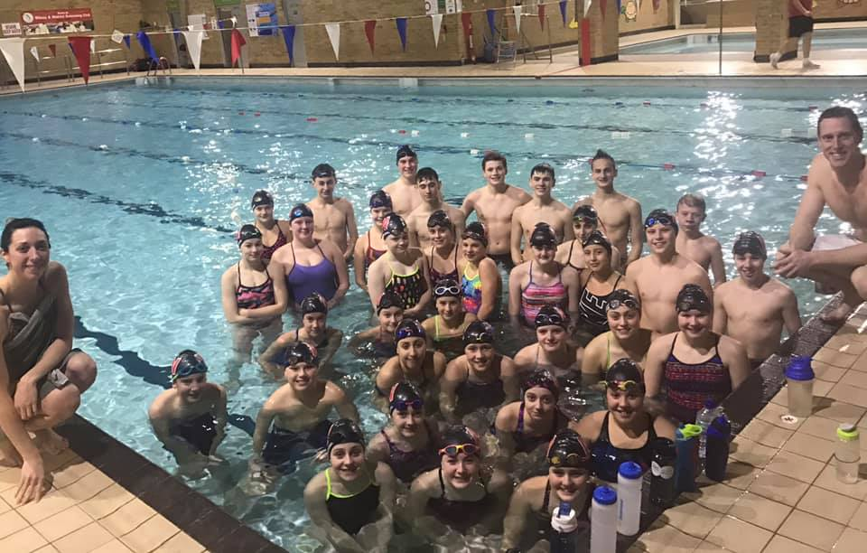

Well done to William winning 3 medals at the BD deaf gala at Loughborough

New records broken in March:
Diddy Championship records from heats:
Henry Purcell 10yrs - 50 BK and 100IM
William Phair 12yrs- 100IM, 100BK and 100FLY
Maya Thorsdottir-Saldana 12 yrs - 100FLY
New Short Course club records:
Henry Purcell - 9yrs 100m IM at Diddy Heats
New Long Course club records:
Wycombe L1:
James Bunyard 50BRS and 100FS - Open
Jessica Miller 800FS - 13U, 15U, Open
200FS - 13U
Eleanor Perks 50BRS - 13U, 15U, Open
100BRS - 13U, 15U, Open
200BRS - 13U, 15U, Open
200IM - 13U, 15U
400IM - 13U, 15U, Open
Luton L1:
James Bunyard 200FS Open
Lucy Howarth 100FLY 13U
Jessica Miller 1500FS 13U, 15U, Open

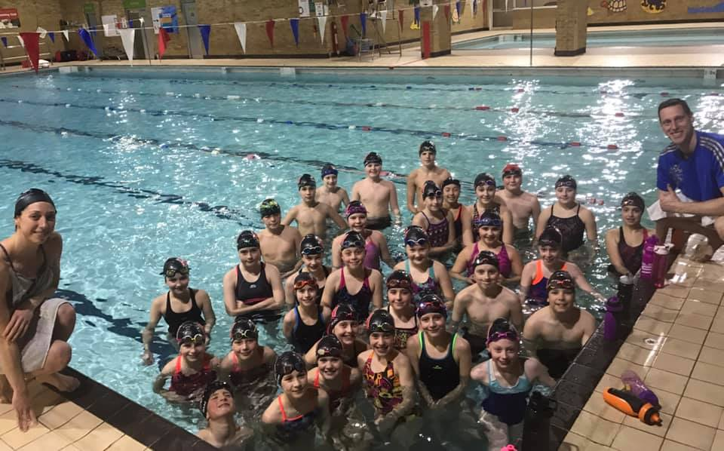

Level 1 meet medal winners in March

