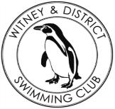
Chantal’s W&DSC Head Coach Highlights May Report 2018
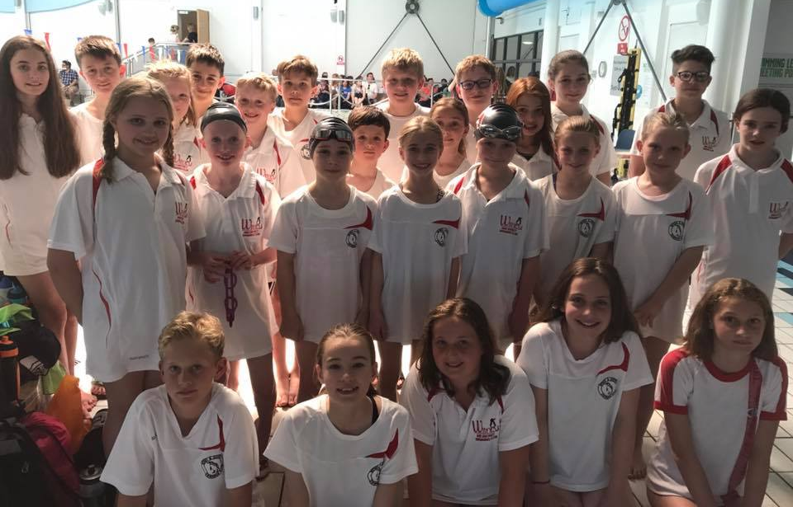
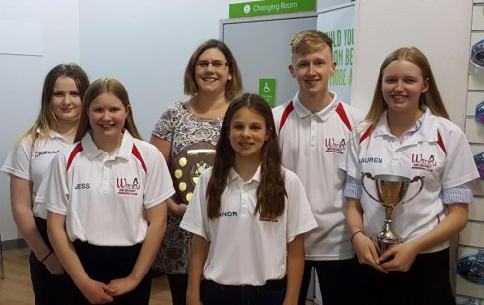
Well done to the swimmers who raced at the Thame Development meet

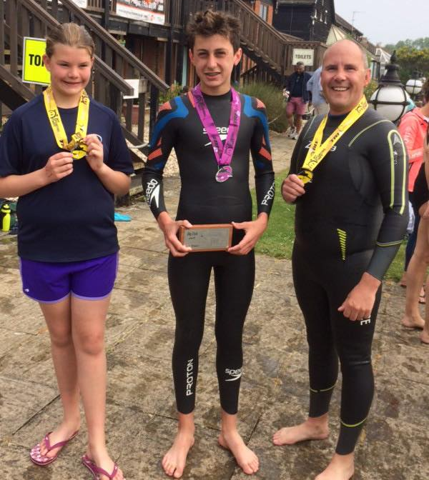
Success at West Oxfordshire Sports awards!!

New May Club records:
Ella Edwards – 15/u LC 100m FLY
Jonathan Opalczewski – 13/u LC 50 FLY
Maddie Good – 15/u LC 1500m FC
Maya T-S – 11/u LC 100/200 BRS
Eleanor Perks – 13/u LC 50/100/200m Brs
Hattie Lever – 9yrs 400 FC / 200m IM
Lauren Mellings – 15/u LC 400m IM

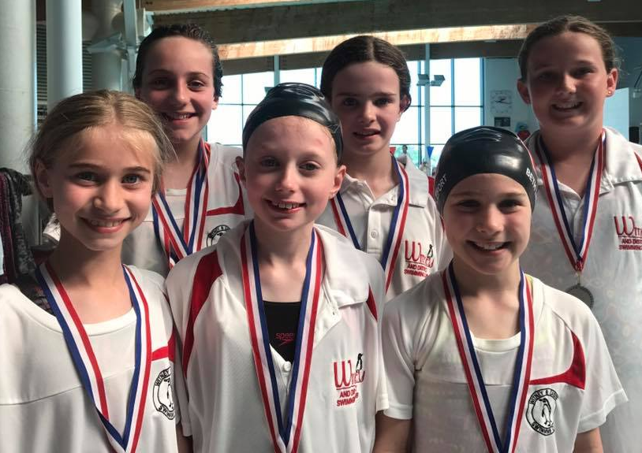

Success at OW for Hugo (1st Big Fish), Megan (8th small fry) and coach Dave!
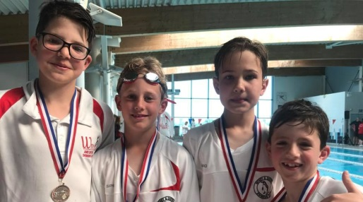


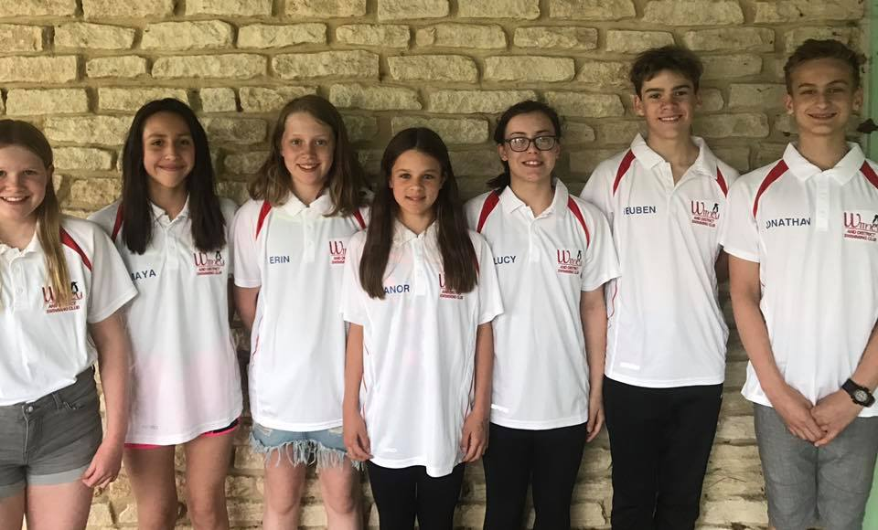
Summer Social BBQ + Chill!
Saturday 30th June
Remind your parents to buy tickets!

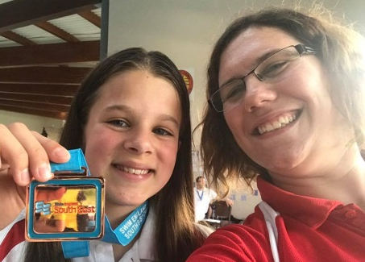

Eleanor’s bronze regional medal!
Well done to the following swimmers who competed at Swim South East Regionals (F=final):
Ella Edwards Eleanor Perks (F)
Lauren Mellings (F) Jessica Miller (F)
Ellie Browne (F) Reuben Coppuck
Maddie Good Erin Stewart
Georgia Duff (F) Jonathan Opalczewski
Ben Kinahan Lucy Howarth
Maya T-S

