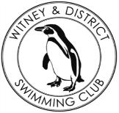
Chantal’s W&DSC Head Coach Highlights
November Report 2017
3rd place at NAL rd 2 means finals for RD3!!
Ranked 6th Div 2 West Midlands
Blan’s success at Irish Masters Nationals:
Club championship finals fun!

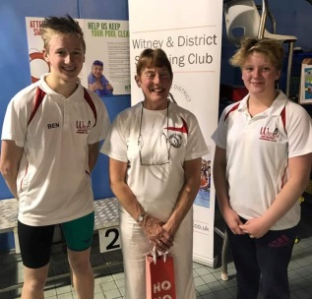
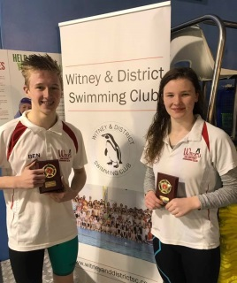
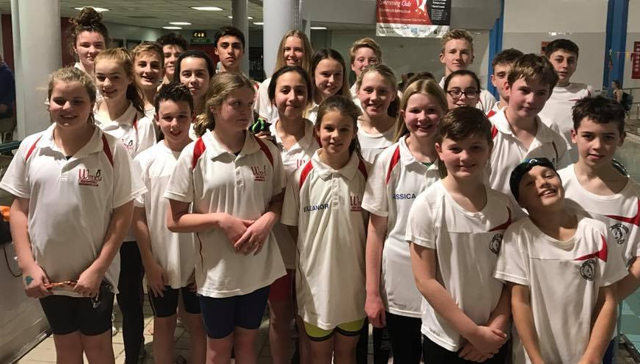
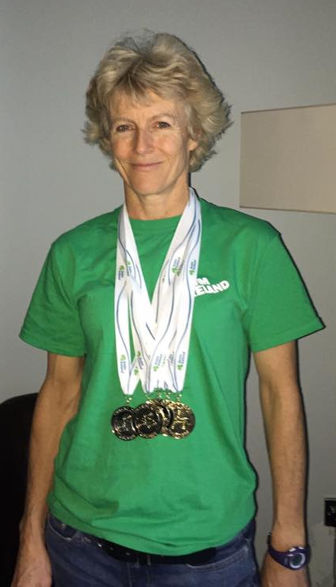
Skins winners – Georgia + Ben
Captains Ben + Rhiannon with Mayor Chris and Club president Chris James

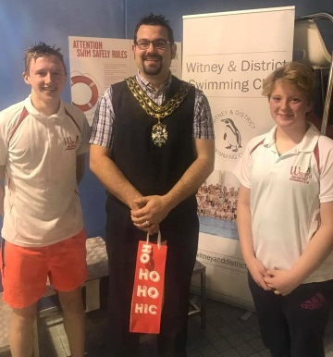
New Club Championship records:
Jonathan – 100 BK Malik – 100 FLY + FC
Georgia – 200 IM + 100 BK Reuben – 100 BRS
Jessica – 100 FC Camille – 100 FLY
Erin – 100 BK Ella – 100 FLY
New club record: Hugo – 1500m FC
New Club relay record:
Lauren, Ellie, Georgia and Maddie – 15/u 4x50m Medley

OVER 110 PB’S at Club Championship finals!!!

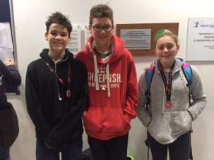

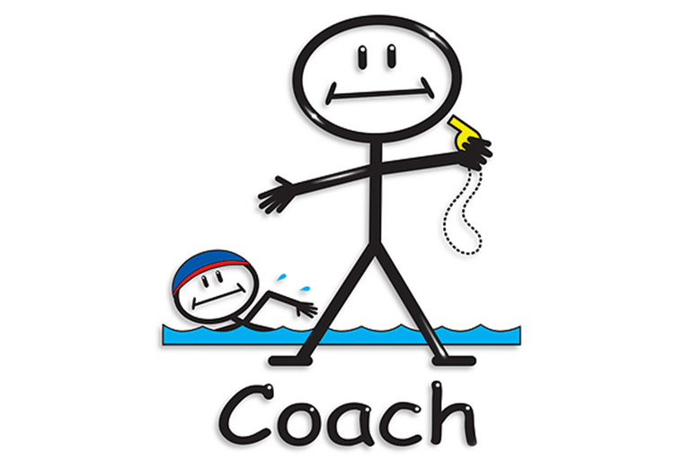
Winter Regionals Success!
Georgia, Ben, Ellie, Maddie and Lauren

Coaches are really happy to see great progress this month on those important processes – strokes, turns, starts, finishes, streamlining……..
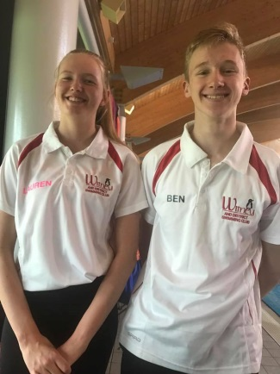
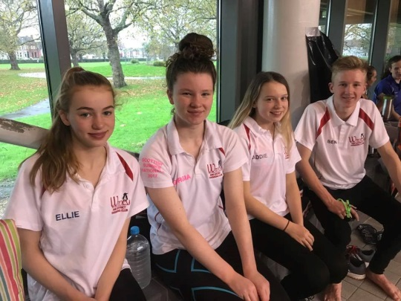


Don’t forget to ask Santa nicely for your swimming Christmas presents!
Sunday 17th December
- Development Day
- Christmas social
- Penguin Draw
- Club Championship presentations
- Food and Fun!!!

