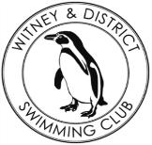
Chantal’s W&DSC Head Coach Highlights Nov+Dec Report 18
Good luck ONB Distance events!
1500m FC – Hugo, Sammy, Jess
400m FC – Ethan, Reuben, Jonathan, Hugo, James, Katie, Hattie, Ellie, Maya, Erin, Sienna, Harriet, Jess, Eleanor, Sammy, Rosie, Ellie, Lauren, Steffi
400m IM – Erin, Sienna, Harriet, Eleanor, Jess, Sammy, Rosie, Ellie, Ethan, Reuben, Hugo, Cameron

New Club records:
Jess Miller 13/u 800 + 1500m FC , Maya T-S - 11/u 50m Brs / Eleanor Perks - 13/u 100m Brs , 13/u 4 x 50m Medley relay - Jess, Lucy, Erin and Eleanor, Hugo Jinks 15/u 1500m FC, Sienna Saunders (11/u 100m Bk), Maya T-S (11/u 100 + 200 Brs), Eleanor Perks (13/u 100m Brs) , Henry Purcell (9/u 200m Bk)
New club championship records from finals – James Bunyard, Ben Kinahan, Maya T-S, Jess Miller, Lucy Howarth, Eleanor Perks, Georgia Duff
New club records from club champ finals – Henry Purcell, Ben Kinahan, Maya T-S, Jess Miller, Eleanor Perks


Club championship finals
Skins winners – Georgia, Ben + James
13 CCR’s and 6 CR’s
ONB County Champs
34 swimmers
28 relays
231 individual swims
Happy
New
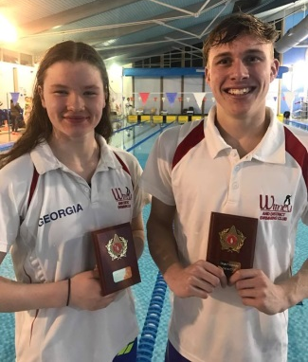
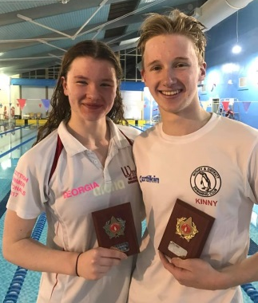
Year! Year!

Club championship finals
Ella and Jess both competed in a range events with Ella achieving a final in the 200m Fly and Jess silver medal (and welsh champion) in 1500m FC

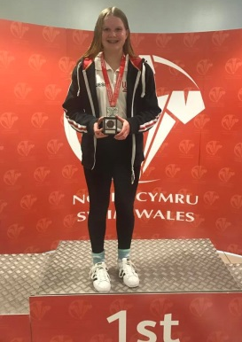
Winter regionals results
Ella, Ben, Georgia and Maddie all competed in the
open Swim
South East
Winter regionals.
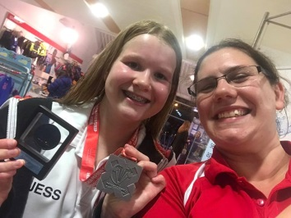
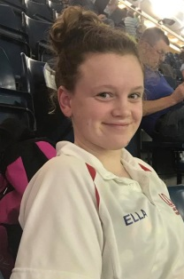
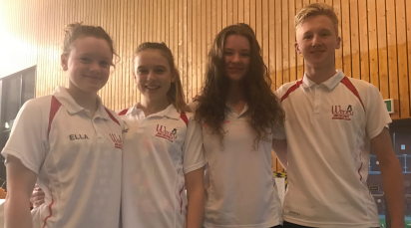

Georgia at Scottish SC Nationals in Edinburgh
Moving up rankings and 2 PB’s in 100 BK and 50 Fly

National Arena League success!!
Coming 4th in final round we are now in
Division 1 for 2019!

